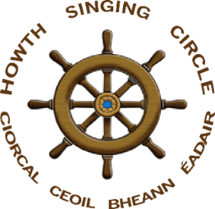

Uachtaráin: Diarmuid Ó Cathasaigh (RIP)
Saoithe: Paddy Daly, Niamh Parsons, Ann Riordan
The Sweet Nightingale
New Series, no 24, September 2022

From The Abbey Tavern Back To the Sea Anglers’ Club

The ongoing post-Covid problems of the Abbey Tavern have necessitated a change of venue and our old friends in the Howth Sea Angling Club on the West Pier have welcomed us back with open arms. We leave the Abbey Tavern with heavy hearts as Richard Tobin and his staff have treated us with kindness and generosity and, of course, Howth Burns Nicht is synonymous with the venue. As The Sweet Nightingale goes to press comes news that the Abbey Tavern is on the market, an announcement that has caused shock and disbelief throughout the Howth community. We wish Richard and all the Abbey staff every best wish in their uncertain times.

So, see you all back in the Howth Sea Angling Club, a venue where we spent many happy years.

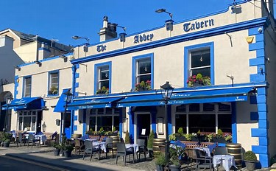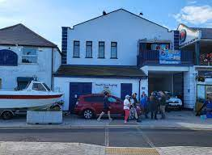
Ann Riordan & Laurence Bond manage our Harvest Night while John the Barman carried off the main prize
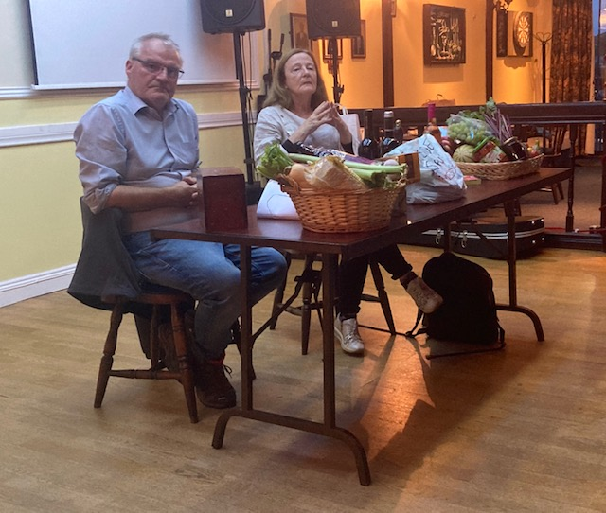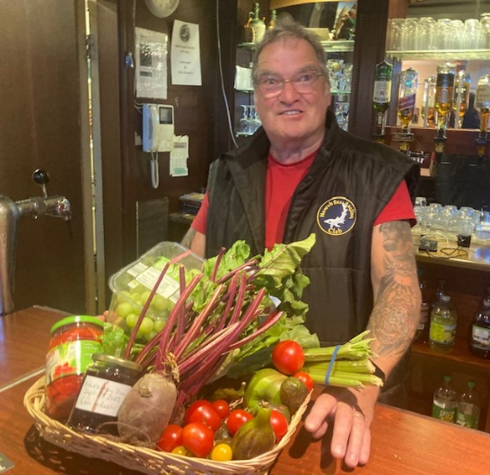

Where Does Your Money Go ?

As is our practice, here you can see what happened to the voluntary €4 donation you make at our monthly sessions.

Our accounts for the 2021-2022 season show an opening balance in September 2021 of €2,632.96. Income for the year until 1 September 2022 was €2,450.57 and expenditure was €2,725.06. Thus, for the year, a small deficit of $€$274.49 was recorded. Much of this arose from the disappointing support for The Wilsons concert, a wonderful night of singing and music. This leaves an opening balance of €2,358.47 at the start of the current season running from 1 September 2022.

The main outlays were the outlay for the (virtual) Burns Nicht, the 20th Anniversary Concert with The Wilsons and copies of the Anniversary Video ‘I Have Spent It In Good Company’, copies of which are still available. Our ongoing costs relate to the hire of rooms and fees for guest singers. In addition – and maintaining the HSC’s tradition of fund-raising for worthy causes – €405 was raised by July’s Singing the Fishing session and donated to St Francis Hospice, Raheny.

Without your donations, HSC could not contemplate engaging in our wide range of activities. We deeply appreciate your sponsorship of the Club and believe that financial transparency is important to retain your confidence that your money is well spent.
Ann Riordan

Et Avskjedsglass for Randulf – A Parting Glass For Randulf

Our friend in Norway Randulf Stendahl sadly passed away on Sunday 31 July at home and with his family. In his last days, he rang to tell many us of his illness and asked that his parting best wishes and thanks be sent to all those who befriended him and shared songs with him in Ireland. He made regular trips and attended many singing sessions. In Howth, he was a regular contributor, always welcome as a good singer and admired for his gentle, engaging manner. We lift a parting glass to a cherished friend.

Til hans familie og venner på Lillehammer sender vi våre oppriktige kondolanser. Mange irske stemmer vil synge til hans ære. Ní fheicfimid a leithéid arís.

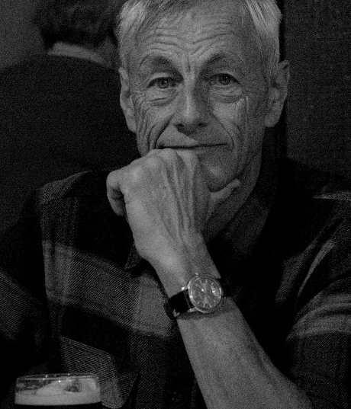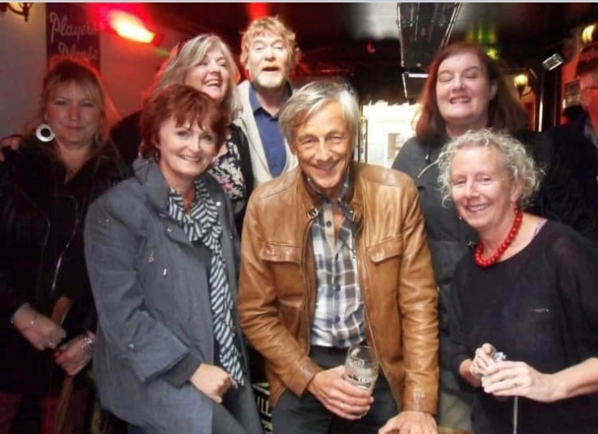
Colm Keating’s fine portrait of Randulf and Randulf with Martina Nic Cearnaigh, Deirdre Madden, Niamh Parsons, Barry Gleeson, Anne Parsons Dunne & Helen Lahert

‘Under a Harvest Moon’

Our return to the Howth Sea Angling Club witnessed a quiet but highly enjoyable night with generous donations to the Harvest Baskets – the biggest one being a surprise reward for John the Barman who drew the winning ticket. Ably managed by Laurence Bond and Ann Riordan, the night was packed with good songs, some fine performances and a lot of fun. Walter Kennedy took us back to the Botanic Gardens with ‘The Last Rose of Summer’ and, later, Robert Burns’ beautiful autumnal love song ‘Westlin Winds’, written when the bard was sixteen in 1775! Michael King chilled the room with ‘The Unquiet Grave’ and – in welcoming Walter’s sister Geraldine and Malachy O’Reilly from Adelaide – Eric Bogle’s ‘And the Band Played Waltzing Matilda’. Niamh Parsons added to the anti-war sentiments with a new song that took us from Anne Frank’s hiding place through Palestine to Ukraine. Eddie Phillips – Farmer Eddie with his bag of Bayside spuds on the night – was, as ever, dead on the theme with a Copper Family harvest song while Angela Plunkett delighted in the joys of ‘Home Grown Tomatoes’. Anne Parsons reflected on being ‘In My Prime’ and Jack Plunkett sang of a woman celebrating her 102nd birthday by dancing! Ann Riordan and Geraldine O’Reilly displayed formidable terpsichorean skills when dancing along!

Máirídhe Woods took us to ‘Mendocino’, Geraldine O’Reilly to ‘Caledonia’ and Brian Doyle to Clare and Skibbereen. Helen Lahert gave a great performance of Shane McGowan’s ‘Broad Majestic Shannon’ while Malachy O’Reilly’s tour-de-force was ‘Too-Ra-Loo-Ra-Loo-Ra!’, a rendition that truly filled the room! Larry O’Toole sadly found the pub had no beer while Úna Kane strolled ‘On the Strand of Howth’ with Pádraig Pearse. Eileen Clancy took us down the ancient Corlea Trackway while Ann Riordan shared some ‘Plums’ gathered by Gillian Clarke.

The contributions to the Harvest Baskets were terrific and allowed a good few to go home with something tasty. The tradition of free raffles is one of the Club’s joys together with the return to home made sandwiches thanks to Ann Riordan’s efforts. Our thanks to everyone who came along and how good is it to be singing live again !

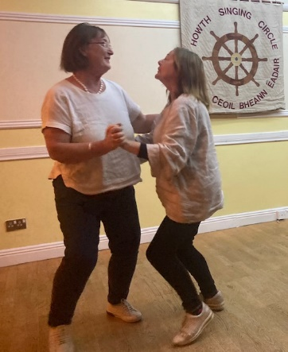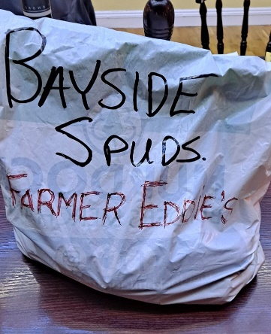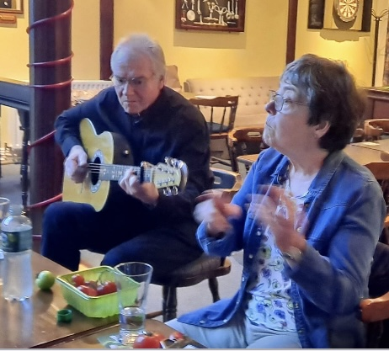
Geraldine O’Reilly and Ann Riordan rehearsing for Strictly; the new potato crop from Eddie Phillips’ estates in Sutton; and Jack & Angela Plunkett celebrating ‘Home Grown Tomatoes’

The Blessing of the Boats

Howth Singing Circle were delighted to be invited by the Howth Fishermen’s Association (HFA) to participate in the Blessing of the Boats ceremony, this year part of the Howth Maritime & Seafood Festival. After a glorious Saturday when the crowds were sardines around the harbour and getting on or off the peninsula was a chore, incessant rains kept the crowds low on the Sunday 11 September. Our crew were undaunted and reported aboard although the event had to be started in the shelter of the HFA’s marquee.

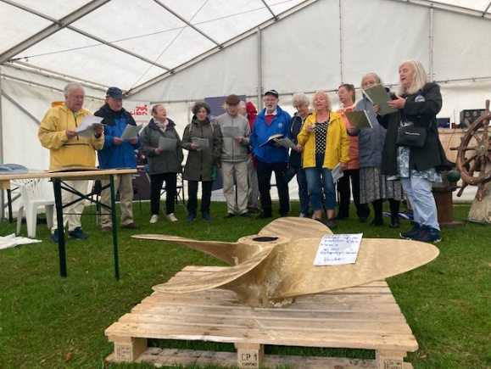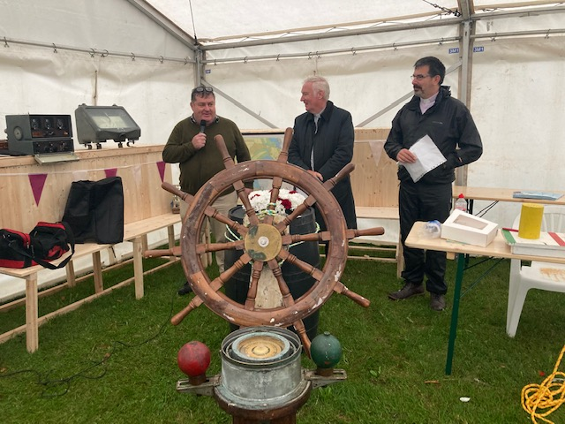
Behind the propeller of the Purple Heather, lost off Castletownbere, the Howth Singing Circlers were Gerry O’Connor, Walter Kennedy, Ann Riordan, Úna Kane, Eddie Phillips, Brian & Mary Doyle, Helen Lahert, Siobhán Moore, Anne & Niamh Parsons. On the right, Seán Doran (HFA), Father Cyril Mangan and Rev Philip Heak prepare to Bless the Boats

Our participation had been arranged by Helen Lahert and Ann Riordan and, co-ordinating with Tracy Floyd, maintained a long tradition of our involvement in this moving event. Howth’s fishing industry is much depleted from the days when the HSC was founded but the port and its seafarers remain at the heart of the community and we were honoured and delighted to pay our respects. The Blessing – which finished at the monument to Lives Lost at Sea and the harbour wall – was conducted by Fr Cyril Mangan (St Fintan’s, Sutton) and Rev Philip Heak (St Mary’s, Howth).

Our songs and singers were Helen Lahert, ‘Three Score & Ten’; Brian Doyle, ‘The Leaving of Liverpool’; Gerry O’Connor, ‘Old Whitby Harbour’; and Siobhán Moore, ‘The Greenland Whale Fisheries’. After the Blessing at the monument, we sang ‘The Parting Glass’. Our singers were Paddy & Antoinette Daly; Brian Doyle; Úna Kane; Walter Kennedy; Helen Lahert; Siobhán Moore; Gerry O’Connor; Anne & Niamh Parsons; Eddie Phillips; and Ann Riordan. Our thanks to Seán Doran and the HFA for refreshing the crew in Howth Yacht Club after the event.

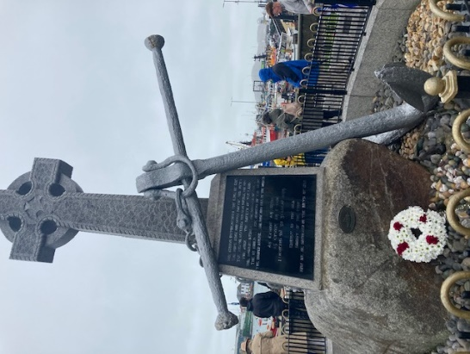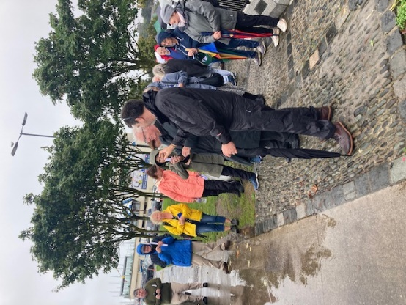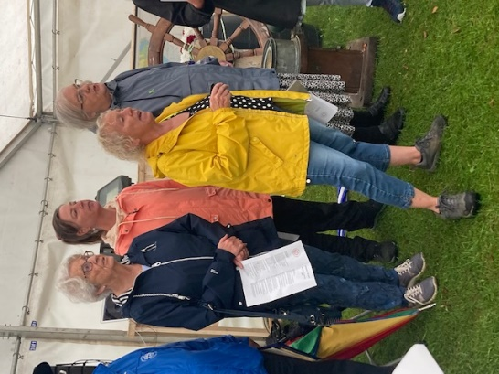
Howth monument to Lives Lost at Sea; the Blessing of the Boats; our Skipper for the day Helen Lahert with Mary Doyle, Siobhán Moore & Anne Parsons

HSC 21st Anniversary Video ‘Good Night & Joy Be With You All’

On Thursday, 20 October, the second of our two Anniversary videos – ‘Good Night & Joy Be With You All’ – will be launched by Meabh Meir (Belfast Singing Circle) via a Zoom presentation. After our first 20th Anniversary video – I Have Spent It In Good Company – was received to critical acclaim, Francy Devine, Ann Riordan and Séamas Sheils have worked to script, film edit and produce this second production for our 21st Anniversary. Those singers featuring are Shona Donaldson Anderson, Cathal Caulfield, Andrew Clarke, Francy Devine, Mick Fowler, Len Graham, Helen Lahert, Eugene McEldowney, Eibhlís Ní Ríordáin, Daoire Ó Baoill, Willy O’Connor and Fergus Russell. In addition, the Howth Singing Circlers can be seen singing Mick Fowler’s ‘All Hail! All Hail!’ – the Club’s carol – and ‘The Parting Glass’. In addition, musicians include Andrew Clarke (guitar); Larry Egan (box); Aoife Kelly (concertina); Cathy Potter Kelly (harp); John Kelly (fiddle); Charlie Lebrun (flute); Seán Óg McKenna (banjo); Mick Mullen (guitar); Rónán Galvin (fiddle); and Howth St Lawrence Pipe Band.

The ‘Postcards From Howth’ where people reflect on their favourite memories of the Howth Singing Circle are a novel and interesting feature. They include Andy & Kay Burke; Morag Dunlop & Janet Weatherston from Scotland; Eileen Clancy; Stiofáin Ó hAoláin; Gerry O’Connor; Niamh Parsons; Eddie Phillips; and Richard Tobin. The video’s presenters are Laurence Bond, Paddy Daly, Brian Doyle, Helen Lahert and Ann Riordan.

So, you can look forward to a night of nostalgia with some fine singing and musicianship, as well as many photographs of our activities over the years.

Buíochas Mór

We thank those who have contributed to this Sweet Nightingale: Helen Lahert (photographs); Howth Sea Angling Club; and the Howth Singing Circle Committee – Laurence Bond, Paddy Daly, Francy Devine, Brian Doyle, Helen Lahert, Daire Ó Baoill, Gerry O’Connor, Niamh Parsons and Ann Riordan.

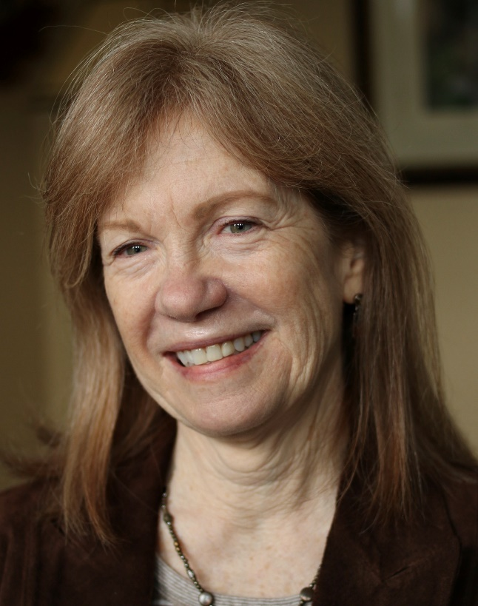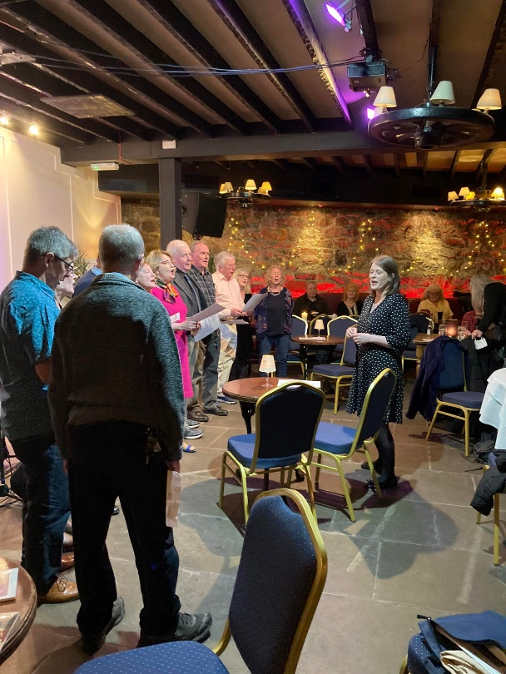
Claudia Anderson from Chicago – our Three in a Row in October and Shona Donaldson Anderson leading the HSC Choir at our Anniversary Concert last April

Our Autumn Programme

Thursday, 1 September – ‘Under a Harvest Moon’ with Laurence Bond & Ann
Riordan

Thursday, 6 October – Francy Devine & Fergus Carey ‘Songs From Munster’
with Three in a Row from Claudia Anderson (Chicago)

Thursday 20 October – Zoom launch of 21st Anniversary Video, Good Night &
Joy Be With You All, by Maebh Meir with Laurence Bond &
Séamas Sheils

Thursday 5 November – Brian Doyle & Walter Kennedy, ‘The Times They Are
A-Changing – Songs of Bob Dylan’
Three in a Row – Walter Kennedy

Thursday 8 December – Gerry O’Connor & Dara O’Baoill, ‘O The Holly’
Three in a Row – Niamh Parsons

Thursday 5 January – Helen Lahert & Niamh Parsons, ‘Nollaig na mBan’

Saturday, 28 January 2023 – Howth Burns Nicht 2023 – Abbey Tavern

Sunday, 29 January 2023, 3-6.30 – Fare Thee Weel Session with Special
Guests Luck Penny (Aodán Jaff Mac Séafraidh & Jackie Jefferies)

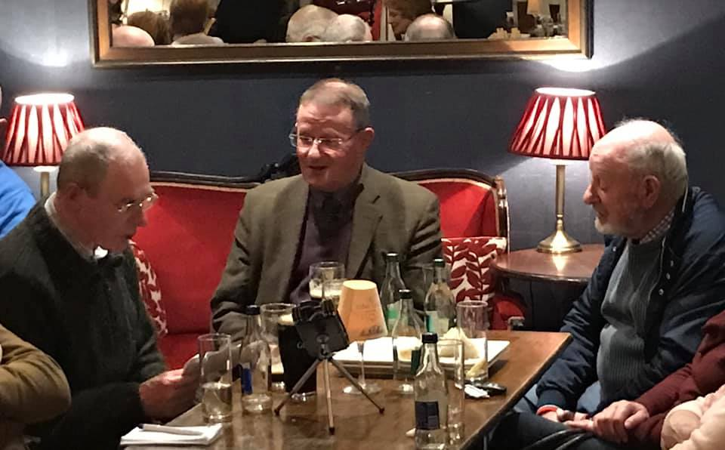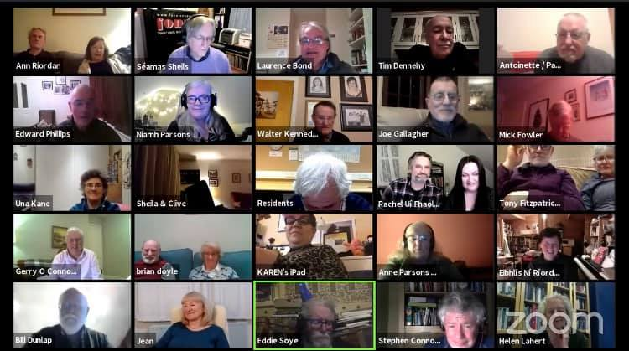
Three wise men who might appear around this time of year – Eddie Phillips, Walter Kennedy & Brian Doyle; while we bade farewell to Zoom until mid-October but thank all of you, from far and near, who joined us during Covid

