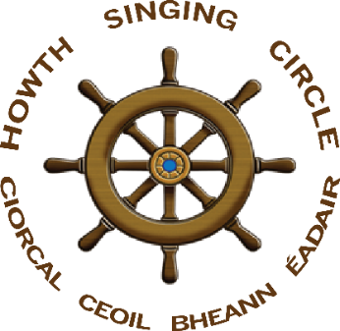
an open session in aid of St Francis Hospice
Singing the Fishing

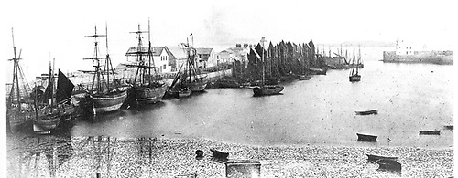
the herring fishing fleet, Howth, West Pier, 1860

Fir an Tí
Paddy Daly & Francy Devine

Saturday, 16 July 2022 – 3-6pm

Howth Sea Angling Club, West Pier

all welcome

‘With our nets and gear we're faring
On the wild and wasteful ocean.
It’s there that we hunt and we earn our bread
As we hunted for the shoals of herring’

