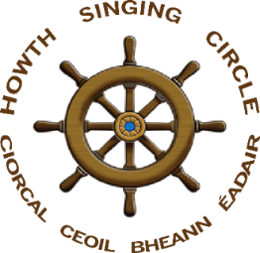

Uachtaráin: Diarmuid Ó Cathasaigh (RIP)
Saoithe: Paddy Daly, Niamh Parsons, Ann Riordan
The Sweet Nightingale
New Series, no 19, July 2021

On To Our Twenty-First !

Our Twentieth Anniversary Years has been blighted by the Covid pandemic but it was nevertheless a remarkably full year. We have had monthly Zoom sessions which – after a somewhat shaky start – have featured some high-quality singing and generated a real sense of company. Thank you to all who took part. We launched Cathal Caulfield’s pamphlet, Tales of Humour, Wonder and Woe, and Diarmuid Ó Cathasaigh’s CD Mór mo Mholadh through Zoom and Facebook, both occasions having a warmth and real sense of company about them. Our Burns Nicht in association with Edinburgh Folk Club and The World’s Room also proved highly successful and broke new ground, encouraging us to consider compiling a video to celebrate our Anniversary. I Have Spent It In Good Company which was also widely praised. Videos of both events are available on Youtube –

Burns Nicht - https://www.youtube.com/results?search_query=howth+burns+nicht+concert
Twentieth Anniversary Video - https://www.youtube.watch?v=E8LK9vRNhjc&t=65s

I Have Spent It In Good Company – DVD Now Available

We have had a lot of requests for copies of I Have Spent It In Good Company and it is now available as a DVD at €10 including post and packing. Orders can be placed through any of the Howth Singing Circle Committee members.

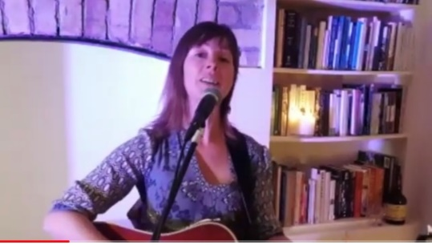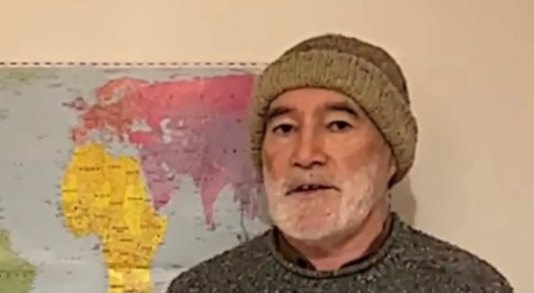
Screen shots from the video: Siobhán Moore and Tony Fitzpatrick

Irish Music Magazine Review of I Have Spent It In Good Company

In the June 2021 edition of the Irish Music Magazine, an independent review of I Have Spent It in Good Company by Frank Greally was carried. We thank Frank, Robbie Heuston and all at the Irish Music Magazine. Frank’s review is reproduced in full here.
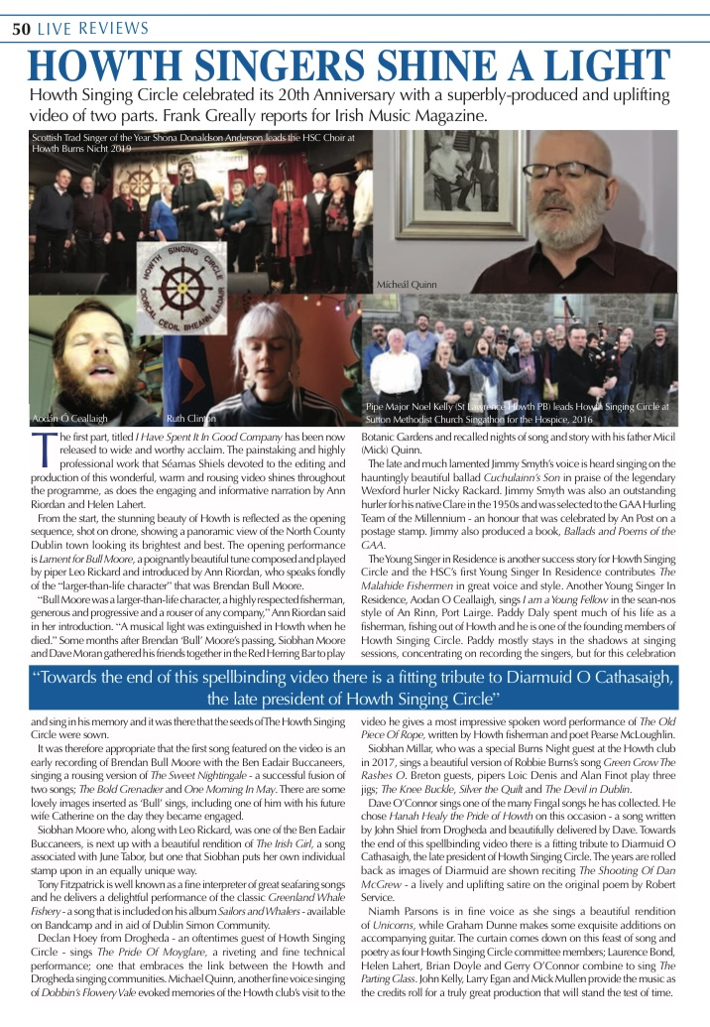

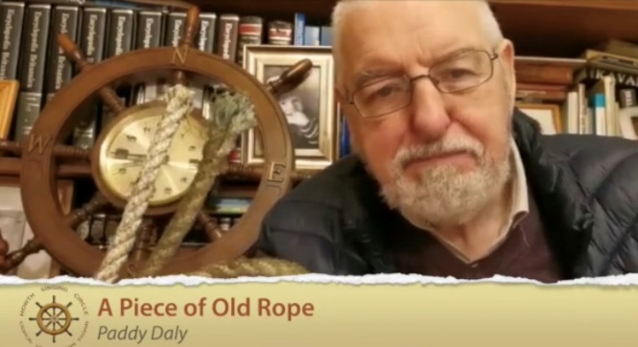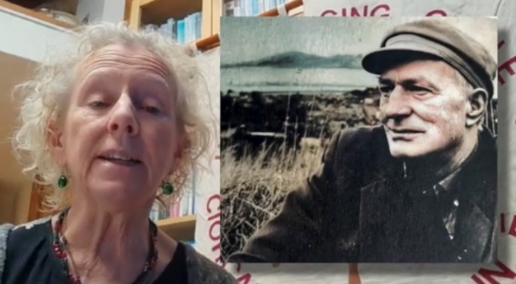
Paddy Daly, his piece of old rope, Helen Lahert & the late Pearse McLoughlin

Mór Mo Mholadh ! Diarmuid’s CD Launch

We have many ways of remembering people in our hearts and in our minds, in photographs and words that they have put down on paper during their lifetime, but there is no more powerful way of bringing the person we have lost back to mind than to hear their voice ringing crystal clear and true. The Zoom launch of Mór mo Mholadh was a veritable reminder of this.

Liam Ó Droma brought the number of people joining Zoom to one hundred and more tuned into Facebook from the US, Canada and Europe, to celebrate the life and creative genius of Howth Singing Circle’s late President Diarmuid Ó Cathasaigh, a talented musician, singer and dramatic reciter of poems. The night was hosted by Fir an Tí Francy Devine and Daire Ó Baoill who calmly battled the tech gremlins and non-muted interruptions. Séamas Sheils organised production and the background videos and photographs accompanying the playing of Diarmuid’s songs, music and recitation.

Diarmuid’s friends and family will be forever grateful that he professionally recorded this treasure trove of sixteen amazing tracks at Shankill Recording Studios in 2009 and they chose their favourites from the CD for the launch. The night began with Diarmuid’s brother-in-law Liam O’Donoghue’s lovely singing of ‘Seán Ó Duibhir a Ghleanna’, citing Diarmuid’s connection to Tiobraid Arann. His sister Mary chose Diarmuid’s haunting version of ‘Eibhlin A Rún’, enhanced by the backdrop of Ireland’s Eye and photographs of Diarmuid in full singing flight.

Helen Rowsome Grimes from the great Irish piping family and long-term friend of Diarmuid’s, fittingly played a whistle hornpipe composed by her father in 1936, the year of Diarmuid’s birth, which she titled ‘Diarmuid 1936’. Diarmuid’s children, Aoife, Rónán agus Naoise selected their favourite, an amhrán gallánta, ‘Ar Eireann Ni Neosfainn Cé Hí’. Diarmuid is accompanied on this track with the wonderful music of Máire Breathnach. Former Mayor of Fingal and long-standing friend of Diarmuid’s, Dave O Connor, gave us a wonderful version of ‘One Evening Fair’ and this was followed by the choice of the Lawlor family, a medley of Diarmuid’s harmonica tunes, ‘Mo Theaghlach’ and ‘Óró Bog Liom’.

Andy Burke, a neighbour and friend of Diarmuid’s formally launched the CD with his own close insights into the character and personality of the man he held dear. It was fitting that this should be followed by Diarmuid reciting, in his indomitable way, the parody of the Robert Service poem, ‘The Shooting of Dan McGrew’. No one who experienced Diarmuid performing this live will ever forget the pure energy and vitality that he exuded when acting out the story. Background photographs, including one of Diarmuid at Service’s log cabin in the Yukon, reminded us of the dimming of lights and the shots ringing out that often accompanied this performance, not to talk of the Klondyke whiskey and the gun on the table. This footage accompanying this track was taken from I Have Spent it in Good Company, the first of two videos produced to celebrate twenty years of Howth Singing Circle.

Áine Ní Cathasaigh, Diarmuid’s loving wife, thanked all involved in the launch and particularly singled out the time and commitment of Francy Devine for his contribution. She spoke of Diarmuid’s spontaneity and thirst for adventure and illustrated this with stories that brought more than one tear to the eyes of listeners. As would always have been the case, with Diarmuid leading at the end of Howth Singing Circle nights, ‘The Parting Glass ‘was sung, this time by Daire Ó Baoill, in a macaronic version translated by his mother. Diarmuid will be delighted as he watches down from above.
Helen Lahert

The proceeds of this CD will go entirely to St Francis Hospice in Raheny and the Irish Cancer Society.
It is available for purchase on Bandcamp: http:/diarmuidocathasaigh.bandcamp.com/releases

Andy Burke Launches Diarmuid’s CD

Mór Mo Mholaidh was officially launched by Howth Singing Circle stalwart Andy Burke in a warm, entertaining and tender tribute to his old friend, Diarmuid. We reproduce Andy’s words here

This is a very special, unique, occasion. Tonight, we celebrate the life and creative genius of somebody who was a great friend to all of us. And though the occasion is tinged with sadness because Diarmuid is not with us, we are truly grateful for the privilege of having known him, enjoyed his talents and company for decades, and also shared his great sense of fun. His enthusiasm for what he was interested in, and so good at, contaminated all of us.

Diarmuid was a multi-faceted and multi-talented person in music, singing, recitation, folklore and sport. You may not know that he played Minor Hurling for Westmeath! In fact, you would be hard-put to think of something Diarmuid did not do! But he bore all his gifts very lightly. Hal Roach’s great ‘Put Down’ for upstarts was to say they were ‘Legends in their own minds’. Diarmuid is a legend in our minds but was never one in his own. He just did not think that way.

While we’re all aware of Diarmuid’s many talents, there were deep-rooted traits to his character that, I think, deserve special mention. He was a man of huge integrity, great respect for the dignity and rights of other people. He took on causes where he felt that individuals were being wronged, even though there was absolutely nothing in it, but aggravation, for Diarmuid himself.

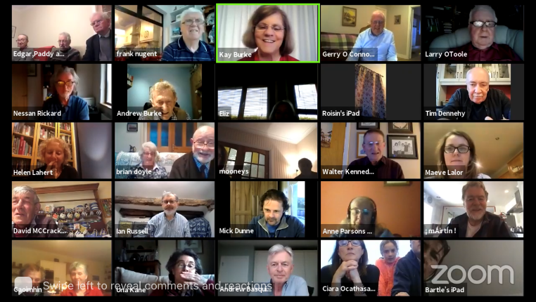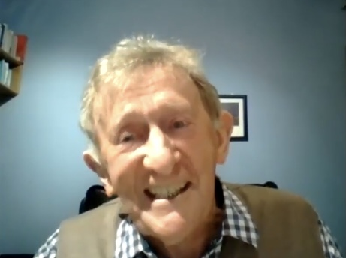
an attentive Zoom audience as Andy Burke launches the CD

Diarmuid was one of the most generous, caring and outgoing people I’ve ever known. He was fundamentally ‘other directed’ – the very opposite of ‘self-centred’. He was forever going out of his way to help others, promote the Irish language, music, song, folklore and recitations. He was particularly encouraging to younger singers and musicians. He had a huge circle of friends (including all of us) and the written tributes from far and near following his passing bear witness to what he meant to so many people.

We are most fortunate that Diarmuid went to the trouble of professionally recording a broad and wonderful selection of his material some years back and has now left us a treasure trove of his work. Francy Devine rightly pointed out to me that, when it came to music/songs/recitations, Diarmuid was also a man of integrity – he gave full credit to everybody involved – those who composed the music, wrote the lyrics or put the recitations together – and also to those who created different versions of them. Have a look at the notes he left us on each CD item.

Nothing would please Diarmuid more than that the proceeds of this CD will go entirely to charity. Áine (along with several others) has put a huge amount of preparatory work into this and she must be delighted that it is being launched tonight. And might I say that, when it comes to integrity, generosity, friendship and caring for others, Áine and Diarmuid were two of a kind. They had a wonderful life together – as Áine herself says: ‘Never a dull moment’.

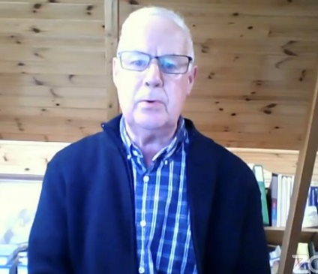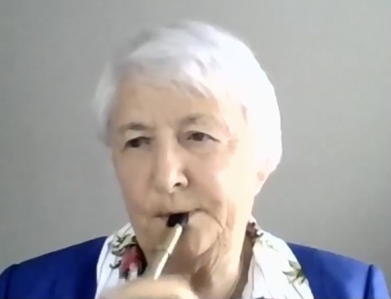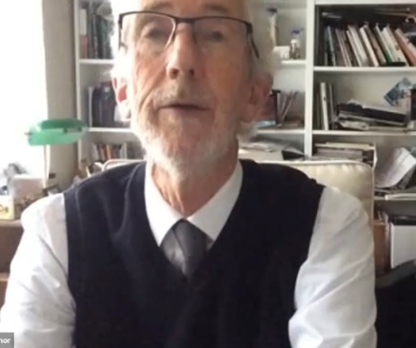
Liam O’Donoghue, Helena Rowsome Grimes and Dave O’Connor paying tribute to Diarmuid in song and tune

While Diarmuid had a prodigious memory, it let him down badly on one occasion. I hope Áine won’t mind me divulging this. During their first year married, they went shopping on one occasion and Diarmuid, as always, was most helpful trying to ensure that they wouldn’t forget anything. BUT, this time, he forgot one thing: it was Áine’s birthday. In spite of multiple hints, Áine finally asked him: ‘Diarmuid, are you forgetting anything?’ Finally, she had to tell him. He was mortified. So ever afterwards if Áine wanted to get Diarmuid’s full, and undivided, attention, all she had to do was ask: ‘Diarmuid, are you forgetting anything?’

An early Christian saint, John Chrysostom, once said, ‘Those whom we have loved and lost are no longer where they were. They are wherever we are’. Diarmuid is living on in his daughter and sons, in each of his grandchildren, in his loving relationship with Áine, in the wonderful memories we all have of him, and now in this new CD. When you listen to it, you’d think that he is actually in the room with you – in the way he puts the songs and recitations across.
Agus, anois, mar focail scoir, ba maith liom a rá: ‘Mór ár Mholadh do Diarmuid fhéin agus a Bhean Céile, Áine’. And with that, it is my great honour to launch this marvellous CD to preserve the memory, the voice, and the music of a wonderfully gifted and generous human being – a great friend to all of us - Diarmuid Úasal Ó Cathassaigh. We will always miss him.

‘He Lives In Our Hearts’ – Aidan O’Hara Reviews Mór Mo Mholadh

Diarmuid Ó Cathasaigh, Mór Mo Mholadh - Great Is My Praise! A Selection of Songs, Recitations & Tunes, https://howthsingingcircle.com, €10 + p&p.

An rud adúradh faoin sár-amhránaí Nioclás Tóibín go raibh ardmheas ag Diarmuid Ó Cathasaigh air, d'fhéadfaí a rá faoinár gcara Diarmuid é féin: ‘Duine séimh cneasta abea é agus bhí cion agus meas ag gach duine air’. Meas air mar dhuine, mar scéalaí agus mar fhear ceoil.

We've heard people say, ‘Well, he's gone now, but he lives in our hearts’. Certainly, in Diarmuid's case he will always live in our hearts, and also through this recording and its photos he's very much with us; and we smile and laugh with him and live again in the joy of his singing, his words and music. We share Máire Mhac an tSaoi's summing up of Diarmuid's contribution to making our times with him such a joy: ‘Diarmuid belongs in a noble succession of 'gadaithe géara na geamoíche' ('skilled thieves of the winter's night'), who kept our forefathers hearts up and continue to delight ours’.

Music and song were his primary pleasures and he delighted in telling where and from whom he learned this song or that. And if anyone was interested in a particular song, he could provide fascinating and detailed information on its origin and on its composer. This is what's on offer in the comprehensive CD booklet (34 pages) with copious notes on each song, tune, and recitation - sixteen tracks in all. In telling us where he got his material, Diarmuid takes us on his own life's journey, in a way, recounting in great detail, for example, the year he sold masking tape to printer and publisher Colm Ó Lochlainn who showed him the proof sheet with the words to The Two Travellers (track 2). Hilarious.

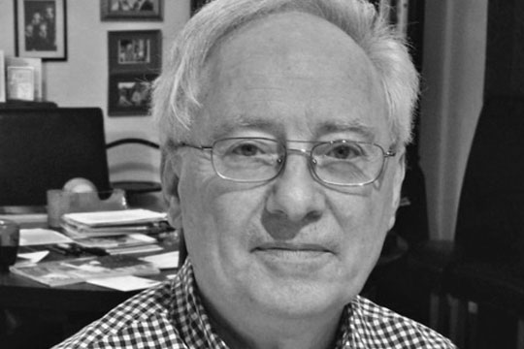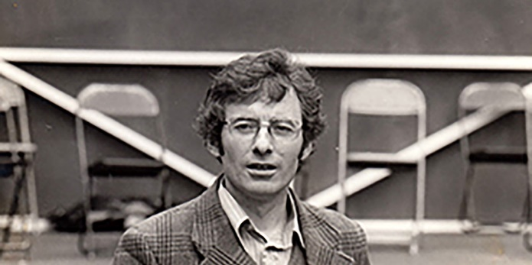
Aidan O’Hara, folklorist, and as Director Newfoundland & Labrador Folk Festival, see https://www.itma.ie/newfoundland/people/collectors/aidan-ohara

Diarmuid's CD booklet is chock-full of wonderful tales of the songs and their provenance. Among the songs and recitations on the CD are ‘Ae Fond Kiss’ reflecting his great love of Scotland's songs in Scots or English and Gaelic; ‘The Man from God Knows Where’’ with a gem of an account of the whole story of the United man, Thomas Russell, and the woman who wrote the verses, Florence Mary Wilson. His lengthy background notes to the songs Mo Theaghlach and ‘Oró Bog Liom’ (track 15) start off: ‘From 1957-1963, I lived in Donnycarney and could not have been in a better place’. And he goes on to tell us that there in that Dublin suburb, he met up with such prominent piping names as Leo Rowsome, Dan O'Dowd, and Paddy Moloney. In their company at family gatherings and elsewhere Diarmuid added to his store of songs in Irish and English and learned dancing, as well. His chosen instrument, however, is the harmonica which he plays masterfully and with flair.

Diarmuid's love of words was also evident in his lifelong collection of books in Irish and English and a visit with him and his loving wife, Áine, was a book lover's delight. The volumes dealt with every aspect of Irish life and culture in novels, histories, treatises, poetry, song and memoir. Diarmuid was always ready to share with a guest his knowledge of a work or an author and would impress one with his wide knowledge on many subjects. All this enjoyment was added to by Áine the consummate host who 'fed and watered us' with sean-gacha deoch agus nua-gacha bídh.

He enjoyed engaging in word play in Irish and English, and one we shared was about a Conamara man who returned home after years away. He parked his big American car outside the pub and entered with a wealthy-looking woman on his arm and sat at the bar. When an onlooker asked his companion where he got the money, he was told he had chased the wealthy lady for years, and added, ‘Déarfainn go bhfuair sé é i leaba a chéile’. Those last four words can be interpreted as meaning he got his wealth gradually (and patiently), and also 'in the bed of his loved one'.

Just as Diarmuid was well served in developing his love of song from prominent figures like Nioclás Tóibín, Colm Ó Lochlainn and Seán Óg Ó Tuama, so, too, was he blessed in having such devoted friends to work on this production whom he had wished to thank. Along with his dear wife, Áine ‘and his family for their loving support’, they include Steve Byrne, Máire Breathnach, Séamus Brett, Máire Mhic Aogáin, Terry Quinlan, Neville Wright, Máire Mhac an tSaoi, and the Howth Singing Circle. And Diarmuid who had Áine's support with the CD project from the start would be ... well, singing her praises for her heartfelt speech and her work in packing, distributing and mailing the CDs.

All of us who attended the CD launch online on 20 May 2021 are grateful to Ann Riordan and Francy Devine for all they did to make it such a memorable occasion. Finally, the CD notes end with the following: ‘In accordance with Diarmuid's family's wishes, proceeds from this recording will be donated to the Irish Cancer Society and the St Francis Hospice, Raheny’.

‘I'll gently rise and softly call
Good night and joy be with you all’
Aidan O’Hara

A Garland For May – Songs of Work & Labour

Tony Fitzpatrick led off a fine night of songs of work and labour with ‘Tolpuddle Man’, Graham Moore’s tribute to the six Dorset farm labourers transported to Australia in 1834 for their trade union membership and concluded with Ewan MacColl & Peggy Seeger’s ‘Ten Young Women & One Young Man’, a tribute to the Dunne’s Stores strikers and their stand against Apartheid. Ably assisted by Anne Gourlay, Tony ran an enjoyable night assisted by Francy Devine, Ann Riordan and Niamh Parsons. Eddie Phillips explained ‘How I Worked My Youth Away’ and John Keeley reflected on his apprenticeship while Andrew Basquille brought us ‘Up To Monto’. Walter Kennedy lamented that ‘Murphy Can Never Go Home’ and Carole Prior gave a powerful performance of Davy Steel’s ‘My Life’s Been Coalmining’. Roscommon’s Declan Coyne delivered ‘The Mullingar Recruit’, a great song, and Mick Dunne complained that he was ‘Always Expected to Carry the Can’.

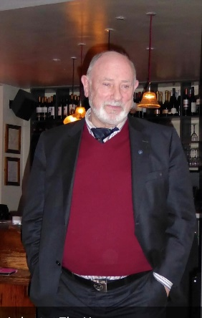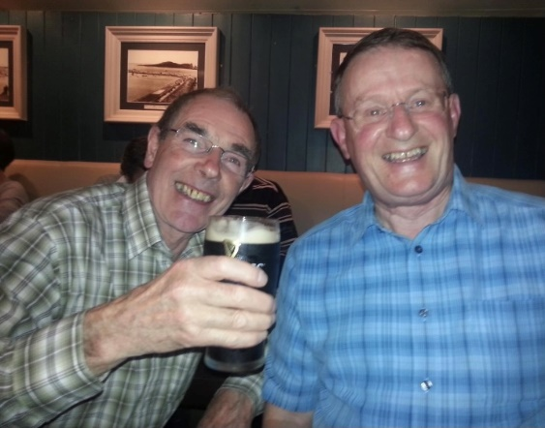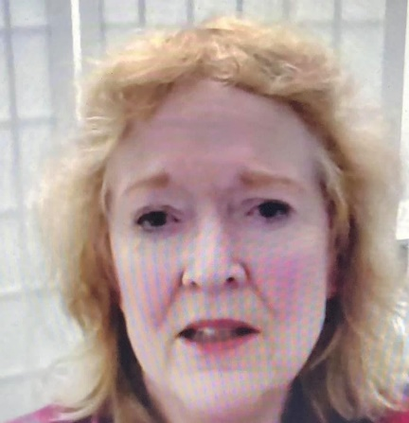
Brian Doyle, Eddie Phillips and Walter Kennedy, three great stalwarts of Howth Singing Circle
and Marianne McAleer, the women who put Super into Weston-Super-Mare !

Fergus Carey sang Alan Parry’s tribute, ‘We Are the Limerick Soviet’, and Helen Lahert presented a moving version of Woody Guthrie’s ‘Roll On Columbia, Roll On’, accompanying herself on guitar. Mike Mecham sang to a photograph of Johnny Longstaff with ‘Ta-ra To Tooting’ recalling those who defended the Spanish Republic. Anne Lamb movingly performed ‘A Miner’s Prayer’ as Gerry o’Connor drifted from the land, would you believe it a Graeme Miles’ song. Ian Russell recounted that a Sheffield ‘Grinder’s Not a Man’ while Máire Ní Bhaoill brought the jostle and sounds of the ‘Magherafelt May Fair’. Claudia Anderson poignantly recalled the story of ‘The Factory Girl’, Tom Finn worked the mixer with ‘Crooked Jack’ and George Henderson mourned the ‘Closing of the Monty’, a local pit. Séamas Sheils presented Billy Bragg’s ‘Power in Union’, Eugene McEldowney travelled ‘Out to Otago’ and Pat Burke sang his own tribute to Dún Laoghaire’s 1913 martyr ‘James Byrne’.

Niamh Parsons sang James Oppenheim’s ‘Bread and Roses’, an anthem for women workers and bringing memories of women textile workers striking in Lawrence, Massachusetts, in 1912. There were many other fine performances in a night of high quality, blighted only slightly by wobbly internet connections. In the break, Francy Devine delivered a presentation on Jim Connell, author of ‘The Red Flag’ to the accompaniment of his own recording of Connell’s ‘The Old Poacher’s Song’. For this reviewer at least, a highlight among many was Michael O’Leary’s bouncy presentation of Terence O’Flaherty’s ‘Return to Camden’. He recommended we check out O’Flaherty’s own version on Youtube – https://www.youtube.com/watch?v=oOzQR51Pg4Q Well, Michael O’Leary’s ‘lift’ and pace were wonderful, traditional singing at its best. It took me back to concrete gangs, the 1972 Building Workers’ Strike, watching Darach Ó Catháin standing on top of a trench singing his heart to drive a storm back over the Pennines. Mighty stuff, Michael!

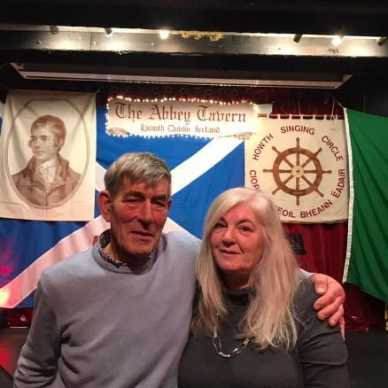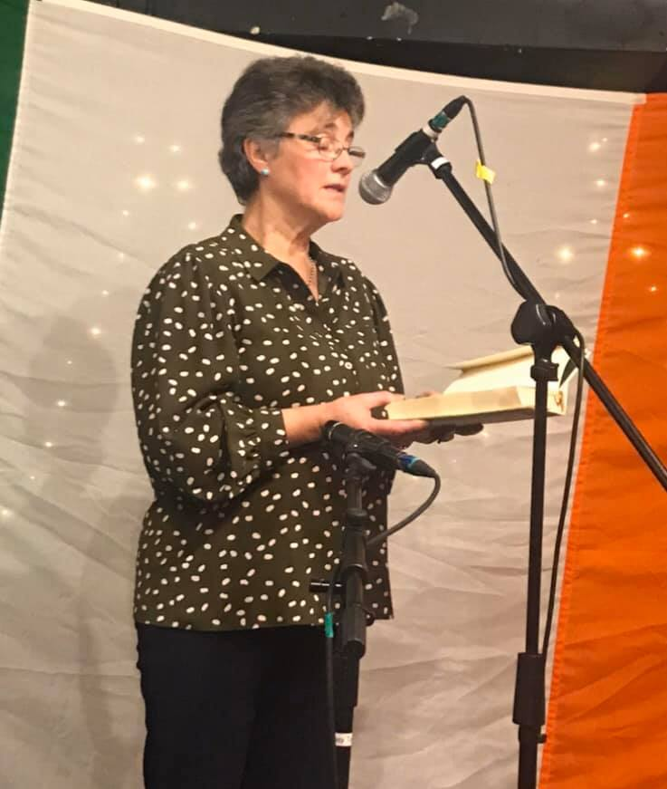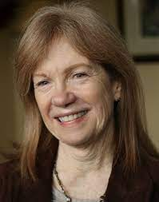
Dave McCracken, a regular visitor from Northumberland, our own Úna Kane and Claudia Anderson, who has made many fine Zoom contributions from Chicago

Songs of Summer, June 2021

Mna a’Tí for the June session were Helen Lahert and Ann Riordan and we were delighted to welcome forty participants to the session, ranging from regulars at our live sessions in Howth to our many new friends from across the globe. The theme ‘Songs of Summer’ and summertime was well represented in poem and song. We had ‘Summer Day’ (Kay Burke), ‘Pleasant and Delightful’ (Eugene McEldowney),’The Dublin Saunter’ (Walter Kennedy), ‘Sailing Down the Summerwood’ (Helen Lahert) and summer flowers were blooming with ‘My Ringsend Rose’ (Úna Kane), ‘Dobbins’ Flowery Vale’ (Marianne McAleer) and ‘The Banks of Sweet Primroses’ (George Henderson). Bob Dylan’s 80th birthday was marked by Máiríde Woods’s rendition of ‘Hey, Mr. Tambourine Man’. In addition, June 2021 was Gypsy, Roma and Traveller History Month and this was recognised by a number of contributors through songs such as ‘The Bonnie Ploughboy’ (Ian Russell), ‘Freeborn Man’ (Frank Greally), and ‘Tramps and Hawkers’ (Francy Devine). In addition to those listed, all contributions on the night were thoughtfully chosen songs and poems and every participant contributed to a warm and friendly atmosphere at the session.

The highlight of the night was, of course, Brian Doyle’s Three-in-a-Row spot. Brian is a stalwart of Howth Singing Circle, a member of the Committee and is one of only three people to be ‘capped’ by HSC (along with Walter Kennedy and Eddie Phillips), during their night of sporting songs in the Sea Angling Club. Brian treated us to a trio of Ewan McColl songs, ‘Shoals of Herring’, ‘Freeborn Man of the Travelling People’ and ‘Sweet Thames Flow Softly’. Brian interspersed his songs with biographical information about Jimmy Miller/Ewan McColl and details about the songs themselves. All Howth Singing Circle sessions are concluded with the singing of ‘The Parting Glass’. Daire O’Baoill treated us to a beautiful, macaronic version, incorporating the translation by his mother, Eilín Ní Bhaoill.
Ann Riordan

Review of The Gig For Gaza – A Song For The Dispossessed

As events unfolded in Jerusalem and Gaza, Musicians’ Union of Ireland (MUI) activist Francy Devine, together with Andy Irvine, a former MUI President, and Harry Bradley came up with the idea of a A Gig For Gaza. The MUI and SIPTU supported the idea with a Concert broadcast on 31 May with monies raised going, at the Palestinian Embassy’s suggestion, to Meca [Middle East Children’s Alliance] for medical aid for kids in Gaza.
Michael Halpenny kindly reviews the concert for us

MC Abdul is a rapper who has become an internet sensation, his work viewed by millions. However, he’s not from downtown Los Angeles, but rather speaks of war-torn Gaza, suffering under the constant threat and actuality of Israeli attack and bombardment. His real name is Abdalrahman Alshantti and he’s only twelve years old, and if his style, delivery and presence is beyond impressive, the content of his message, a collaboration with Cork’s GMC Beats, is a memorable cry for justice from the heart of Palestinian youth. Appearing with the kind permission of his father and at the suggestion of the Palestinian Ambassador to Ireland, Dr. Jilan Abdalmajid, who later addressed the concert, MC Abdul was the lead act in Gig For Gaza, an on-line solidarity concert organised by the Musicians’ Union of Ireland (MUI) and SIPTU to raise funds for medical aid through the Middle East Children’s Alliance (Meca). MC Abdul was joined on the virtual stage by a stellar cast of musicians and singers, all giving up of their best for the dispossessed of Gaza and Palestine.

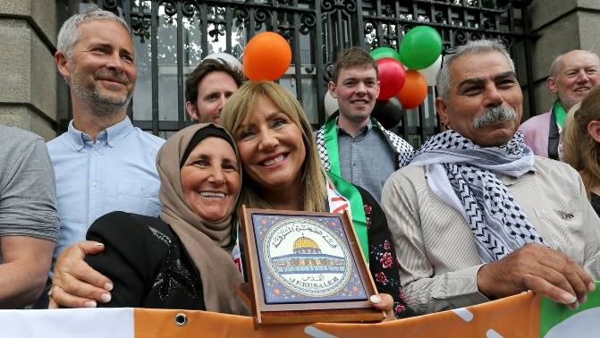
Twelve year old rapper MC Abdul and Frances Black celebrating with Palestinian friends after the Control of Economic Activity (Occupied Territories) Bill 2018 was passed by the Oireachtas

First up was folk icon Andy Irvine, a former MUI President, with ‘Erin Go Bragh’, itself a call for freedom from discrimination and sectarianism and an outstanding Scottish song rendered powerfully by a master of his craft. The next on echoed the observation made by flute player, Harry Bradley, that ‘traditional folk music comes from the poor and dispossessed labouring people … as a gift for dispossessed people everywhere’. And they didn’t disappoint. The Kelly Family (John, Aoife and Charlie Le Brun), a living, breathing archive of Irish traditional music, played a selection of tunes from Clare, a county whose history has known more than its fair share of poverty, oppression and emigration.

Later, Bradley, one of the event organisers and renowned exponent of the flute, played two stand-out tunes from the repertoire of that universal gift to the dispossessed: ‘The Spike Island Lasses’ and ‘Drogheda Bay’. He was preceded by fellow musician, Belfast-based harpist and teacher, Ciara Taaffe, who’s graceful and sensitive interpretation of the seventeenth century air ‘The Wild Geese’ also reminded us of our own history of dispossession and flight. Adding poignancy to her playing was the fact that the harp as an instrument and symbol is equally revered in both Irish and Palestinian cultures.

The poem ‘Running Orders’ followed. It is a tour de force by American poet Lena Khalaf Tuffaha about the daily terror of life in Gaza. Read by actor, Ann Russell, an Irish Equity Executive member, its unforgettable opening lines tell of the ghoulish warning, a bare fifty-eight seconds long, received by Gaza residents before Israeli forces bomb their houses and apartments: ‘They call us now, before they drop the bombs. / The phone rings and someone who knows my first name calls and says in perfect Arabic, ‘This is David’.’

Equally powerful was fellow actor Seán McGinley’s rendition of Francy Devine’s poem ‘Hadassar Horowitz’s Great Grandson’ which tells of an elderly Jewish woman protesting against Israeli expansion and all the devastation that follows from it. It reminds us of those in Israel who are opposed to the authorities’ oppression of Palestinians. ‘Little Yellow Roses’ is a song inspired by the Spanish Civil War but refers to freedom fighters everywhere. It was delivered with grace and feeling by its author, Francy Devine, who as well as being one of the comperes along with SIPTU’s Yvonne O’Callaghan, is one of the finest singers in the tradition today.

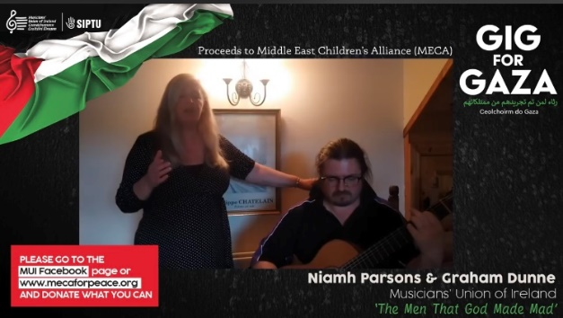
Above: Andy Irvine leads off the Gig For Gaza with ‘Erin Go Bragh’ and the HSC’s Niamh Parsons (MUI President) and Graham Dunne perform ‘The Men Who God Made Mad’
Below: Róisín Elsafety delivers a beautiful acoustic version of ‘An Phalistín’ from her home in Conamara and Paul Anderson plays his ‘Lament For The Dispossessed’, specially composed for the Concert and performed in Migvie Kirk, Tarland, Scotland


The wonderful Niamh Parsons and her equally gifted guitar accompanist, Graham Dunne, sang of a different group of freedom fighters. ‘The Men That God Made Mad’ tells of the San Patricio Battalion, Irishmen in the service of US Army who chose to fight with the Mexicans in the American-Mexican War of 1846-48. Their leader, later executed by the US along with other San Patricio leaders, was John Patrick Riley and a plaque in his honour can be found in his native Clifden, County Galway.

Adding his talents in song was seán-nós singer, musician and People Before Profit activist, Eoghan Ó Ceannabháin. ‘The Deepest Breath’ was originally written for the homeless and dispossessed of Dublin but the crisis in Palestine impelled him to write this version so as to ensure that the deaths of Palestinians are more than numbers, but are ‘vanished dreams and mourning families’. In truth both the singer and his song are a revelation to those who come to him for the first time and the sensitive accompaniment of Ian Kinsella on guitar and Kaitlin Cullen-Verhauz on cello made this yet another high point of the evening.

Aberdeenshire fiddler, Paul Anderson, is no stranger to Ireland and is a frequent visitor to Scoil Samhraidh Willie Clancy and to Howth Burns Nicht. As well as being an acknowledged master of the Scottish fiddle he is also a renowned composer for the instrument and his evocative, ‘Lament for the Dispossessed’ (in Arabic, ‘Rathaa’ Almahrumin’), was especially written and composed for the concert. Uilleann piper Seán McKeon turned to an air popularised by Thomas Moore and the signature tune of the late traditional music broadcaster and collector Ciarán Mac Mathúna. ‘The Lark in the Clear Air’ has an evergreen quality and in the hands of Seán McKeon, brings a renewed message of hope which was balanced by the joyful eighteenth century composition ‘Jackson’s Thought’ or, as it is more popularly known, ‘Cherish the Ladies’.

This wonderful evening was rounded off by two singers who are no strangers to Palestine. As well as being one of Ireland’s leading performers, Senator Frances Black successfully moved the Occupied Territories Bill through the Oireachtas and has long been a champion of the Palestinian cause. Written by Michael Hart with music by Bill Shanley, her ‘Song For Gaza’, backed up by Aoife Scott’s punchy video of recent footage by Gerry McColgan, Fadi and others, shot recently in Palestine, offered not just solidarity but defiance in its memorable refrain: ‘We will not go down in Gaza tonight’. Finally, Conamara singer, Róisín Elsafty, whose family has long standing links to the Palestinian cause, brought to the virtual stage a specially recorded acoustic version of Treasa Ní Cheannabháin’s classic anthem, ‘An Phailistín’. Written after the Second Intifada in 2005 it reminds us also of the four wars suffered by the Palestinian people since then. In the hands of the sensitively accomplished and always enjoyable Elsafty it not only complemented Frances Black but brought a great evening to a close.

All that remained in this trade union organised solidarity concert was another anthem, this time that of the MUI & SIPTU and a refreshing reminder of our own history of struggle, James Connolly’s ‘Watchword of Labour’, sung in a recording by the late labour activist, Joe Deasy.
Michael Halpenny

The Gig For Gaza has so far raised €8,000 for Meca
and can still be viewed on Youtube by searching for MUI Gig For Gaza
or at https://www.youtube.com/watch?v=x3cMIMq440&t=94s

Song Presentation at 49th Scoil Samhraidh Willie Clancy
Online School

The 49th Willie Clancy School will be an online event again this summer. You can register for all online presentations for a mere €10 at https://scoilsamhraidhwillieclancy.com/online-school

Of particular interest to Howth Singing Circlers is the illustrated lecture ‘Who Feared Not the Might of the Foe: Songs & Poems of the Irish War of Independence, 1919-1921’. It was conceived and scripted by our own Francy Devine and Dr Pádraig Óg Ó Ruairc, an eminent historian of the period and edited and produced by Séamas Sheils of Fonn, the online traditional music website. The songs are presented with details about the incidents they describe and biographical information about the song’s author. In addition, contemporary photographs add context and atmosphere as the songs are sung.

Performers are Peadar Cleary, Stephen Connor, Tim Dennehy, Francy Devine. Vincent Doherty, Daoirí Farrell, Aoife Kelly, John Kelly, Noel Kelly, Charlie Le Brun, Mícheál Mac Donncha, Deirdre Ní Dhorchaí,Eibhlís Ní Ríordáin, Aodán Ó Ceallaigh, Pádraig Ó Nualláin, Mark Redmond, Paul Robeson and Pádraig Varian.

The presentation is not a history of the War of Independence – despite the substantial historical content – but an indication of the songs sung during the war and composed either contemporaneously or relatively soon after the event. Given the nature of the times, some songwriters published their material anonymously and have remained anonymous. Those whose work does feature are Sigerson Clifford, Patrick Galvin, Willie Gillespie, Peader Kearney, Mikey Kelleher, Bryan MacMahon, Seán O’Casey and Phil O’Neill aka Sliabh Rua. Songs include ‘The Cumann na mBan’, ‘The Bold Black & Tan’, ‘The Valley of Knockanure’, ‘The Man From the Daily Mail’, ‘Kevin Barry’, ‘Johnston’s Motor Car’ and ‘The Boys of Barr na Sraide’.

In addition to our own Francy Devine’s involvement, Pipe Major Noel Kelly of the St Lawrence Howth Pipe Band plays tunes in honour of Flor Begley who piped during the Battle of Crossbarry, the tunes being ‘Let Erin Remember’, ‘The Minstrel Boy’ and ‘Wrap the Green Flag Round Me Boys’.

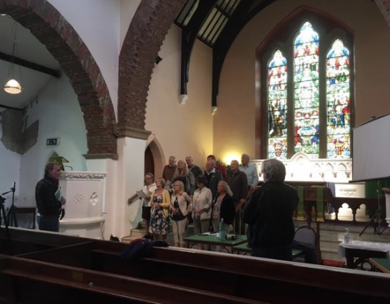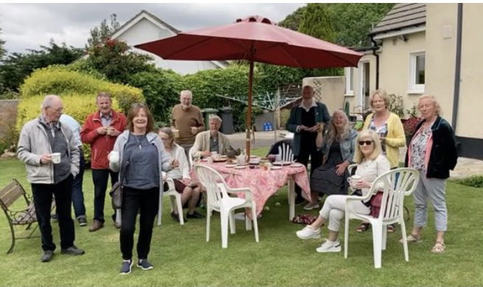
Séamas Sheils and Francy Devine recording ‘The Parting Glass’ in St Mary’s Church of Ireland and tea on Finola Young’s lawn with her wonderful baking to replenish the choristers

Buíochas Mór

We thank those who have contributed to this Sweet Nightingale: Andy Burke; Frank Greally; Michael Halpenny; Robert Heuston (Irish Music Magazine); Aidan Ó’Hara; Séamas Sheils (Fonn traditional music website); and the Howth Singing Circle Committee – Laurence Bond, Paddy Daly, Francy Devine, Brian Doyle, Helen Lahert, Daire Ó Baoill, Gerry O’Connor, Niamh Parsons and Ann Riordan.

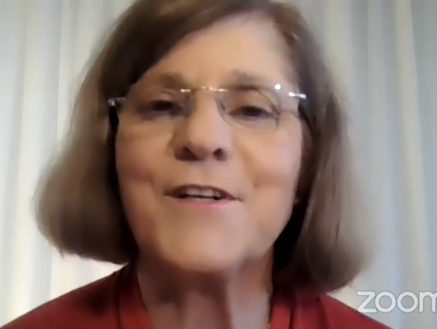
Áine Lalor Ó Cathasaigh and Daire Ó Baoill at Diarmuid’s launch

have a great summer
we hope to see and hear you all in September
whether in the Abbey Tavern or by Zoom

our second Twentieth Anniversary Video, Good Night & Joy Be With You All, will be a highlight of our Autumn programme together with ‘Northern Lights’
a night run with the Aberdeen Branch,
Traditional Music & Song Association of Scotland

