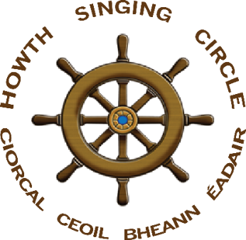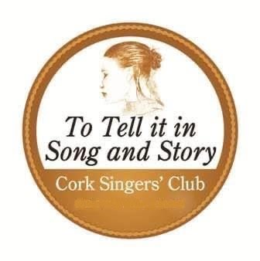
Howth Singing Circle & Cork Singers’ Club
Singing Session for Hospice
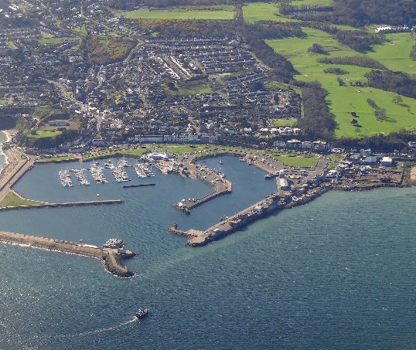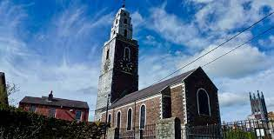
Bean agus Fear an Tí
Niamh Parsons & Jim Walsh
all proceeds to St Francis Hospice, Raheny
& Marymount Hospice, Cork

Saturday, 26 June 2021 at 8pm

event by Zoom & live on Facebook
to book a Zoom place contact
rioann@gmail.com or baldtiler@yahoo.ie

‘She exceeds Flora, and bright Aurora, ‘Then too, when the evening sun's sinking to rest
And beauteous Venus from the briny froth - Sheds its golden light over the sea
I'm captivated - I do repeat it - The maid with her lover the wild daisies pressed
By Hannah Healy, the pride of Howth’ On the banks of my own lovely Lee’

