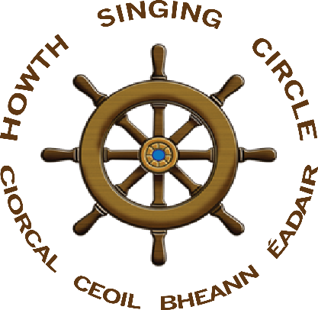
The Sweet Nightingale
New Series, no 8, March 2018

Howth Singing Circle Saoithe

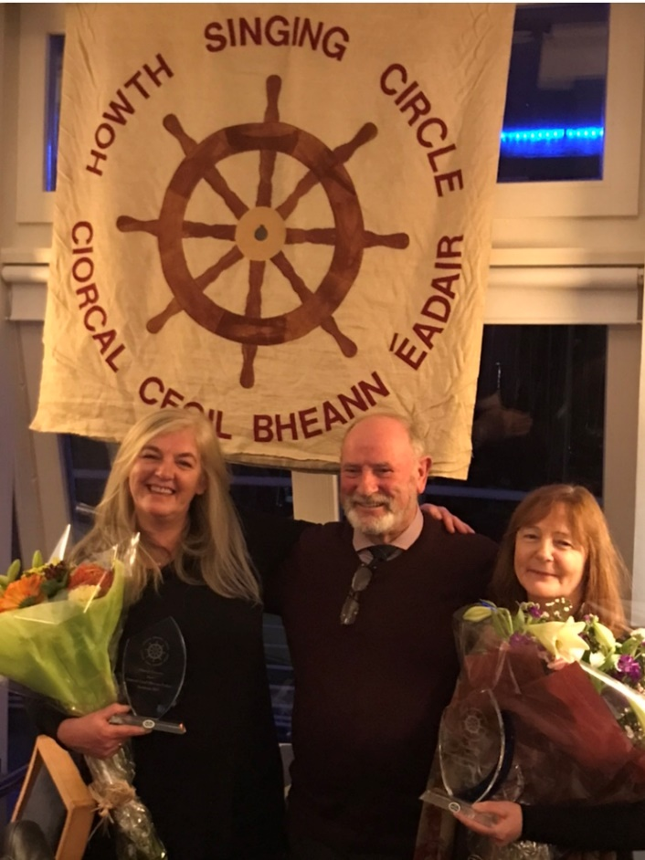
Brian Doyle with our new Saoithe Niamh Parsons and Ann Riordan

At our Dinner in November, Brian Doyle inducted two more of our stalwarts as Saoithe of the Howth Singing Circle. Joining our first two appointees, Paddy Daly and Diarmuid Ó Cathasaigh, were Niamh Parsons and Ann Riordan. Niamh has been a valued and valuable regular almost from the beginning generously sharing her lengthy experience as a professional recording artist with the rest of us, ever encouraging and enthusiastic. Niamh was a member of Killera, Loose Connections and Arcady, appearing throughout Ireland and in Austria, Belgium, Brittany, Denmark, England, France, Germany, Netherlands, Scotland, Spain, Switzerland, Wales, Japan and North America. Her recordings, with Graham Dunne, include Blackbirds & Thrushes (1999); In My Prime (2000); Heart’s Desire (2002); Live at Fylde (2005); The Old Simplicity (2006); and Kind Providence (2016). Ann Riordan, a founding member, has regularly proved vital to the unseen organisation of events like the Burns Nicht, Fiddle Bus, Singathon and much more. No Club could operate without diligent and unsung work behind the scenes and it is appropriate that that contribution be acknowledged. We have no plans to induct any other Saoithe in the foreseeable future but felt it important, as we enter our eighteenth season, that some recognition be given to Ann and Niamh alongside Diarmuid and Paddy.

FeilimiÍ O’Connor & Stuart Carolan

October’s session – ably managed by our Young Singer in Residence Cathal Caulfield – provided a night of high quality, led by our Special Guests from County Louth – Feilimí O’Connor from Ravensdale, north of Dundalk, and Stuart Carolan from Tullyallen, north of Drogheda. They brought a very welcome band of supporters including Stuart’s wife Siobhán and his father Pat who delivered a moving version of ‘Along the Silvery Tide’. Mountaineer, explorer and broadcaster Dermot Somers sang of the tough life of workers from the Steel City of Sheffield; Noel Bailey urged the laddies to come; Irene Bagenal taught us how to tell widow from bride; and Gerry Cullen delved into his bluegrass roots. There were many other notable performanced: Laurence Bond roamed the bogs of Shanaheever; Diarmuid Ó Cathasaigh rendered the late poet Michael Hartnett’s thoughtful translation of ‘Na Connery’s’ and Gerry O’Connor sounded the last call of the day. Andras Scarff, a German visitor, brought us to Tirol; Helen Lahert was up on the sweet brown knowe; and Eugene McEldowney courted a blacksmith! Eddie Phillips sailed aqway on the rioll of the sea and Cian Ó Súilleabháin made a triumphant return via the fields of Athenry. Cathal and his brother Éoin played sets on fiddle and flute and Cathal sang od ‘An Cailín Dubh’. Another fifteen singers added to a crammed evening.

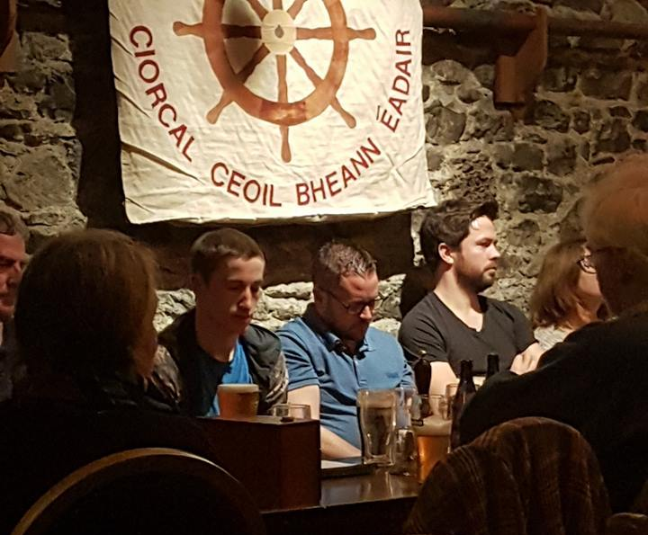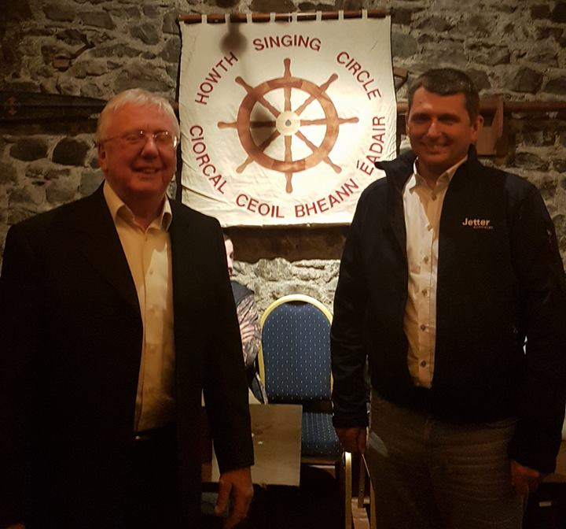
Cathal Caulfield with Guests Stuart Carolan and Feilimí O’Connor listening intently; Gerry O’Connor mit seinem Freund Andreas Scarf (photographs Gerry O’Connor)

Our Guests, appropriately, were the stars, however, each displaying their singing pedigree derived from their parents, grandparents and families. Feilimí’s arrangements of ‘Green Grow the Laurel’ and, especially his Inis Toraigh version of ‘Dónal Óg’ floated over an audience silent in deep appreciation. He completed his set with ‘Son, Come Tell It Unto Me’ and a haunting ‘Siúil a Rún’. Stuart began with his grandfather’s very different version of ‘The Wild Rover’ and styled as phoenix ‘The Maid of Ballymore’, a song ‘pinched from me father’. His Shetland ‘Night Parting Song’ was a favourite to a Howth audience who minded the song from Brendan ‘Bull’ Moore’s singing, reminding us why we started the Club. Stuart concluded with ‘In This God Forsaken Land’, his voice carrying the pain and anguish of the song-writer’s experience. Led by Gerry Cullen, the Drogheda folk concluded the night with the Carolan family version of ‘The Bonnie Light Horseman’, the chorusing powerful and moving.

So, thanks to Feilimí, Stuart, and all the Boynesiders, for a night that will liove long in the memory.

Musicians’ Union of Ireland

The Howth Singing Circle is proud to say that two of our Committee members serve on the Executive of the Musicians’ Union of Ireland (MUI) – Francy Devine and Niamh Parsons. Niamh is particularly active serving on SIPTU’s Service Division and Sectoral Committees. Youican learn about the MUI at http://mui.ie/about-the-mui/ and follow its activities through its quarterly newsletter SoundPost –
https://cloud.3dissue.com/86718/87064/194137/SoundPostAutumn2017/html5/index.html?page=1&noflash
Finally, of course, the MUI welcomes members who are musicians, singers, teachers, composers or writers or those who wish simply to be unionised in solidarity with musicians: http://mui.ie/join-the-mui/

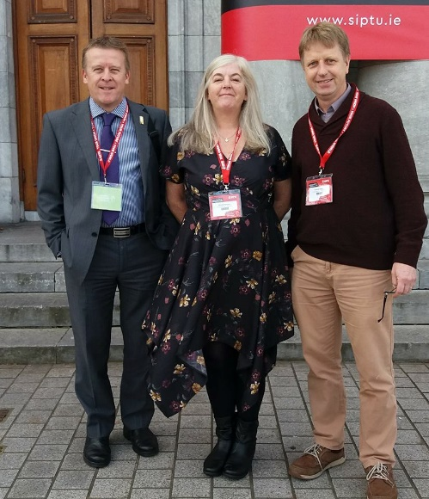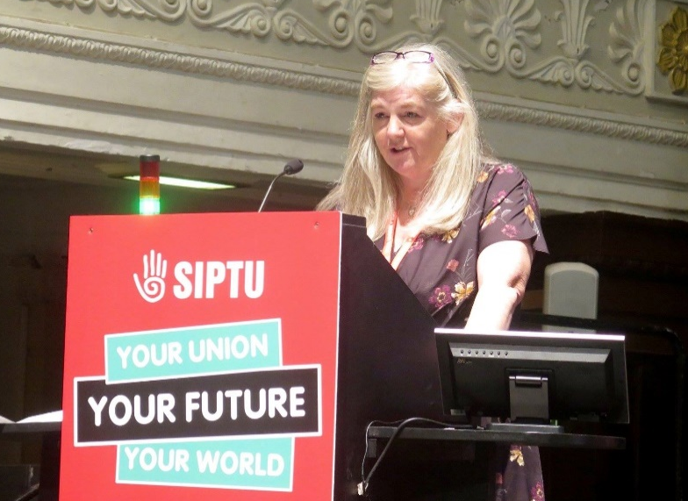
Niamh with SIPTU Organiser Graham Macken and MUI President Séamus Doyle at the SIPTU Biennial Conference in Cork in October: and Niamh at the Conference Rostrum

Contagious to the Nile

In November, Tom Finn and Tony McGaley provided a night of fun and high-quality singing on the theme of ‘Contagious to the Nile – Dublin Comic Songs’. Helen Lahert for got her sailor while Brenda Ní Ríordáin remembered her Shéamuisín; and Joe Gallagher and Gerry O’Connor – who made a lovely couple – couldn’t remember or was it that they couldn’t forget? Laurence Bond waxed lyrical by the Dargle; Eddie Phillips got fluthered with Phil; Úna Kane kept dubious company with Dicey Riley; and Angela Murray wandered between the Liffeyside and Salonika. Eugene McEldowney visited The Monto as Siobhán Moore chased fleas on Rothesay-O! Andrew Burke paid tribute to Conor Cruise O’Brien – well, maybe not tribute but he remembered him; Walter Kennedy was let into the Charladies’ ball; and Brian Doyle was with a Twangman somewhere in the vicinity of Kimmage. Irene Bagenal recalled a Gamekeeper while Tony McGaley regretted the failure of Dublin City Council to develop the Blue Lagoon. Peter Byrne left his shaving kit in a salubrious Australia lodging house; Andrew Basquille strolled through Bloom’s Day; and Éamonn Hunt sand ‘Maloney’s Lament’ and regretted ‘The Girl I Left Behind Me’ – two great songs. Antoinette Daly, Tom Finn, Martina Nic Cearnaigh, Diarmuid Ó Cathasaigh, Philip O’Connor, Larry O’Toole, Kieran Wade and Joy also performed. Barry Gleeson was the perfect choice for Three in a Row with Leo Maguire’s ‘The Dublin washerwoman’, ‘The Ballad of Pearse Reilly’ – a Joycean tour de force; and, betraying one suspects a misspent youth, ‘Tamango’s’. In this form, Barry is irresistible, hugely entertaining, a master of his craft and a joy to listen to and be entertained by. Thank you, Barry.
Good People All This Christmas Time
Our Christmas was graced by two Santies: Mick Fowler and Gerry O’Connor appearing suitably attired creating a sustained atmosphere of fun and seasonality. Eugene McEldowney began with ‘O The Holly’; Tom Finn gave us Seán Tyrrell’s ‘The Lights of Little Chistmas’; Walter Kennedy presented ‘The Boar’s Head’; and Helen Lahert sang of ‘This Lovely Christmas Night’. Recording artist Séamus Ó Súilleabháin sang ‘A Winter’s Tale’ from his newly released CD and Cian Ó Súilleabháin recalled ‘Molly Malone’. Joe Gallagher gave a beautiful rendition of Barbara Callan’s ‘Solstice Carol’ while Laurence Bond wondered while he wandered. Máire Ní Chróinín took enormous delight in doing unspeakable things to turkeys; Úna Kane recounted Christmas’s twelve days; Kieran Wade confessed that he had never got used to life on the dole; while Eddie Phillips got the whole earth to sing. Mick Fowler sang his own composition – Howth Singing Circle’s carol ‘All Hail! All Hail!’ Mairidhe Woods seduced ‘Santa Baby’ while Fergus Russell gave the Three in a Row: ‘Diana Kitty Anna Mariah’; ‘Rolling Home’; and his bird song, a composition open to considerable interpretation! The raffle provided nearly twenty prizes and folk when home in splendid festive form after a night of fun, frolics and fine singing.

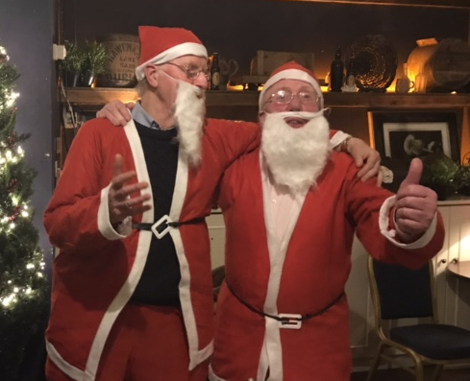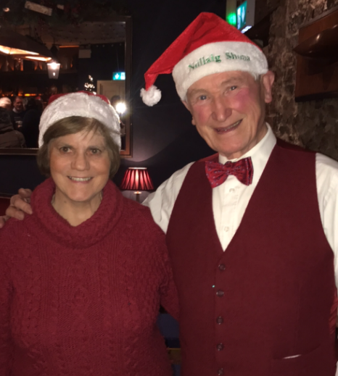
The two Santies, Mick Fowler & Gerry O’Connor, and their two Little Helpers, Áine agus Diarmuid Ó Cathasaigh

Songs for Nollaig na mBan
Niamh Parsons hosted a well-attended opening session of 2018 with songs to celebrate Nollaig na mBan. Antoinette Daly began by scaling the ‘Green Hills of Antrim’ while Máirídhe Woods sang in the style o0f Loretta Lynn. Peter Byrne sang of ‘The Dark Eyed Sailor’ and ‘The Grey Funnel Line’ and Daoirí Farrell was a Contender whilst wearing a Galway Shawl. Walter Kennedy was hard to see as he just sang in the twilight while Stiofán Ó hAoláin serenaded Eibhlín a Rún’. Diarmaid Ó Cathasaigh played Sliabh na mBan and Séamus Ó Súilleabháin ploughed Pat Murphy’s meadow. Eddie Phillips sang a Kilmore Carol and Paul Redmond stirringly presented his own composition ‘Ben Eadair Lass’. Spanish visitor Carlos presented a painful sick note but recovered to work on England’s motorways. Ann Riordan read Seán Ó Ríordáin’s ‘Oiche Nollaig na mBan’ and Tony McGaley presented his own comic view of the tradition. Highlight was Graham Dunne’s Three in Row of tunes: ‘The South West Wind and Petticoat Breeze’ in honour of Peadar O’Loughlin; Gershwin’s ‘Summer Time’; and ‘Ard Uí Cuan’ followed by reels. He then accompanied our host Niamh Parsons with their highly original arrangement of Robert Burns ‘The Slave’s Lament’. Over thirty folk performed on what was a very pleasant and engaging start to the New Year.

Burns Nicht 2018 – Joy & Pleasure

Howth Burns Nicht 2018 – the eighteenth such occasion and tenth to be held in the Abbey Tavern – generated huge acclaim. Presented by Gerry O’Connor and Scots visitor Morag Dunbar, the night began with a section recalling the ending of the First World War. After Mick Fowler began with the County Antrim song ‘Bonnie Wood Green’, there were three readings – all thoughtfully delivered – Úna Kane with W.B. Yeats’ ‘An Irish Airman Foresees His Death’, Frank Allen with Francis Ledwidge’s ‘Soliloquy’ and Finola Young with Ledwidge’s ‘Lament for Thomas MacDonagh’. Gerry O’Connor concluded the section with Graeme Miles’ moving ‘Lights Out’. Troon’s Willie Gibson, making a welcome return after a few years, delighted various ‘ladies’ by reciting Burns’s poems and presenting them to his ‘victims’, all of whom seemed thrilled to be chosen.

Next came our ‘resident band’ of John Kelly (fiddle), John Regan (box) and Mick Mullen (guitar). While noise levels unfortunately rose at this point, many took the opportunity to dance. Later, in the lads’ second set, John Regan played Niel Gow’s slow air ‘Coilsfield House’, a beautiful interpretation and a highlight of the night. Burns, himself a fiddle player, went out of his way to meet Gow, 1827-1807, in Dunkeld on one of his Highland tours. Fiddle Bus Fower had visited Blair Castle and Dunkeld to pay tribute to Gow.

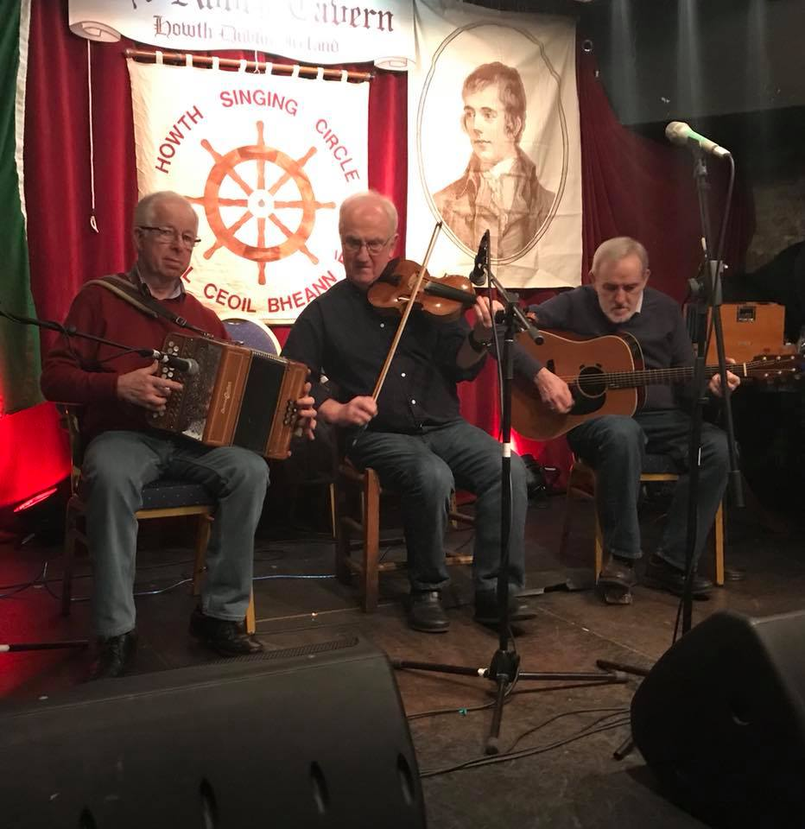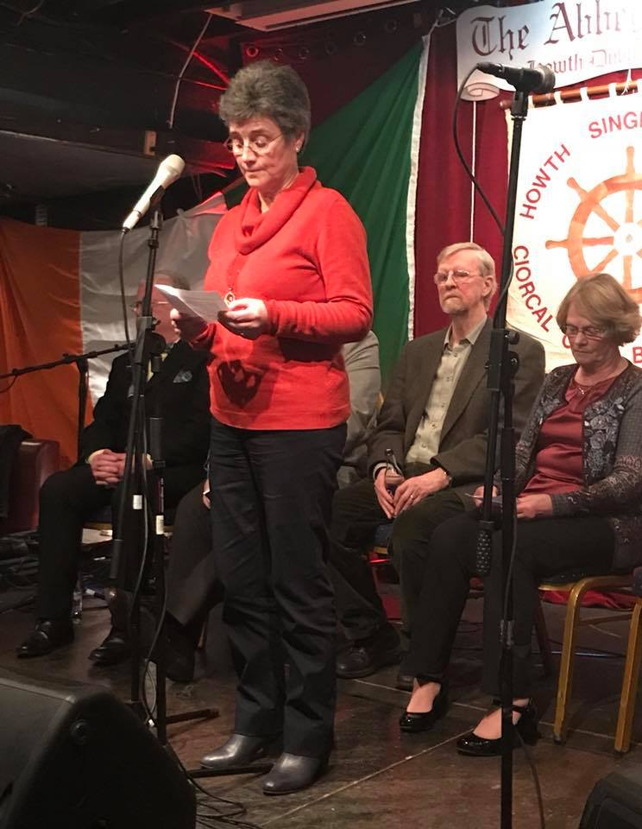
John Regan, John Kelly and Mick Mullen, our much under-valued ‘Resident Band’, and Úna Kane reading W.B. Yeats ‘An Irish Airman Foresees His Death’

This was followed by a powerful set of items drawn from material contemporary to Burns. Diarmuid Ó Cathasaigh played Burns’s ‘Ye Banks & Braes’ on the harmonica and Áine Bean Uí Chathasaigh recited his ‘Lament of Mary, Queen of Scots’, her stage presence and command superb. Young Howth violinist Elizabeth Fox played Wolfgang Amadeus Mozart’s [1756-1791] ‘Romance’ from his ‘Eine Kleine Nachtmusik’, reminding us that one of the first to orchestrate ‘Auld Lang Syne’ was Beethoven. Paul Redmond’s stirring rendition of Thomas Moore’s [1779-1852] ‘The Minstrel Boy Boy’ was magnificent and got the room’s pulses racing.

Then came our Special Guests Robyn Stapleton (Stranraer), fiddler Kristan Harvey (Orkney) and keyboard player Alistair Iain Paterson (Lewis/Bishopton). Technically first class, the trio enthralled, amused and thrilled with a selection dominated by Burns’s songs. In fact, Howth Burns Nicht has probably never had so much Burns material. In her second set, Robyn included songs by Violet Jacob and others and we also discovered that she was – in another life – ‘The Quine That Does The Strip in Inverurie’. Kristan’s fiddle pieces were very well received and her dramatic presence engaged everyone, the tunes ranging from breakneck to the subtlety of Gow’s slow air ‘The Lament For the Death of His Second Wife’. Robyn’s flaming hair, gentle and engaging manner, and clear tones won every heart with many saying ‘the best yet’. We had told Robyn of the ‘Miller Effect’ after Siobhán Miller’s huge success last year but we can only guess at what the ‘Stapleton Effect’ will be!

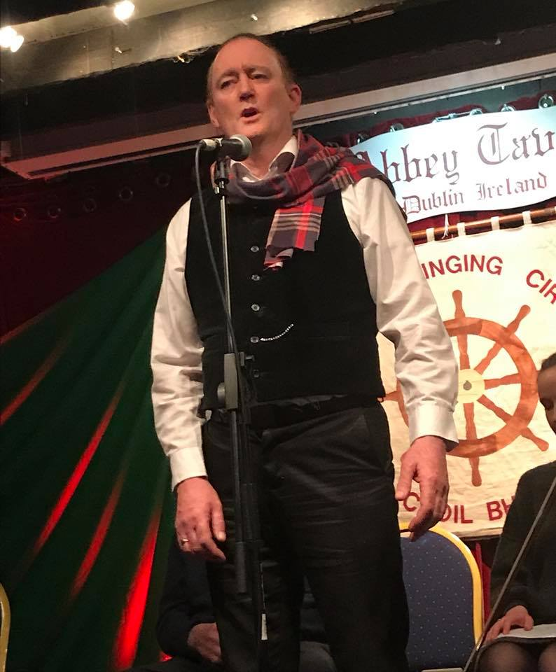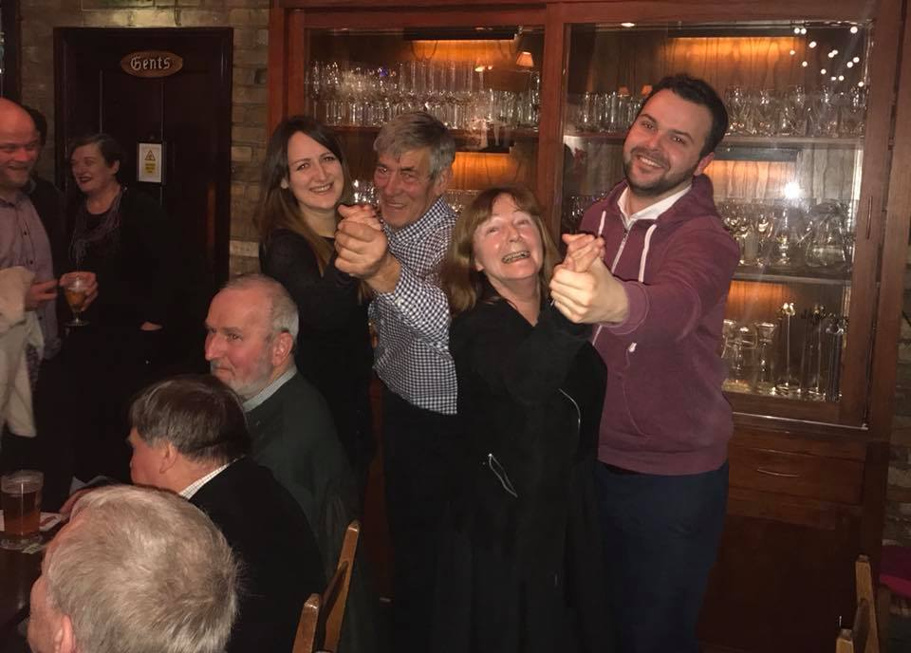
Paul Redmond with his storming delivery of Thomas Moore’s ‘The Minstrel Boy’ and Dave McCracken and Ann Riordan suitably embarrassing our Special Guests Kristan Harvey and Alistair Paterson

An annual highlight was the piping in of the haggis by Pipe Major Noel Kelly and the St Lawrence Howth Pipe Band. The haggis – made by Ricky Higgins of Higgins Family Butchers, Sutton Cross – was carried in by Ardmhéara Mícheál Mac Donncha and addressed, in inimitable fashion, by Willie Gibson. There followed a ‘Scottish Section’ with Carole Prior singing her own composition in praise of a Scots staple ‘Oats’; our own Stiofán Ó hAoláin with some breath-taking ‘Puirt a Beul’; Morag Dunbar and Janet Weatherston, complete with kazoos, with ‘The Kelty Clippies’; and the wonderful tones of Alan Prior with Burns’ ‘My Love id Like a Red Red Rose’. The Finale was led by Janet Weatherston with ‘Happy Ae Are A’ Th’gither’; Francy Devine, ‘Banks o Reid Roses’; and Fergus Russell, ‘Bonnie Light Horseman’. Lastly, Robyn led ‘Auld Lang Syne’ and Diarmuid ‘The Parting Glass’.

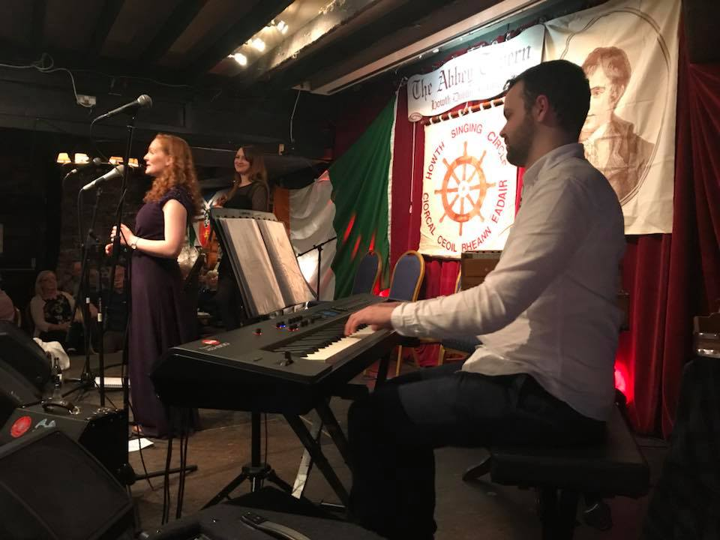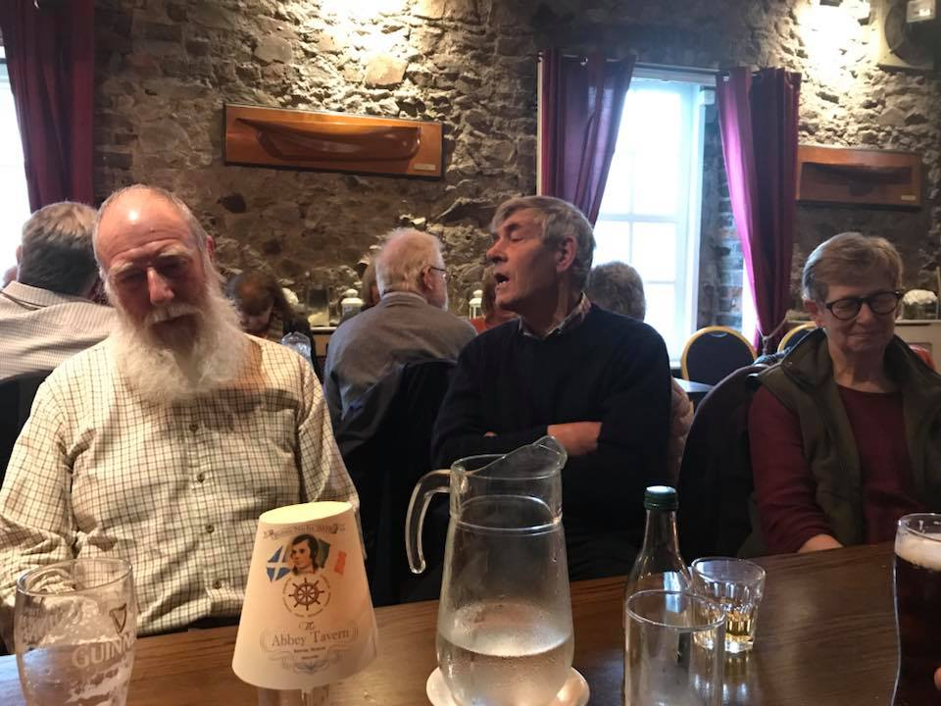
Robyn Stapleton with Kristan Harvey and Alistair Paterson and Burns Nicht stalwarts John Bentham, Dave McCracken and Sheila Bentham

On Sunday, Brian Doyle and Janet Weatherston led a crowded and fun-filled ‘Fare Thee Weel Session’, again in the Abbey, cramming in thirty-seven items as well as a raffle. Incidentally, out of Burns Nicht costs of over €3,700, the Club gave back over €400 in raffle prizes. Performances that caught the ear included SeánÓ hEarcháin, ‘Dear Home o Mine’; Helen Lahert, ‘I Wonder What’s Keeping My True Love Tonight’; Kathy Hobkirk, ‘Ye Hae Laen Wrang, Lassie’; Seán Considine who managed to escape when the Dun Cow went on fire; Pádraig Ó Nualláin, ‘Ballyronan Maid’; Edwarrrrrrrrrd Phillips, ‘Jock o Hazeldean’; James O’Byrne, ‘It’s Written in the Stars’; and Éamonn Hunt who found no man worth regarding. There were many others with many moments of sustained laughter, none more so than when Alan Prior got fu’ on the barley bree. A good few folk stayed on to finish the weekend off with a meal and to be further impressed by the sheer professionalism of Richard Tobin and all his staff in the Abbey Tavern who served up a splendid dinner.

Lastly, we must thank Chris Boland (sound); Christy Hammond (CRM Design & Print) for a fabulous brochure and ticket; Finola Young who hosted our visitors and baked some mouth-watering desserts; Sheila and John Bentham (Loughborough) and Dave McCracken (Tarset, Northumbria) who decorated [and undecorated] the hall and did much else of the mullocking besides; Colm Keating whose wonderful photographs so caught the spirit of the night; and Ann Riordan who managed the door and generally kept an unseen hand on the Burns Nicht tiller. Thanks above all to the 200 and more who attended the events and were so co-operative when buying, settling or sending back tickets and who provided such great audiences and not forgetting the dozens who we simply could not accommodate. The night was aptly named: it was indeed a joy and pleasure!

Finally, we had talked of would this be the last Burns Nicht? The Howth Singing Circle Committee would love to hear constructive views on the matter.

UNESCO Recognition for Irish Folklore Collection and Uilleann Pipes
Late in 2017, UNESCO (United Nations Educational, Scientific and Cultural Organisation) inscribed the Irish Folklore Commission Collection into its 'Memory of the World' Register. This was followed earlier this year by UNESCO adding the uilleann pipes to its list of Intangible Cultural. President Michael D. Higgins acknowledged both UNESCO actions as an honour for Ireland. For uilleann piping, he said that UNESCO’s action was a ‘valuable recognition of the skills, imagination, creativity and importance of those who make, restore and play na píobaí uilleann’. He added that ‘the music and craftwork’ of Ireland ‘connect us in profound ways, weaving together cultural memory and contemporary vision’.

Howth Singing Circle adds its voice to all those connected with the Folklore Collection and na Píobairí Uilleann for their dedication and hard work to ensure that this recognition was won. Whether the State will respond by adequately supporting these two institutions remains to be seen You can learn more about these two now globally significant elements of Irish culture, by visiting www.ucd.ie/irishfolklore/en/ and http://pipers.ie/unesco-recognition-for-uilleann-piping-update/

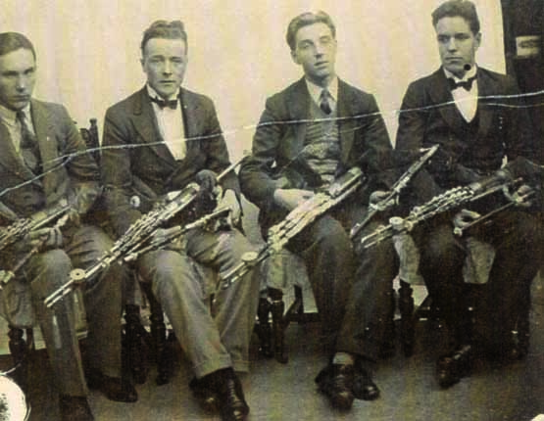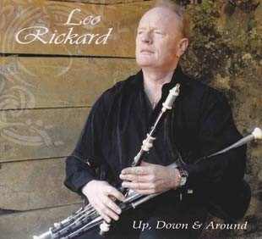
The Rowsome Quartet in the 1940s featuring Michael Páidín, Leo Rowsome, Tom Rowsome, and Eddie Potts; and, right, Howth piper Leo Rickard, whose uncle Jimmy Rickard played with the earliest Rowsome Quartet

Fiddle Bus 5
Fiddle Bus 5 will travel to Antrim on Saturday-Sunday, 7-8 April and, based in Broughshane and Newtown Crommelin will be linking with the County Antrim & Derry Country Fiddlers’ Association. The limited places are, by the time this Sweet Nightingale is published, likely to be booked out and will include the usual blend of Scots and Irish musicians. Organisation has again been undertaken by John Kelly, Liam O’Connor and Ann Riordan.

Music of the Heart: Séamus Ó Súulleabháin’s CD
At the December Howth Singing Circle session, I was pleasantly surprised to discover that James O’Sullivan – known to us as Séamas Ó Súilleabháin – has produced a beautiful album Music of the Heart. Séamus, together with his wife Bernie and their son Cian have been regulars at the HSC over many years. The CD opens with a beautiful rendition of ‘Coast of Malabar’ and includes many well-loved songs such as ‘Boolovouge’, ‘Bruach na Carraige Bhana’, ‘Sweet Ballyvaughan’ and the Don McLean composition ‘Vincent’. Two of my favourites on the album are the haunting melody ‘Ardi Cuan’ and ‘One Starry Night’, a song associated with Liam Weldon. Séamas is accompanied on the CD by the inimitable Mick Mullen on guitar and Liam Curran on fiddle and harmonica. This duo, with Séamas on accordion, features a couple of polkas on the album’s instrumental tracks.

If you like your songs and music with a touch of nostalgia, this album is a must to add to your collection. As the sleeve notes say, ‘This album is a collection of stories. Some old, some new but all with a tale to tell of some event that happened in the past; be it love or tragedy or hope or even sadness’. As the album title says this production is truly ‘Music of the heart’. Well done, Séamas.
Larry O’Toole
Buíochas Mór
We thank those who have contributed to this Sweet Nightingale: Colm Keating; Larry O’Toole, Musicians’ Union of Ireland and SIPTU, Fergus Russell; and the Howth Singing Circle Committee – Laurence Bond, Paddy Daly, Francy Devine, Brian Doyle, Stiofán Ó hAoláin, Diarmuid Ó Cathasaigh, Gerry O’Connor, Niamh Parsons and Ann Riordan.

Spring-Summer Programme

1 February – Stiofán Ó hAoláin with Special Guest Antaine Ó Faracháin

1 March – Francy Devine & Úna Kane, ‘March Hares & Other Madness’

18 March – Sea Shanties at the Howth Prawn Festival with Gerry O’Connor & Fergus Russell

24 March – Sutton Methodist Church Singathon with visiting singers from England

26 March – Singing & Walking Tour on Dublin Quays

5 April – Special Night with Annie Reid (Stonehaven) and visiting Scots fiddle players

7/8 Fiddle Bus 5 to Antrim

3 May – Tony Fitzpatrick & Brendan Kennedy, ‘Me Oul Flower: Floral Songs

7 June – Diarmuid Ó Cathasaigh, ‘Thugamar Féin an Samhraidh Linn’

21 July – Singing the Fishing

