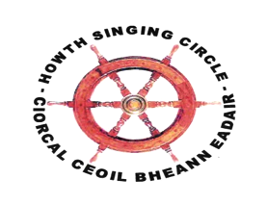
The Sweet Nightingale
New Series, no 3 – January 2016

Happy New Year

Gcéad dul síos, is féidir linn ar mian leo an tsíocháin gach duine agus sláinte do 2016! Thank you all for your suport during 2015, a terrific year full of great nights, marvellous concerts, performances in the National Museum, churches and piers, and, of course, The Fiddle Bus!

This Fearless Maid

Our Young Singer in Residence Ruth Clinton concluded her residency in great style in November when Belfast singer, collector and musicologist Jane Cassidy launched This Fearless Maid. Ruth collected fourteen songs that ‘feature a woman who is not defined by her relationship to a man’. This ‘might be a song written by, about, or from the perspective of a woman, which does not involve any romance’. All the songs were written or sung prior to 1950 and are listed under various themes: ‘Nationalism’, ‘Women at Work’, ‘Witchcraft’ and ‘Lullaby’. Ruth supplies substantial notes to the songs and biographical details on the song writers – some well-known like Meabh Caomhánach [Maeve Cavanagh MacDowell), Charlotte Despard, Winifred Letts, Fanny Parnell or Katherine Tynan, and others who have become obscure like Helena Blackwood (Lady Dufferin), Rose Kavanagh, Mary C.F. Munster, Mary Jane O’Donovan Rossa, Dora Sigerson or Ella Young.

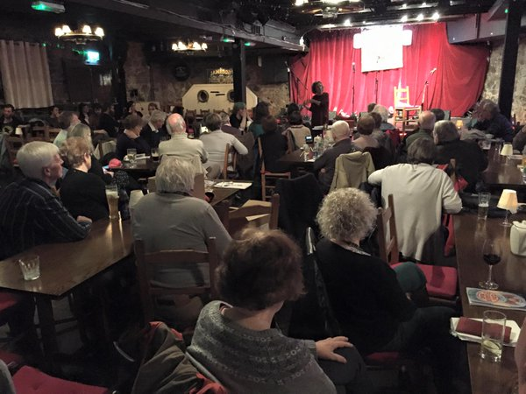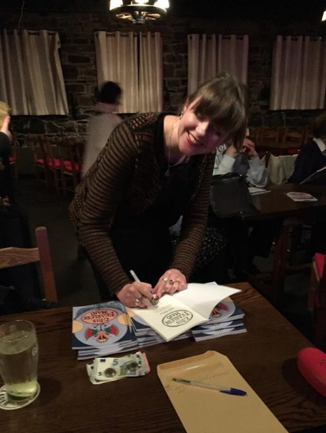
Jane Cassidy launches This Fearless Maid and Ruth enjoys signing a few

On the night, Jane Cassidy appropriately sang ‘The Snuff Box Song’, a song drawn from the Linen industry and a version of events better known in ‘Oh, Do You Know Her or Do Ye Not?’ or ‘The Doffing Mistress’. Its final verse captures its essence: ‘And when the work is good again, / I’m in a better temper, / Bring out your box; we’ll have some snuff, / For I’m the girl who’ll venture’. Ruth sang Mrs Munster’s ‘Lament of the Irish Mother’: ‘The harebell is missing your step on the mountain, / The sweetbriar droops from the hand that it loved’. With fiddler player, Cormac Mac Diarmada, Ruth sang a beautiful arrangement of the lullaby ‘Heezh-ba’, collected in the Sam Henry Collection from Mrs Brownlow, Ballylaggan, Cloyfin, Coleraine, illustrating that this collection, like all song collections, is there to be sung, to be interpreted, to fly off the page. Ann Riordan concludes This Fearless Maid with a tribute to Ruth, outlining her various achievement as artist, singer and performer, and expressing the Howth Singing Circle’s pride in her residency. She has set the bar high for whoever might follow her as a Singer in Residence for the Club.

Many young singers and musicians attended to make the night a bumper one with terrific singing and great craic: Dara Yeates drove a tunnel so well through the London clay, you’d think he was from Fanad or Gaoth Dobhair; Aoife Dermody gave a beautiful rendition of ‘O’Kelly’s Courtship’; Sinéad Lynch took Peggy Seeger’s advice to ‘Don’t Get Married’; Cillian’s ‘Hewin Days’ were through; John Flynn was regal; and Sandy, no doubt, has ‘Sweet Little Apple Cheeks’. Meabh Meir was a welcome return and sang ‘A Poor Loom Weaver’ and with Ruth and Sinéad sang the song they took their collective name from, ‘Landless’. Of the regulars, new Grandpa Tony McGaley discovered that he was, in fact, ‘Me Own Grandpa’; Helen Lahert proved to be a constant lover; Eugene McEldowney was courted by a blackbird; and Robert Kelly told the story of how Jack Judge penned ‘It’s a Long Way to Tipperary’. Other notable songs were Barry Gleeson, Katie Collins of North Strand’, Laurence Bond, ‘The Boys of Mullaghbawn’, Stiofán Ó hAoláin, ‘A Bhean Adaí Thall’; Eddie Phillips, ‘Pull on the Rope – Same Old Fisherman’ [does anyone show more attention to themes than the inventive Mr Phillips?]; Deirdre Madden opened a vegetable stall; Angela Murray let him go without the slightest tarry; and Jack & Angela Plunkett championed ‘Union Maids’. There were nearly forty items and all of a high standard! Maurice Leyden, ‘Lovely Young Kate of Glenkeen’ and Jane Cassidy, ‘The Wager’, brought Belfast Singing Circle voices and added to a night that belonged to Ruth Clinton.

Martin Wyndham-Read

A standing ovation at the end of any performance is heartening in equal measure for artist and organiser. The audience’s spontaneous rise to their feet indicated that those privileged to attend the Gatehouse and Martyn Wyndham-Read concert had enjoyed a presentation of quality singing and songs, music and story, and great stage presence. From the Howth Singing Circle’s perspective, Gerry O’Connor’s enthusiasm to bring Martyn over was met by many – when tickets were being offered – with ‘Martyn who?’ Incredibly, for an artist of international acclaim, this was Wyndham-Read’s Irish debut. Recently formed, Gatehouse were also little known but their line-up guaranteed indicate the topmost quality. And so it proved.

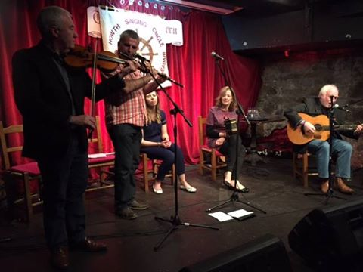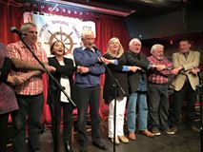
Gatehouse and Martyn Wyndham-Read play ‘Claudy Banks’ and John Wynne, Ann Riordan, Diarmuid Cathasaigh, Niamh Parsons, Martyn, Fergus Russell and Walter Kennedy climax a great night with ‘The Parting Glass’

Gatehouse opened each half with engaging sets that displayed their individual and collective skills. Gatehouse are John McEvoy, fiddle; John Wynne, flute and whistles – not to mention a charming and engaging stage manner; Jacinta McEvoy, guitar and concertina; and Rachel Garvey, vocals. Their music displayed much of their Roscommon/Sligo/Leitrim roots and appeared effortlessly smooth. Rachel’s ‘The Merry Ploughman’ and ‘Over the Mountain’ charmed with a highlight being ‘Easter Snow’ (‘Sneachta Cásca’), Christy Moore’s tribute to Séamus Ennis, the tune being a favourite of the Fingal piper, Wynne’s haunting whistle accompaniment echoic of the great man. Hard to pick from the many great sets but favourites were Packie Duignan’s versions of ‘The Frost is All Over’ and ‘The Mouse in the Cupboard’ and, from Donegal, ‘The Greencastle Medley’. The band set an extremely high bar.

Martyn Wyndham-Read displayed all his stage craft in leading the audience through story and song, song and story. Highlights included ‘Claudy Banks’, Martyn being joined by Gatehouse, the impromptu nature of the piece masked by the sheer class of the resultant arrangement. The night was compered by Gerry O’Connor and Ann Riordan. The Club were represented by Gerry, Niamh Parsons and, in a surprise guest spot, Christy Moore. As to assessing the night, well, that standing ovation is all that needs to be said.

Shanties for Friends of Howth Maritime Museum

On Saturday, 13 November, the HSC concluded an afternoon devoted to lectures and exhibitions of material relating to the sinking of the Tayleur off Lambay as a fund-raising event for the proposed Howth Maritime Museum. A large audience crammed the Abbey Tavern and our crew led the following shanties and sea-related songs: Tony Fitzpatrick, ‘Greenland Whale Fishery’ and ‘The Old Balena’; Brian Doyle, ‘Bound for South Australia’; Siobhán Moore, ‘The Mermaid’; Gerry O’Connor, ‘Whitby Harbour’, and, as a rousing finale, Luke Cheevers, ‘Fall Down Billy O’Shea’ and Fergus Russell, ‘The Grey Funnel Line’. For the audience, an obvious highlight was Seán Ó hEaracháin leading Paul Kelly’s ‘The John Tayleur’. Other up on deck in all weathers were Ann Riordan, Finola Young and Eddie Phillips. The presentation drew wide praise from an audience that were not, perhaps, regular listeners to traditional singers.

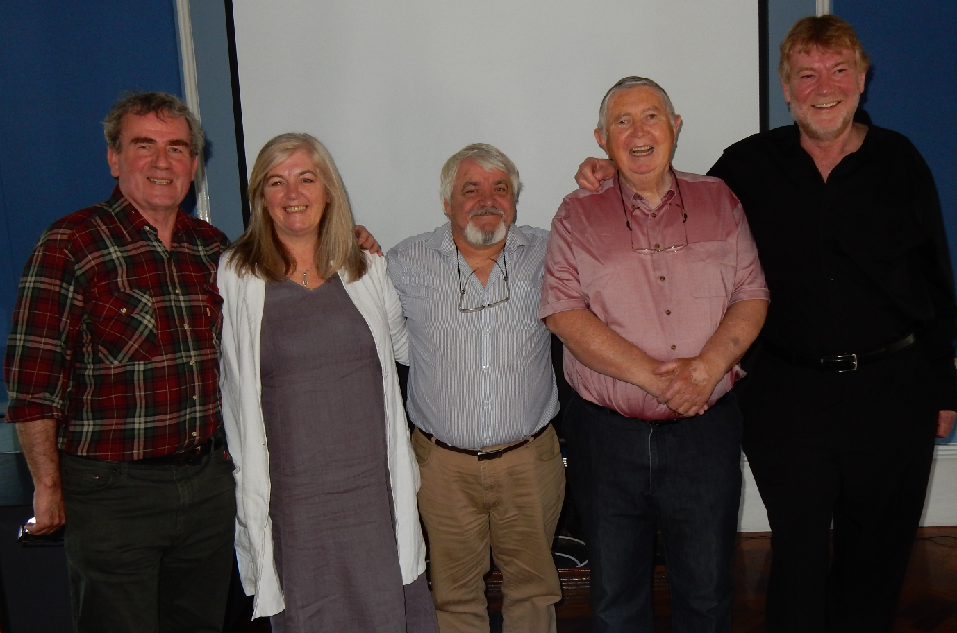
Francy Devine, Niamh Parsons, Fergus Russell, Robert Kelly & Barry Gleeson at National Museum, Collins Barracks presentation of ‘Songs & Poems of the First World War’ in association with Anu Productions play ‘Pals’

Passion For A Song

A Classic Scots Ballad – ‘Andrew Lammie’ as sung by Jane Turriff

It is a pleasure to continue what is now a tradition in The Sweet Nightingale (SN), and choose a song, not as a favourite, but in this case because it still has a fascination for me after thirty years, based on the background story as much as the beauty of the song itself. As Eugene McEldowney said (SN March 2004) ‘it’s like being asked to choose between your children – an impossible task’(!) in picking favourites. But to write about a song or songs to me requires that the approach is different, The choice should be dictated by what one knows or more likely has discovered by accident over time about the ballads, and to share with others one’s experience of the song, and its background. Ultimately, the hope is that enough interest is created here for singers to go and acquire the song as a result. Of course, as you all know, the first experience is a simple love of a song on an initial hearing of it – at a session, or on a recording – rather than reading of it, then later if not too lazy (like me) comes the urge to learn, and then sing it.

The Song and the Story
The title is ‘Andrew Lammie’, but is also well known as ‘Mill of Tifty’s Annie’, or ‘The Trumpeter of Fyvie’ (see photos of the mill and the trumpeter at Fyvie castle), listed as number 233 in the Child Collection (Francis J. Child, English and Scottish Popular Ballads). It seems to have been a very common ballad at one time as other versions are to be found in the main Scottish Collections under the other titles above. For example, Gavin Grieg collected over 12 variants, publishing them in his Last Leaves of Traditional Ballads.

The ‘Ballad of Andrew Lammie’ is based on a true story – though travellers often refer to a ballad as ‘true’ when they believed it to be so, even if it was oftentimes just a myth carried forward by oral tradition through the centuries. Basically it tells of the tragic story of ‘bonny’ Annie who lived at the Mill in Tifty, at Fyvie, then fell in love with Andrew Lammie, much to the disapproval of all of her family, and meets a grisly end at the hands of her brother. The great collector Hamish Henderson recalls being ‘convoyed across the country’ (the lawland leas of Fyvie’) to be shown the actual whereabouts of the ruined mill itself, half hidden by foliage and undergrowth. One of the photos here shows the singer Jane Turriff visiting the location of the song she loved so well all her singing life. Annie’s flat gravestone is nearby dated at 1673, and as Hamish said ‘this makes the story both real and unreal for us, as the lives of the forgotten villagers whose gravestones surround hers there in Fyvie’.

The Singer
It was recorded by Dick Gaughan in 1973, on the album ‘The Boys of the Lough’. This was the initial album of the group of the same, titled after the opening track on the record, and also the only time Dick Gaughan recorded with the ‘Boys’. This was the first time I heard the song sung. I was attracted to it by the superb rendition, with Dick’s characteristic, strong, deep voice.

But three years later I came upon a remarkable LP ‘The Muckle Sangs’, which was a compilation recorded from the great ballad singers in Scotland by Hamish Henderson and others from the School of Scottish Studies in Edinburgh. To list just three of each of the singers/songs gives an indication of the quality of the LP: Sheila MacGregor, Jeannie Robertson, Lizzie Higgins, along with The Gypsy Laddie, The Twa Brothers, The Jew’s Daughter, etc., etc. In a wonderful two LP set with a large 24 page booklet, the last track on side 4 contained but a glimpse of what would be found later. Andrew Lammie was the song, with just four verses by Jane Turriff, and then the full recording of Sheila MacGregor’s version. But I thought at the time those four verses were superbly sung, carrying a deep-welled emotion, not often heard in traditional singing.

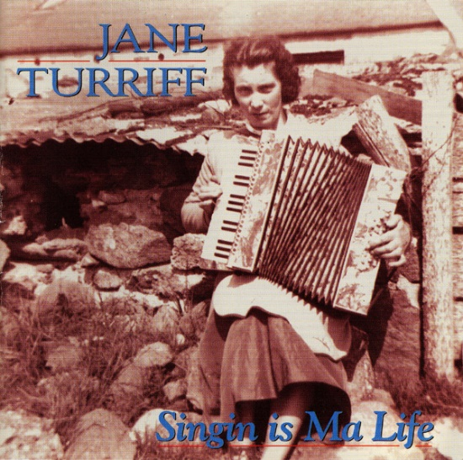
Jane Turriff and our own Mick Fowler, composer of the HSC’s carol, ‘All Hail! All Hail!’

Jane Turriff
Jane was known as one of Scotland’s legendary traditional singers. Born in Aberdeen, she was one of the famous Aberdeenshire Stewards, but she had a strong strain of Irish traveller stock- her maternal grandmother was a Maguire from Ireland, and her uncle the famous Davy Stewart travelled and sang extensively there.

In 1995, I was passing through Edinburgh on my way to Aviemore in the Central Highlands, when I got my hands on a treasure- ‘Singin’ is Ma Life’, Jane Turriff’s own album devoted entirely to ‘her unique voice’ (after 40 years of ‘compilation’ contributions). The CD had luckily just been released. Tom McKean comments in the introduction ‘Listening … I am constantly stunned by her artistry, her quality of tone and the gut-wrenching emotion she packs into her songs’.

Again there were excellent sleeve notes, with quotes from Jane and her comments on each of the songs, as well as the background to her long and difficult life (She was crippled by an injury at four years of age, and used crutches for the rest of her life). To just give two quoted examples, one on her approach to singing in general and then more specifically to the ballad itself- titled ‘Mill of Tifty’s Annie’ on this CD – with no apologies for giving the scots dialect used here (!):

‘Singin is ma life’-
‘Ay, singin’s ma life. My mother an aa, it wis her life an aa and ma dad was musical. It’s a happy body that likes singin and music..’it’s a happy person tha’ sings ..’now in the mornin’ when I’m makin ma tea, I’ll be singin’ ma grans songs, and ma ma’s songs. I’ve no time for folk tha’ dinna like singin’ She would wish her sisters and brothers out of the house, so she could get singing-’An it wis on ma mind the whole day, I can’t get singin!’

on ‘Mill of Tifty’s Annie’-
Her husband’s blind mother (a fine singer herself) used to call to Annie passing at 12 years of age-‘ “Come in a minute, and gie me thon song now, give me Tifty’s Annie”.
An I had tae sing (TA) to her. That was her favourite song’.
(when she had finished singing it for the recording)- “Beautiful, isn’t it now?” “Oh, I love tae pit in the feelin’” “That’s the way tae sing- I’m away in a dream about it.” (see the photo of Jane singing, and visiting the mill at Tifty).

Jane sang a shortened version of the song on the recording, all of seventeen verses, lasting 9 ½ minutes. She in fact knew 52 (yes, fifty two!) verses of the song!

‘The Singin’ of it’
I have not heard the song sung in Ireland once in the thirty-four years since hearing it by Dick Gaughan on that first LP of the Boys of the Lough. Having got past the gestation, and osmosis stage in acquiring a song (!), I ‘threw it out’, as they say, in the Góilín Club three weeks ago. I attach below the lyrics used – eleven verses only, for modern audiences- and singers! – based mostly on the great ‘shape’ Sheila MacGregor put on the lyrics, but including a lot of Jane Turriff’s ‘curves’ as she calls them in the actual singing of it; in other words Dick Gaughan’s version I found to be a little unemotional though superbly delivered , after I had been bowled over by listening to the fragment on the Muckle Sangs, let alone Jane’s full version on ‘Singin is Ma Life’. Though in saying that, I accept that ballads are normally sung ‘unemotional’ and ‘straight’.

I thank the Howth Singing Circle, and especially Francy Devine for this opportunity to put down some thoughts on a Ballad that has fascinated me for a long time, as I have never before attempted to articulate the feelings, and had a chance to share something like this on paper with my good band of fellow singers. Now that I ‘have’ it, I hope I can give it a try in Howth soon!

Mick Fowler
Andrew Lammie

At Mill o’ Tifty lived a man,
In the neighbourhood of Fyvie;
And he had a lovely daughter fair,
Was called bonny Annie.

Lord Fyvie had a trumpeter
And his name was Andrew Lammie,
And he had the art to win the heart
O’ Mill o’ Tifty's Annie.

Her mother called her to the door,
‘Come here to me, my Annie.
Did e’er ye see a fairer man
Than the trumpeter o’ Fyvie?’

But at night when all were to their beds,
All slept full sound but Annie
For love oppressed her tender breast,
Thinking of Andrew Lammie.

For its love comes in at my bedside,
And love lies down beside me;
Love has oppressed my tender breast
And love will waste my body.

It’s up and down in Tifty’s Glen
Where the burn runs clear and bonny
I’ve often gang’d beneath my love
My ain dear Andrew Lammie.

He took himself to the hills so high
To the hilltops o’er Fyvie
And he blew his trumpet loud and shrill
’Twas heard at Mill o’ Tofty.

‘My love I go tae Edinburgh town
And for a while must leave thee’.
‘Och, but I’ll be dead afore ye come back
In the green kirk yard o’ Fyvie’.

But her father he struck her wondrous sore
And also did her mother
Her sisters also did her scorn
But woe be tae her brother

Her brother struck her wondrous sore
With cruel strokes and many
And he broke her back o’er the temple-stone
Aye the temple-stone o’ Fyvie.

‘Oh mother dear go make my bed
And lie my face tae Fyvie,
There I will lie and it’s there I’ll die
For the sake of Andrew Lammie’.

Note: Mick Fowler originally submitted this piece some years ago when The Sweet Nightingale ceased. We are delighted to be able to bring his reflections on a great ballad now . We welcome other contributions from anyone who has ‘A Passion For a Song – eds)

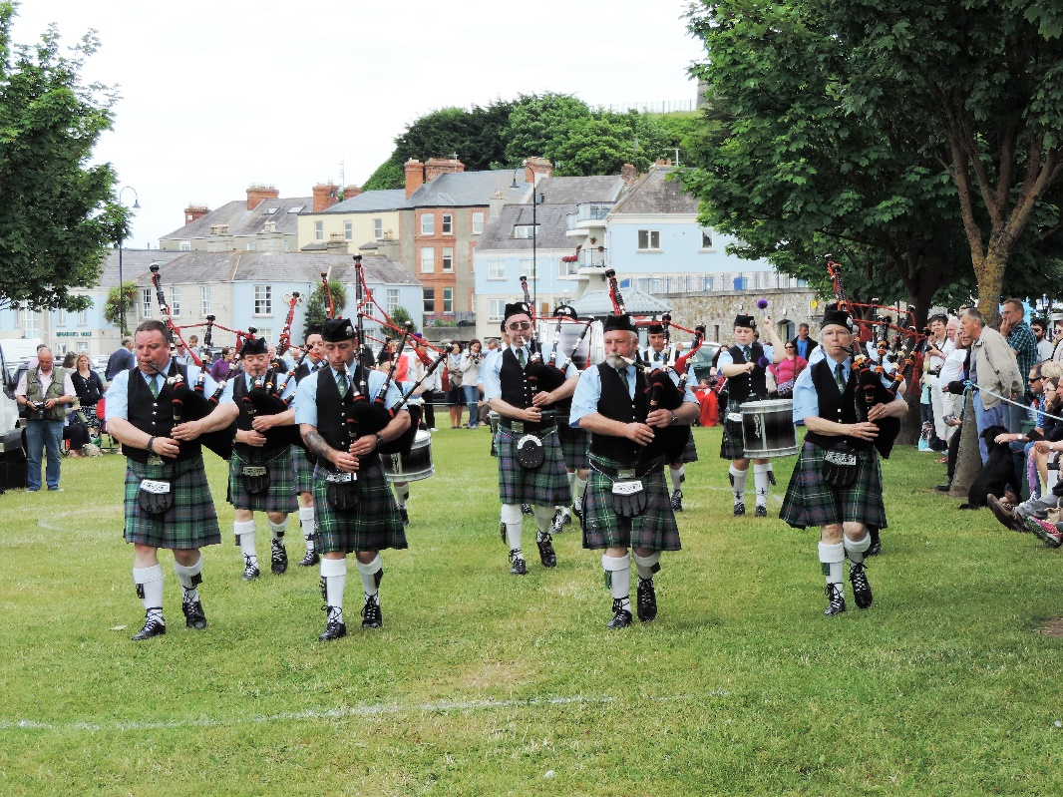
St Lawrence Howth Pipe Band, East of Ireland Champions 2015

Alistair ‘Al’ O’Donnell, 8 December, 1943-3 September, 2015

This tribute to the late O’Donnell by his old friend and music companion Al Atkinson first appeared in Tatters, The Newsletter of Tigerfolk, www.tigerfolk.com, October 2015 and is reproduced with their permission

I first met Al O’Donnell, or Alistair as we knew him then, 53 years ago in September 1962 when I started as a full time student at Nottingham College of Art. We were introduced by Roger Norman, a full –time student who I knew from my evening class visits to the College. Roger, a very accomplished guitarist, was one of the leading lights of the College’s thriving folk scene. To this day I have an absolutely vivid mental picture of my first sight of Al – sitting cross legged on top of a plan chest in the Graphic Design studio while tuning a long neck banjo. So this was what graphic design was all about!

I remember a short, ginger-haired man wearing a corduroy jacket of approximately the same hue. He had a broad welcoming smile and a welcoming handshake and we took to each other from the first. Autumn 1962 brought one of the crucial events of the early days of the English Folk Song Revival with the arrival in our city of the Centre 42 ‘roadshow’. This trades union sponsored cultural mission came to visit Nottingham along with five other towns and cities bringing a programme of musical, literary and theatrical events, all of a strong left wing nature. Along with the plays, poetry readings and theatrical events there was a very impressive folk element with Ewan MacColl and Bert Lloyd heading the bill on a concert in the functions room of the main Co-op store on Parliament Street. In those days there was a very small cadre of professional folk singers most of whom appeared on that concert. It was there that I first heard the singing of Louis Killen and Bob Davenport as well as witnessing the singing debut of Annie Briggs whose studies at the Art College lasted all of four days before she joined the Centre 42 bandwagon.

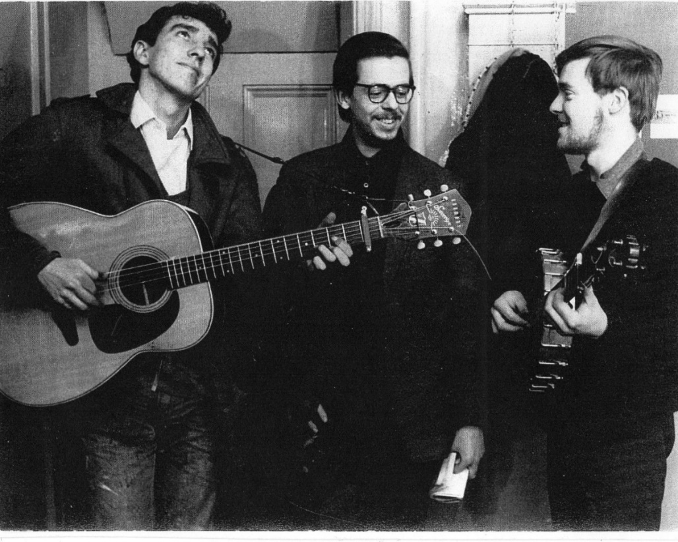’
‘Hard at our studies’ with Roger Norman, Al Atkinson & Al O’Donnell, Nottingham College of Art c1964

Al and I, along with most of the local singers, were signed up as mercenaries to support the full time stars which is how we came to find ourselves supporting Ray Fisher at her gig in the Red Cow, Leicester, another Centre 42 base. This was my debut as a paid singer with a fee of ten shillings, worth about six pints in those days. Alistair was already doing solo gigs for money and was a very accomplished performer, very much admired for his beautiful voice and for his expert playing of the banjo. In those days Nottingham’s chief venue for folk music was the Co-op Folk Workshop held in the Co-operative Arts Centre on Heathcote Street. The club dated from the late 1950s and had been started by a group of enthusiasts amongst whom Spike Woods, another art college veteran, was probably the most notable. The classic format of a folk club evening (ie, resident singers, floor singers and visiting guest) had already evolved. Al, Roger and myself were amongst the residents along with Gil Harper, a fine singer of unaccompanied Scottish ballads, Quentin Hood with his guitar and repertoire of mainly English songs and Gabriel Lavelle who specialised in hearty renditions of Irish material. I suppose the ‘wild card’ was the amazing Tromping Dave Turner who made a valuable contribution with his versions of American songs and, increasingly, his home grown repertoire of surreal ‘decompositions’. We had a glorious couple of years of this regime along with parties, visits to neighbouring folk clubs and regular concerts in the art college students’ union room, organised by Al, Roger and myself and usually in aid of Oxfam. On one occasion our pals Andy Irvine and Annie Briggs turned up as unpaid guest artistes to help us out. In those days anything seemed possible.

In the summer of 1964 Al, having completed his studies, headed back to his native Dublin (his years spent in Grantham and Nottingham having been due to his parents’ employment over here.) Back in Ireland Al quickly established himself as a very popular singer much in demand for club and concert appearances. He also increasingly made a name for himself on the London folk scene along with all the other emerging talents in that most exciting and vibrant era. Al was frequently invited to sing at the Edinburgh Festival, his friendship with Archie Fisher dating from those years. He also undertook tours of Ireland as well as round the English club scene, played in New York and also on the continent. It was whilst touring in Germany with his friend Luke Kelly that the pair of them managed to get themselves arrested for snapping tourist photos in East Berlin. Al even had a spell as one of Sweeney’s Men but came to realise that the life of a full-time touring musician was not for him. By then Al was married to June and had a regular job as a graphic designer and stage carpenter at Raidió Teilifís Éireann, a job which well occupied his time but also gave the chance of occasional performances on the television. He was very proud of his prestige billings on the festivals at Lisdoonvarna, a showcase for the whole range of Irish folk talent, as well as being a featured artist at the Ballysadare festivals. I caught his performances many times, mainly around the favourite Dublin venues such as Slattery’s and the Abbey Tavern at Howth. Post-retirement Al was able to concentrate more on his singing career and even managed to tour Germany twice as a member of the Dubliners.

Al was always a family man and it has been a great privilege for me, over the years, to have been able to visit Al and June and to watch their family grow up. It was marvellous seeing Al and June’s obvious pride in their children Ruán, Conor and Melissa, and their joy as the grandchildren arrived. My overriding impression of Al is of a man who was the most positive and optimistic person that I’ve ever met. I don’t mean a kind of blind optimism because he was always a thoughtful man and a man who was well informed and with an inquiring mind. Al had a basic decency and an understanding of how things should be done. His positive attitude to life was apparent in the way that he dealt with his health problems over recent years and his courage and his refusal to contemplate self-pity were a great credit to him. He was a loyal friend, always with a readiness to appreciate and encourage and with a genuine interest in other people and their lives. I shall always remember Al for his humour, his ready smile and, of course, for his music which gave delight to so many people. So many friends who have known Al over the years will have their own memories of the man and will feel it a privilege to have known him.

Al Atkinson, 21 September, 2015

Francy on The Rolling Wave

On Sunday 29 November, Ellen Cranitch featured Francy Devine on ‘The Rolling Wave’. The hour long programme featured stories, reminiscence and recordings and can be heard at http://www.rte.ie/radio1/the-rolling-wave/programmes/2015/1129/750107-the-rolling-wave-sunday-29-november-2015/?clipid=2043923 The Howth Singing Circle received a high profile in the broadcast, as did ‘Tommy Swan’s Dog’! Central to the show was the CD ‘My Father Told Me’ that Francy made with Steve Byrne & Friends.

Another radio series that Francy was associated with during the year is strongly recommended to all singers, ‘Vocal Chords’ an Athena Productions production for RTÉ Lyric FM. Presented by Iarla Ó Lionáird the five part series can be heard at http://vocalchords.ie/episodes/ The series essentially grew from the long-term collaboration between Iarla and Peter Gabriel and the episodes deal with 1. The Noise Before Meaning and The Sounds Before Singing; 2. Singing Our Way Home; 3. The Stories We Tell; 4. Better Together; and 5. The Global Voice. It is a provocative series that makes the listener think, consider their own attitudes to and performance of singing and it is global in terms of its coverage of vocal styles, traditions and occasions. Well worth setting time aside to listen to.

Forthcoming Programme

7 January – Laurence Bond & Helen Lahert with ‘All The Flowers of the Forest’

Saturday, 23 January – ‘Twas in Sweet Senegal’, Burns Nicht 2016
with Special Guests Dáimh, St Lawrence Howth Pipe Band & mony mair

Sunday, 24 January – 3-6, Fare Thee Weel Session, Sea Angling Club

4 February– Stiofán Ó hAoláin with Special Guest Aodhán Ó Ceallaigh

3 March – 8pm, illustrated presentation from Dónal Maguire on the ‘Songs of Michael Davitt’
followed by singing session, ‘Songs From the Land’ from 9pm

7 April – Niamh Parsons with ‘Easter Snows’

28 April – Malinky in Concert

12 May – A Special night when The Night Before Larry Come to the Seaside

2 June – Brian Doyle with theme to be announced

Saturday 16 July – Singing the Fishing – annual fundraiser for St Francis Hospice, Sea Angling Club, 3-6

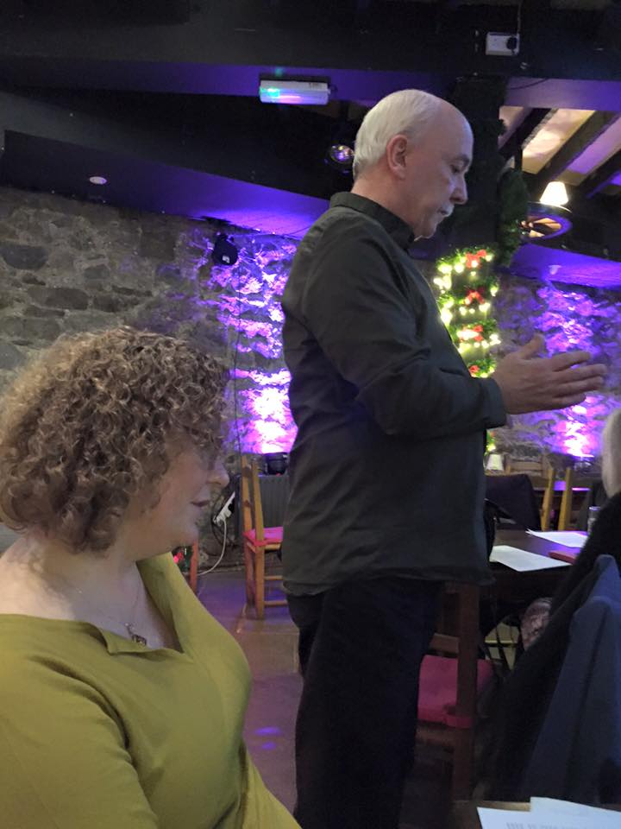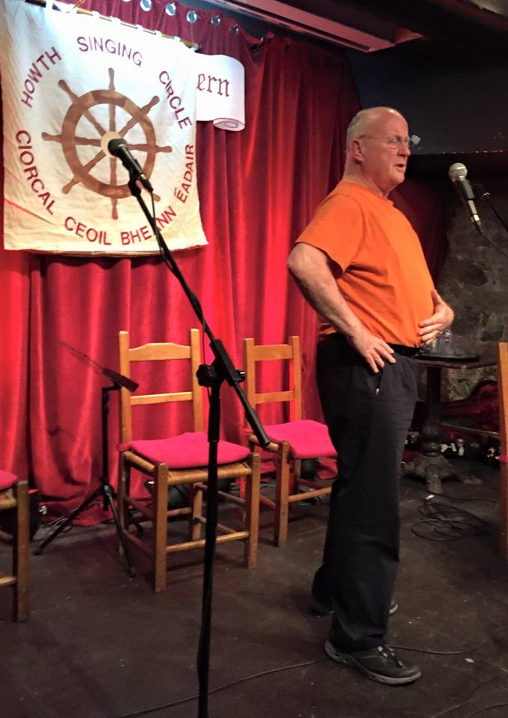
Máire Ní Chróinín with Tim Dennehy and Christy Moore at the Martyn Wyndham-Read gig

Dick Gaughan- on the 1st Boys of the Lough LP, Leader Records : Trailer LER 2086: 1973; now on CD LER CD 2082: 2004.
‘Scottish Traditions 5 -The Muckle Sangs’ (meaning Big Ballads) : LP issued 1975, by the School of Scottish Studies, Edinburgh; contains Jane Turriff on Side 4, Track 5; excellent Classic Scots Ballads selection.
Jane Turriff: ‘Singin’ is Ma Life’: Springtime Records SPRCD 1038: 1995.

