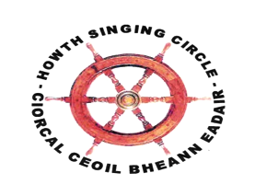
The SWEET NIGHTINGALE
New Series, Number 2, October 2015

‘De som vill sjunga alltid hitta en låt’
‘Those who wish to sing always find a song’ (Swedish proverb)

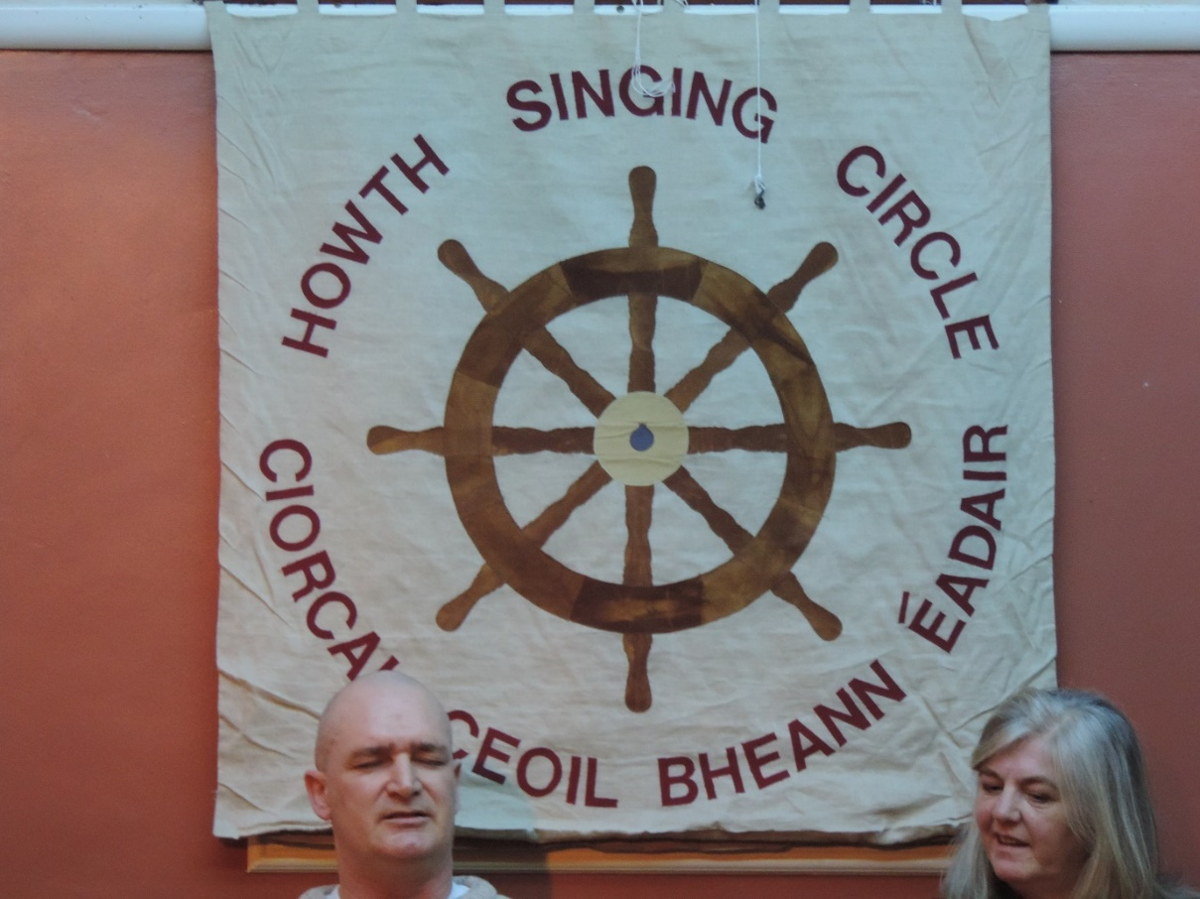

Robert Kelly’s Wheel

The Howth Singing Circle was founded in the autumn of 2001 to maintain the memory of Brendan ‘Bull’ Moore, Howth fisherman and singer who provided much rich entertainment over many years in the town and in seaports around our coast. After his friends gathered one evening to sing in his honour in The Red Herring, such was the enjoyment that the idea of a monthly session followed. We first met in the back room of the Pier House, a crowded, very smoky and often quite noisy – but much-loved – venue. Few in 2001 imagined that we would still be flourishing and entering our fifteenth season.

Over those fifteen years, many people contribute to the Howth Singing Circle in many different ways. The most conspicuous are those who sing or play but there are many other vital ingredients to the HSC that can go unnoticed: various administrative and organisational tasks; arranging furniture and remembering the banner and the box; and, perhaps most important of all, coming along to listen to and enjoy the performances. Robert Kelly’s songs and singing have long been a delight. His style and song selection are unique and thoroughly loved by all at the Club. His songs can be poignant, quirky, highly amusing, stunningly beautiful – even his impersonations of horses and other livestock are a joy. He has, however, contributed something very special and very permanent, a hand-crafted ship’s wheel – fashioned from mahogany, teak, oak and pine – that displays all his skills of cabinet making and carpentry.
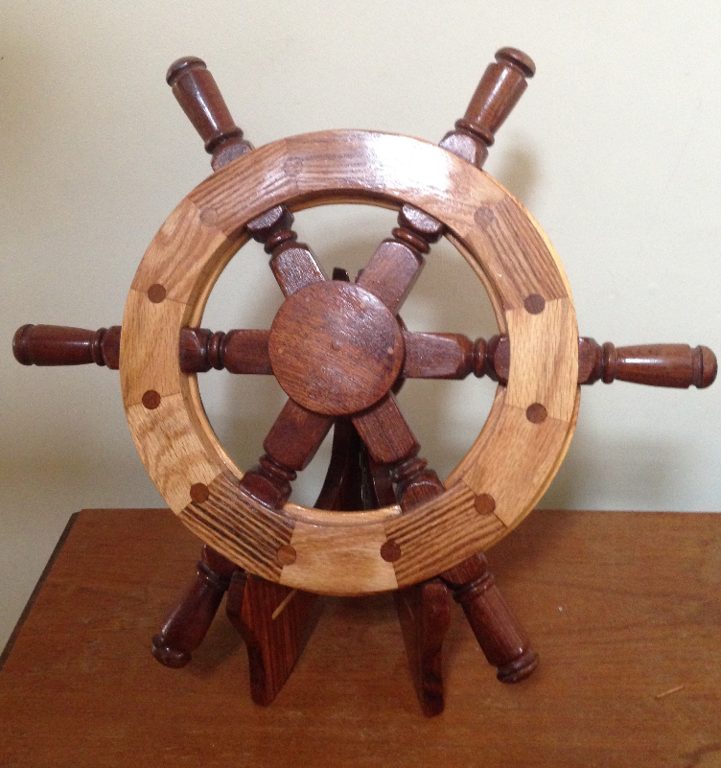

Along with our banner – made by Liz Reilly of Naul – Robert Kelly’s wooden wheel is something we are all very proud of. We are grateful to Robert for the time he gave to conceive, design and construct the final, impressive product. It graces any occasion and reflects the joy he has both taken from and provided to the HSC.

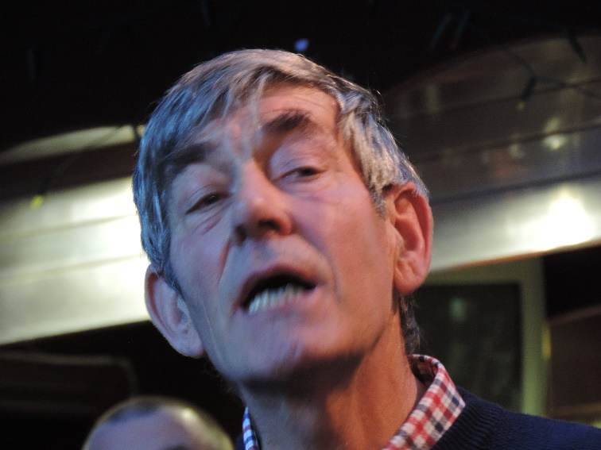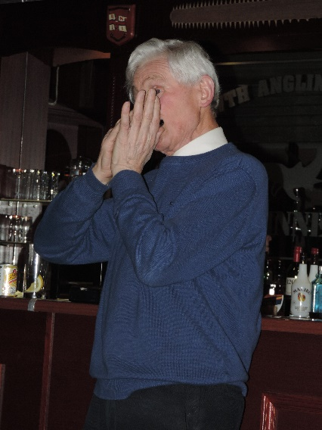
hAol
Burns Nicht standard bearers: Northumbria’s Dave McCracken agus Diarmuid Ó Cathasaigh (Beann Éadair agus Lú)

Who Will Thrash the Corn Now?

Well, Ann Riordan and Eugene McEldowney led a great starting night for the Sixteenth Season of the HSC. The standard of the singing and song and recitation choices was high with the Harvest Songs element well to the fore. Graham Dunne set the bar high with two sets of tunes at the beginning of each half, his ‘When First to This Country’ being truly exquisite. Notable songs among the thirty singers, for these ears at least, were Eugene’s Copper Family ‘Young Brethren’; Tony Fitzpatrick, ‘The Kerryman’s Ramble to Tipperary’ with his own concertina accompaniment; Joe Gallagher, ‘The Slave’s Lament’, Angela Murray, ‘A Spailpín a Rún’; Gerry O’Connor, ‘With the Harrow & Plough’; Aoife Caomhánach, ‘When Autumn Leaves Start to Fall’; and Ciarán Ó Maoiléoin, ‘Sweet Ennistymon’. It was great to hear strong, fresh voices: Marie Smith, ‘Mantle So Green’; Nora Shovlin, ‘The Hills Above Drumquin’; and Paul Byrne, ‘In the Town of Listowel’. A highlight of the night was the Harvest Basket which overflowed thanks to the generosity of those who brought items to put into it. Indeed, it allowed for a number of lovely prizes in the now traditional, free Howth Singing Circle raffle. The winner was the Travelling Librarian himself, Tony McGaley and here he is below with his bounty.

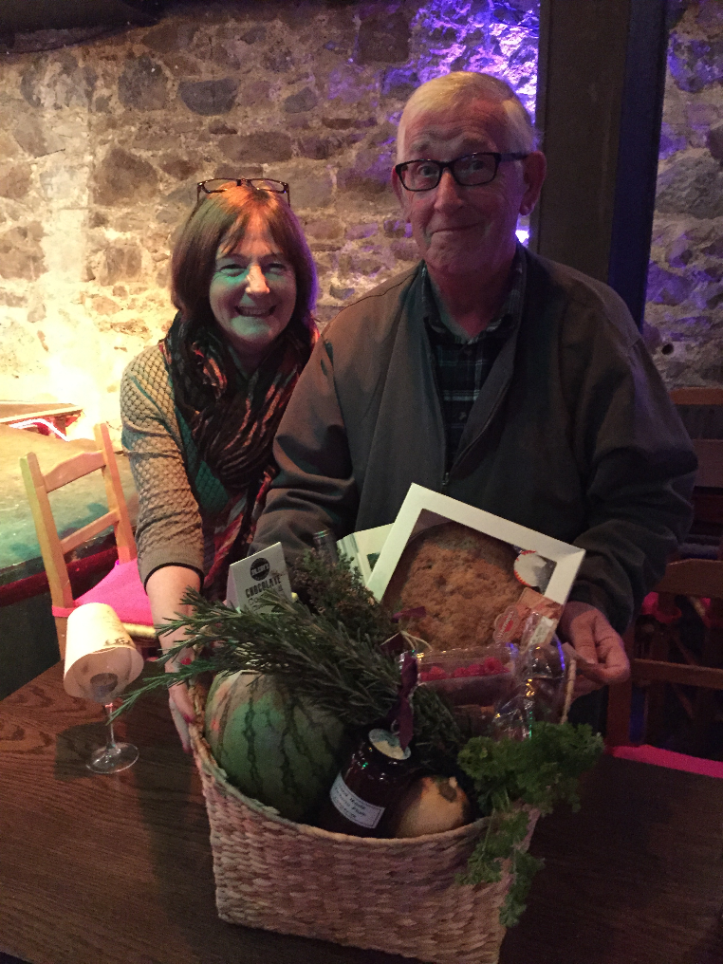
Ann Riordan & the winner of the Harvest Basket Tony McGaley

The Sweet Nightingale would welcome anyone who would review our events. Such reviews were a great feature of the early newsletters. If the standard of singing and song is as high as it was on the September night, then reviewing will be an easy task. Well done to all concerned and thanks to Ann & Eugene for leading a splendid night.

Visit From Tiger, Poppy & Grand Union Folk Clubs

In April, Howth Singing Circle again hosted singers from the English East Midlands, representing the Tigerfolk Traditional Folk Club, Long Eaton, Derbyshire; Poppy Folk Club, Nottingham; and Grand Union Folk Club, Barrow-on-Soar, Leicestershire. For those interested, these clubs can be followed at http://tigerfolk.com; www.poppyfolkclub.co.uk; and http://guf.org.uk. In the Tigerfolk newsletter, Tatters, John Bentham recorded his reflections on their time in Ireland.

I know it is tempting fate but every time we go over to Ireland the weather is kind and so it was in April when a group of us went across for a cracker of a weekends singing. Whilst waiting for the party to assemble on the Thursday evening, one or two were looking out from the hotel across the estuary at Malahide and you could have been in the South of France, it was stunningly beautiful in the early evening sunlight. We all felt it was a good omen (apart from those who were stranded at the airport back in England!). Decisions were made and half the party set off for the sing and another car waited for the later arrivals.

That evening we were in the company of the Howth Singing Circle in their new venue, the Abbey Tavern. Famed for recordings of Irish group and singers over many decades and now home to Burns Nicht celebrations, numerous concerts and the Singing Circle, we were welcomed with open arms by old friends and new acquaintances alike. When our second car arrived everyone got to know each other a little better as, sardine style, we all hotched up a bit and squeezed everyone in. Ably MC’d by Ann Riordan and assisted by one of our gang, the night was one of good honest singing with food and drink liberally dispensed with much mirth and merriment. It was a credit to Ann that everyone who wanted to perform had the opportunity and as is the way of good nights the time to sing ‘The Parting Glass’ came round much too soon.

The intention of the visits is not just to enjoy the singing but also for people to have time to wander off and discover more about this area around Dublin Bay. As it was Friday, O’Donoghue’s called a number of our party and thanks to Jerry O’Reilly not only did they enjoy listening but one or two were asked to play and sing. Treasured memories of the weekend were amassing. After a meal overlooking Howth Harbour, fine food to accompany stunning scenery, we ambled back to town for a ‘House Ceilidh’ courtesy of Ann Riordan and Francy Devine. Amongst the diners were Niamh Mac Neela and Liam O’Connor who were shortly to be married but we weren’t there to celebrate the nuptials, we were there to listen to their music. Two young but very talented fiddlers who were a joy to listen to but not only that, the breadth of their knowledge was immense and how Liam could effortlessly swap from one style of fiddling to another to demonstrate a point was tremendous. More singing between tunes and a supper of Leicestershire cheeses and ale meant, as is usual on these visits that we got up and went to bed on different days.

The sun was shining and inviting everyone to explore on Saturday and after a breakfast people dispersed to do their own thing until early evening when we would meet up for a bite to eat before going to a sing in Bray Singing Circle that is run by George Henderson. After one or two nominated singers, it was a jump-in session and although not the sort of thing that some of our party were accustomed to it went pretty smoothly. The advantage was that a theme could develop and be pursued round the room. Again a packed room with food, drink, laughter and song to speed us on towards midnight, when George announced that the visiting party should finish the night. No second invitation was needed and the ‘Feral Choir’ hit the floor running with big chorus songs enough to shake the plaster off the walls. The hour long journey back to Malahide sped by as we all re-lived yet another night of warmth and fellowship through song. In fact the journey went that fast that we hadn’t finished reliving the whole night so we adjourned to the bar to make sure that were able to do just that.

During the planning of this weekend it had been suggested that we might like to visit Glasnevin Cemetery on the Sunday morning. Now this needed a bit of explaining but it all became clear when the list of graves we were to visit also came with the names of the singers and the songs they were to sing here it is:

 | Occupier | Grave | Song | Performer
1 | Peader Kearney | sd36 | Sergeant William Bailey | Niamh Parsons
2 | Maud Gonne | td24 | Sez She | Luke Cheevers
3 | Big Jim Larkin | td38 | Roll Away the Stone | Manus O’Riordan
4 | Margaret Burke Sheridan | xd16 | Marble Halls | Seán Ó hArcáin
5 | Frank Ryan | rd22 | Viva La Quinta Brigada | Fergus Whelan
6 | John Keegan Casey | nc7 | Rising of the Moon | Laurence Bond
7 | Brendan Behan | va21 | Auld Triangle | Fergus Russell
8 | Jimmy O’Dea | mf57 | Biddy Mulligan | Luke Cheevers
9 | Harry O’Donovan | ai 160.5 | Daffodil Mulligan | Niamh Parsons
10 | Zozimus | ag30 | Finding Moses | Máire Ní Chróinín
11 | James Joyce | xd6.5 | Song at Twilight | Seán Ó hArcáin
12 | New Angels Round Tower |  | The Soddin’ | Ann Buckley
13 | Charles Stewart Parnell | plot | Avondale | Francy Devine
14 | Charles Stewart Parnell | plot | Parnellites (Yeats) | Manus O’Riordan
15 | For deceased friends | trees | The Life of a Man | Francy Devine

Some of the deceased will be known to you and some not and that is how it was with us, so it to Fergus Russell we must give thanks for researching and telling the history of each individual as we went round. Included in their number were politicians, poets, music hall artists, singers, song-writers and political activists, a truly eclectic mix. But Fergus did have his reward, a conveniently placed pint of Guinness on the headstone of Brendan Behan that he consumed after singing ‘The Auld Triangle’. A great many there were friends of Tom Crean who sadly left us recently and with the permission of his widow, Margaret, we paid our respects at his recently erected headstone, a poignant moment for many and Eugene McEldowney sang ‘The Holmfirth Anthem’. We were just about done but there was one more grave to visit which was across the road in another part of the cemetery. Jimmy Kelly led the way and on reaching the plot started to recount stories of his brother Luke and also to sing. It was here that this most fascinating and memorable part of the weekend, for all of us, ended but not before the company joined in one or two farewell songs that were sung with much sincere feeling. Fergus is a stalwart of An Góilín and it was to the Teachers’ Club, where that club is held, that we repaired for a farewell singing session. Again, for some of our party on their first visit, it was an eye-opener to be in this elegant Georgian building on Parnell Square in the heart of Dublin. I don’t know if ably is the correct adjective to use of our MC, Luke Cheevers, perhaps I should say that Luke ran the session in his own inimitable way which was thoroughly entertaining! Such is the way of these things the time sped by and it was with fond farewells and promises of return visits and invitations to come over to England that we headed back to Malahide. A quiet meal in the hotel on the Sunday evening and the inevitable but quieter sing rounded off yet another very, very memorable trip which re-affirmed old friendships, forged new ones and has us already starting planning to welcome an Irish return visit.

A special heartfelt thank you to the Howth Singing Circle, Ann Riordan and Francy Devine for organising and co-ordinating everything over the weekend for without their hard graft the tour would not have been the resounding success it was. We all raise a glass to you both

our thanks to John & Sheila Bentham for organising their end of things and for this interesting report

Bird Song Project

The Howth Singing Circle were ably represented at the Dublin Bird Song Project Concert at the National Library in Kildare Street by Eugene McEldowney and Niamh Parsons. Our own night in May, hosted by Anne & Niamh Parsons was a great night with innumerable references to avian creatures.

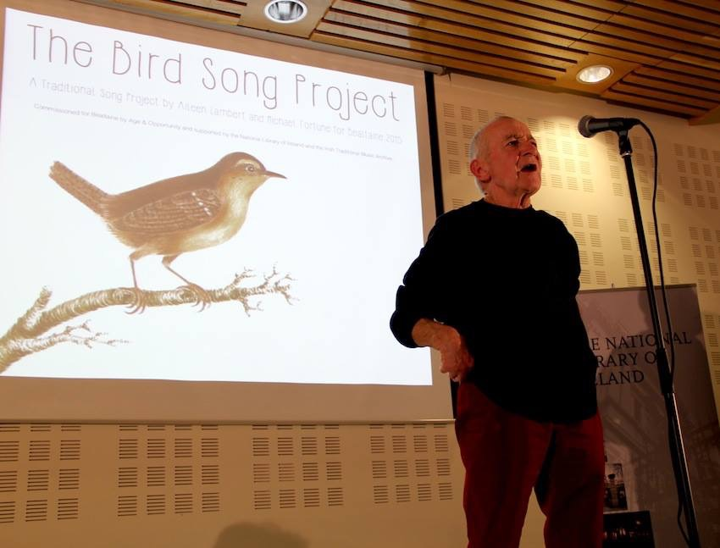
Eugene McEldowney singing in the National Library

Singing The Fishing

On Saturday, 18 July a goodly number gathered in the Sea Angling Club for our annual ‘Singing the Fishing’ session in aid of the Hospice and run, as usual, with the support of An Góilín Traditional Singers’ Club. On the bridge for the afternoon were Brian Doyle and Máire Ní Chróinín and they steered the ship well through the welcoming and familiar waters of the Angling Club who, as ever, provided great hospitality and respectful service. Nearly forty people performed, with poets Paula Meehan and Theo Dorgan adding their own, beautifully constructed verses to the occasion. Many made a great effort with the theme with Eddie Phillips – a man who can be relied upon to rise to the challenge of even the most obscure theme – leading off with ‘Away From the Roll of the Sea’. Laurence Bond paid homage to the legendary Sam Lerner fifty years after his death with ‘The Drowned Lover’; Gerry O’Connor sailed ‘South to Australia’; and Brian Doyle sang of ‘The Last of the Great Whales’. Jack Plunkett delivered a beautiful version of Archie Fisher’s ‘The Final Trawl’; Alan Woods – a welcome sight and sound – sang of ‘The Bold Fisherman’; Seán Ó hArcáin sang beautifully to the seals; and Tony Curtis did a grand job on ‘Lord Franklin’. For me, women’s voices impressed with some memorable renditions: Niamh Berry, ‘Lowlands of Holland’; Helen Diamond’s lovely version of the ‘The Sea Apprentice’; and Mary Murphy’s poignant presentation of ‘The Evelyn Marie’ which sank off Rathlin O’Byrne Island, Donegal in January, 1975. This was perhaps the song of the afternoon and fitting tribute to the six crew who lost their lives: Paddy Bonner, Roland Faughnan, Hughie Gallagher, Tom Ham, Johnny O’Donnell, and Joe O’Donnell.

All singers contributed to an afternoon of great quality: Aoife Caomhánach, Mick Caldwell, Fergus Carey, Luke Cheevers, Antoinette Daly, Mick Dunne, Barry Gleeson, Helen Lahert, Helen Lawlor, Willie Lawlor, Eugene McEldowney, Tony McGaley, Martina Nic Cearnaigh, Máire Ní Chróinín, Willie O’Connor, Stiofán Ó hAoláin, Ciarán Ó Maoléoin, Larry O’Toole, Angela Plunkett, Fergus Russell, and Maridhe Woods. We must not forget the listeners and special mention must be made of Mick and Maria Dunne’s three children who were an absolute credit to them and themselves, entertaining and delighting all.

We have forwarded the afternoon’s proceedings of €400 to St Francis Hospice, Raheny. Well done all concerned.

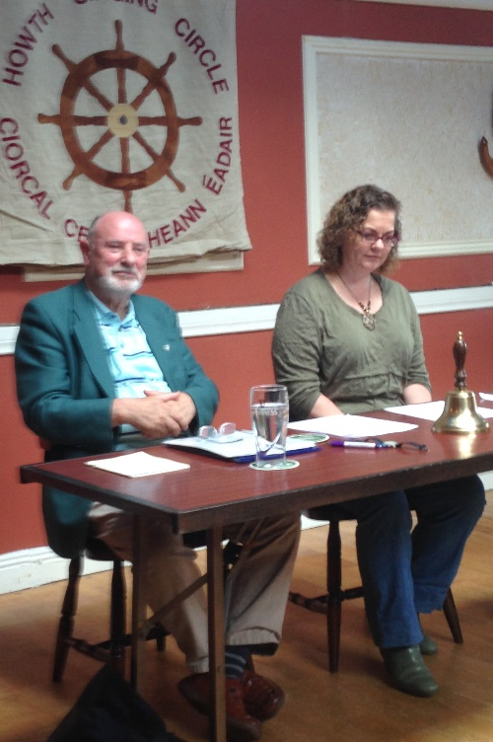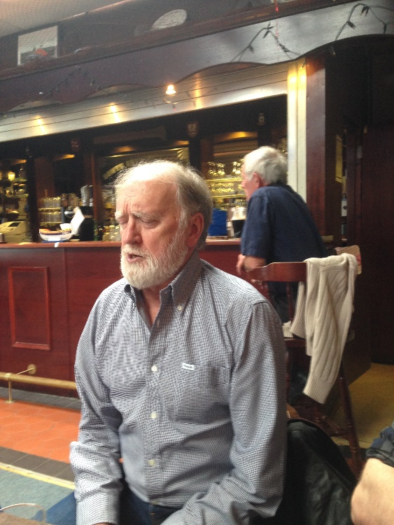
Brian Doyle, Máire Ní Chróinín & Luke Cheevers at Singing the Fishing

HSC Presents First World War Songs in National Museum

On 12 August, in a repeat of a presentation originally made for Dublin City Council in City Hall in 2014, the Howth Singing Circle – supported by singers from An Góilín Traditional Singers’ Club – performed a programme of ‘Some Irish Songs & Poems of the First World War’. This presentation was done between performances of Anu Productions highly-acclaimed, all-action drama ‘Pals’. Contemporary songs from the Irish Worker and Workers’ Republic were augmented by Barry Gleeson singing Harry O’Donovan’s ‘Dublin Fusiliers’, Pete St John’s ‘Johnny McGory’ and Jack Judge’s ‘It’s a Long Way to Tipperary’; Robert Kelly singing Cormac McConnell’s ‘A Silent Night (Christmas 1915)’ and Tom Smith’s ‘Blackbird of Slane’; Niamh Parsons singing Sam Starrett’s ‘John Condon’, and Fergus Russell singing ‘Because He Was Smarter Than Me’. Poems from Thomas Kettle, Francis Ledwidge, Winifred Letts, Katharine Tynan and W.B. Yeats were read by Anu Productions Bairbre Ní hAodha. Howth Singing Circlers will get an opportunity to see this show before the October monthly night in Howth.

Fr

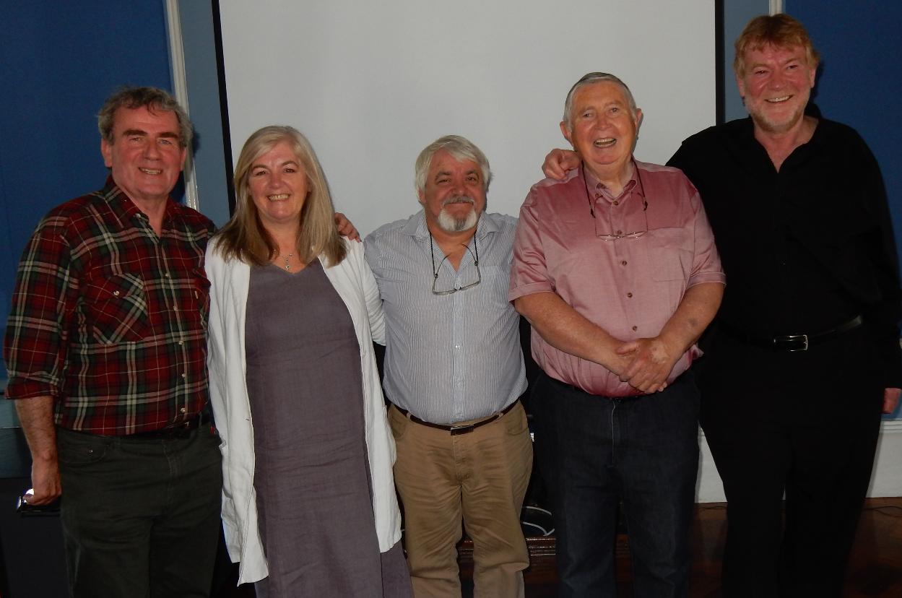
Francy Devine, Niamh Parsons, Fergus Russell, Robert Kelly & Barry Gleeson at the National Museum of Ireland,
Collins Barracks (photograph, Paddy Daly)

Burns Nicht Brochures

A full set of our now celebrated Burns Nicht brochures, from 2009-2015, have been deposited in Howth Library’s Local History Section; the Irish Traditional Music Archive, Dublin; Linenhall Library, Belfast, which contains a large ‘Burns & Burnsania’ collection, www.linenhall.com/pages/burns-burnsania; Elphinstone Institute, University of Aberdeen; and the National Library of Scotland, Edinburgh. The brochures have been critically acclaimed, not least for their gathering of information on Robert Burns and his, surprisingly many, Irish connections. Preparations for Howth Burns Nicht 2016 – when our Special Guests will be Dàimh – are well underway and if anyone would like to contribute articles or photographs for our brochure, please forward items to us.

Programme for Autumn-Winter 2015-2016

Note that all events are held on Thursdays in the Abbey Tavern
commencing at 9pm sharp unless otherwise stated.

3 September – ‘Who Will Thrash the Corn Now? with Eugene McEldowney & Ann Riordan

1 October – 8pm, audio-visual presentation of ‘Songs & Poems of First World War’ with Francy
Devine, Luke Cheevers, Robert Kelly, Niamh Parsons, Ann Riordan & Fergus
Russell followed by singing session, ‘War & Peace’ from 9pm

15 October – 8pm Concert with Martyn Wyndham-Read & Gatehouse, tickets €10

5 November – presentation by Singer in Residence Ruth Clinton

19 November – Dinner details to follow

10 December – ‘It Was the Holly …’ – Christmas Session with Special Guest Tim Dennehy

7 January – Lawrence Bond to lead night on theme to be announced

Saturday, 23 January – Burns Nicht 2016 with Special Guests Dáimh, St Lawrence Howth Pipe
Band & mony mair
Sunday, 24 January – 3-6, Fare Thee Weel Session, Sea Angling Club

4 February– Special Guest Aodhán Ó Ceallaigh

3 March – 8pm, illustrated presentation from Dónal Maguire on the ‘Songs of Michael Davitt’
followed by singing session, ‘Songs From the Land’ from 9pm

Micil Ned Quinn

The passing of Michael ‘Micil Ned’ Quinn on Sunday 31 May occasioned widespread grief among traditional musicians, singers and storytellers across Ireland and indeed around the world. Born in 1926 in the townland of Carricknagowna between Mullaghbawn and Belleek, South Armagh, Micil Ned was the eldest of John Ned and Alice Quinn‘s eight children. It was a musical house, noted throughout the district for tunes, songs, dancing and storytelling. John Ned had a great store of songs. Micil Ned began his working life as a hired farm worker and later worked for Newry Number Two Rural and the NI Housing Executive. With his wife Tessie (née Murchan) he moved to Mullaghbawn in 1966.

Micil Ned was ‘the lynchpin’ in the Ring of Gullion Branch of Comhaltas Ceoltóirí Éireann, which he had helped found in 1975. He was also a founder of the Forkhill Singing Weekend and of the Stray Leaf Folk Club. He appeared to be known by every singer and musician in Ireland and walking with him up the main street in Miltown Malbay during the Willie Clancy Week was like accompanying the President as few passed him by without acknowledgement, warm greeting and exchange of tales. Progress to the intended destination could be slow but the delays memorable.

Micil Ned, with his son Miceál, was a guest of the Howth Singing Circle, as well as attending several others nights. He delighted audiences with songs and stories, the latter based on characters, events, phrases and sayings from his locality. Like the roads around Mullaghbawn, these stories seldom took a straight path to the point – although they always eventually got to their intended destination. This was story telling at its best. These tales were not book learned but evocations of Micil Ned’s youth, the rural culture of South Armagh and Down and North Louth. Audiences, of all ages, were spellbound and – no matter how many times they had heard the story before – left reeling with laughter. Few will ever butter their toast on the wrong side after receiving instruction from the master and, as to smuggling sausages from Dundalk to Newry, well the less said the better!

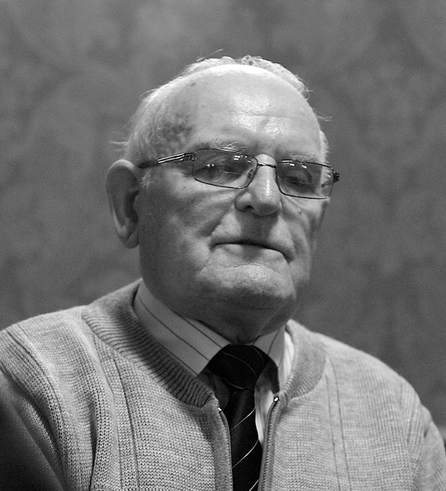
Micil Ned Quinn

Micil Ned was always immaculately dressed, starch white shirt and tie, his hair brushed neatly back. As he rose, his eyes twinkling with an intoxicating mixture of divilment and joy, an air of expectation settled over whatever company he was performing to. And he was a true performer. He never disappointed with song or story or both. There was always a sense – and perhaps as he reached his eighties – an increasing sense, that what was being witnessed was unique. He dipped into the bran bucket of his repertoire and fetched out a handful of lore and legend, pathos and humour, recalling the characters and customs long gone and not to return. Fortunately, many videos and recordings of his songs and stories can be treasured on the Na Píobairí Uilleann – see http://pipers.ie/source/media/?mediaId=21648&galleryId=775 and http://pipers.ie/source/media/?mediaId=21651 – and ITMA sites – see ‘The Man That Shot the Dog’, www.itma.ie/inishowen/singer/mick-quinn

Micil Ned was predeceased by his wife Tessie. The Howth Singing Circle extends its deepest sympathies to his children Pauline Mulligan, John, Catherine Rice, Miceál and Fiona McVerry, his grandchildren, brothers Seán and Eamonn, sisters Nancy and Brigid, and his wider family. One of his favourite songs was ‘Craigie Hill’ and this short appreciation concludes with the lyrics of that song.

It being in the springtime and the small birds they were singing,
Down by yon shady harbour I carelessly did stray,
The thrushes they were warbling,
The violets they were charming
To view fond lovers talking, a while I did delay.
She said, ‘My dear don’t leave me all for another season,
Though fortune does be pleasing I 'll go along with you,
I 'll forsake friends and relations and bid this Irish nation,
And to the bonny Bann banks forever I 'll bid adieu’.
He said, ‘My dear don't grieve or yet annoy my patience,
You know I love you dearly the more I'm going away,
I'm going to a foreign nation to purchase a plantation,
To comfort us hereafter all in Amerikay’.
‘Then after a short while a fortune does be pleasing,
T’will cause them for smile at our late going away,
We’ll be happy as Queen Victoria, all in her greatest glory,
We’ll be drinking wine and porter all in Amerikay’.
If you were in your bed lying and thinking on dying,
The sight of the lovely Bann banks, your sorrow you’d give o’er,
Or if were down one hour, down in yon shady bower,
Pleasure would surround you, you’d think on death no more.
Then fare you well, sweet Cragie Hills, where often times I’ve roved,
I never thought my childhood days I’d part you any more,
Now we're sailing on the ocean for honour and promotion,
And the bonny boats are sailing, way down by Doorin shore.

Al O’Donnell

The singer and musician Alistair ‘Al’ O’Donnell sadly passed away on 3 September in St Colman’s Hospital, Rathdrum, County Wicklow. His death was mourned by a deeply appreciative traditional music world. Alistair Noel O’Donnell was born on 8 December, 1943 to a Geordie father with Donegal roots and a mother from Dumfries, Scotland. The family migrated to Grantham, Lincolnshire from Harold’s Cross, Dublin, when Al was young. He studied at Nottingham College of Art where he became lifelong friends with another Al, the respected English folk singer Alan Atkinson. O’Donnell quickly became a widely-respected performer in the burgeoning clubs of the Folk Song Revival, uniquely marrying English, Scots and Irish material. He performed with Peggy Seeger and Ewan MacColl, Martin Carthy, Ray and Archie Fisher, Humberside’s The Watersons and Belfast’s McPeake Family. He appeared at leading folk clubs – his home club ‘The Co-op’ in Nottingham – and festivals, becoming a highly-acclaimed and much-loved artists.

O’Donnell issued two now iconic LPs, both produced by Bill Leader. The first, Al O’Donnell (Leader Records, LER 2073, 1972), contained what were to become highly influential and oft imitated versions of some classic material: ‘Avondale’, ‘Streets of Derry’, ‘Lord Inchiquin’, ‘Larry’, ‘Maid on the Mountain’, ‘The Green Linnet’, ‘Ramble Away’, ‘Matt Hyland’, ‘Crooked Jack’, ‘Cuilin’, ‘Me Tune’, ‘James Connolly’ and ‘Ned of the Hill’. Al O’Donnell 2 came in 1978 (Transatlantic/Logo, LTRA 501) with more great renditions: ‘The Granemore Hare’, ‘Bonny Woodhall’, ‘Sliabh na mBan’, ‘The Connerys’, ‘An Bunnan Buídhe’, ‘The Dark Eyed Sailor’, ‘Dónal Óg’, ‘Lord Abore & Mary Flynn’ and ‘The Madman’. O’Donnell’s interpretations became definitive and influenced subsequent treatments by acclaimed bands like Steeleye Span.

Returning to Ireland, O’Donnell’s family commitments saw him largely withdraw from performing as – from 1969-2003 – he worked as a graphic artist in RTÉ. As his family grew and time permitted, he returned to public performance and issued the double CD Ramble Away in 2008. This was a mixture of old and new material, some composed by himself: ‘Streets of Derry’, ‘One Morning in May’, ‘Raglan Road’, ‘Ramble Away’, ‘What Put the Blood?’, ‘Grey Funnel Line’, ‘Banks of Sicily’, ‘Wicklowmen of 98’, ‘Callin’ on Song’, ‘Sammy’s Bar’, ‘The Night Visiting Song’, ‘Avondale’, ‘Jock o Hazeldine’, ‘Bunnan Buí’, ‘Streets of Derry’, ‘Dónal Óg’, ‘Forgive Me Quick’, ‘Matt Hyland’, ‘James Connolly’, ‘Going to the West’, ‘The Night Visiting Song’, ‘Sammy’s Bar’ and ‘The Connery Brothers’. For those unfamiliar with his work, a trawl of YouTube is highly rewarding: see ‘Sammy’s Bar’, www.youtube.com/watch?v=rhllhvfp46I

In tracking traditional singing, O’Donnell can be overlooked. The path tends to follow the Clancy Brothers and Dubliners, Luke Kelly and on to Christy Moore. O’Donnell was, however, a hugely influential contemporary of all these artists and forged extensive connections with Scots and English performers, collectors and enthusiasts. Few can claim not to have been influenced by O’Donnell’s guitar style, tuning and melodic interpretation. His ‘Avondale’ or Cyril Tawney’s anthems ‘Sammy’s Bar’ and ‘Grey Funnel Line’ are the versions first brought to mind. In 2010, O’Donnell joined the Dubliners on tour in Germany, a time when he made a number of well-received appearances in The Cobblestone.

Al O’Donnell was the Howth Singing Circle’s guest way back in the Pier House days. He proved a lasting friend, a constant encourager, a generous sharer of songs and their provenance, a performer who never disappointed. He was, in every sense, great company, kind and welcoming. He could be feisty when moved to complaint – usually over some social injustice or maltreatment of a fellow artist. His musical interests stretched well beyond traditional folk music and his compositions – like ‘Westmoreland Jane’ – merit a wider audience.

Al O’Donnell was a major figure in traditional singing and his loss is acutely felt. The Howth Singing Circle extends its sincere condolences to Al’s wife June and their children Ruán, Conor and Melissa and their extended families. Here’s one more day on the Grey Funnel Line, Al.

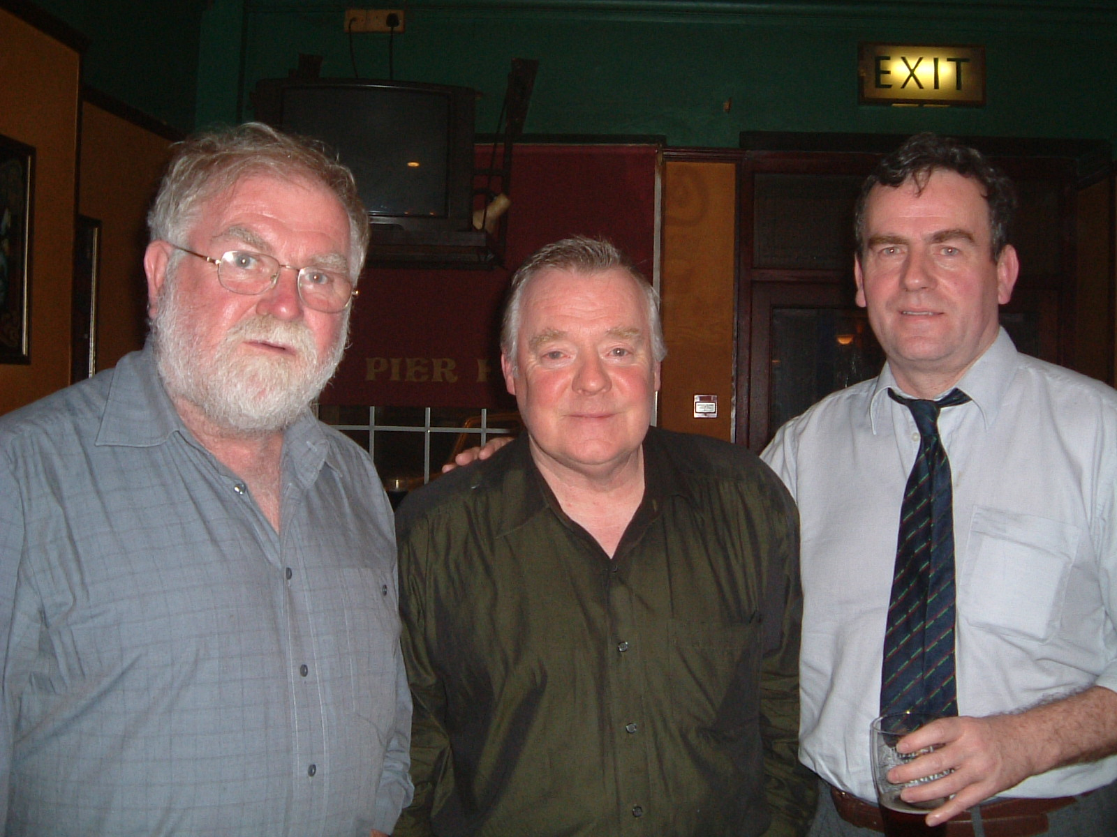
Tom Crean, Al O’Donnell & Francy Devine in the Pier House (photograph Paddy Daly)

HSC Committee
The HSC Committee is Lawrence Bond, Paddy Daly, Francy Devine, Brian Dunne, Gerry O’Connor, Stiofán Ó hAoláin, Niamh Parsons, Ann Riordan & Fergus Russell. Feel free to forward any suggestions or ideas you may have about improving our Club to any of the Committee or contact us through Facebook or website.

The Sweet Nightingale welcomes articles, reviews, images or other material from any Club members.

Memories of Fiddle Bus Twa

Top, l-r: Liam O’Connor with Pat McAndrew, son of the legendary fiddler Hector McAndrew; Paul Anderson; Fiddle Bus Piper Matt Milne; and Gerry O’Connor at Cambus O’ May;
middle, l-r, Mick O’Connor, John Kelly, Michael Tubridy, Iain Murray, James Littlejohn, Liam O’Connor & Paul Anderson at Scot Skinner’s grave, Aberdeen; Michael Tubridy, Séamus Glackin, Mick O’Connor and John Kelly at the memorial to The Tarland Minstrel, Peter Milne;
bottom, l-r, Breton dancing as Charlie Le Brun plays at concert in Hall, Tarland; and Shona & Paul Anderson welcoming us aboard Fiddle Bus Twa (Photographs Mick O’Connor & Francy Devine)

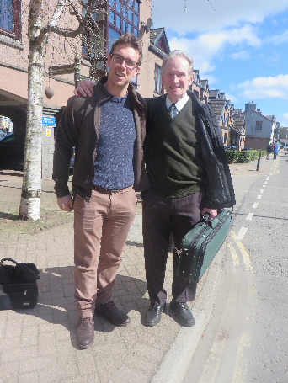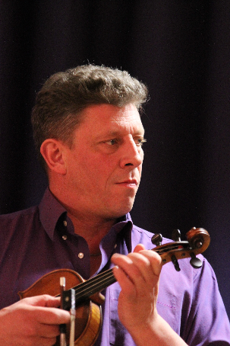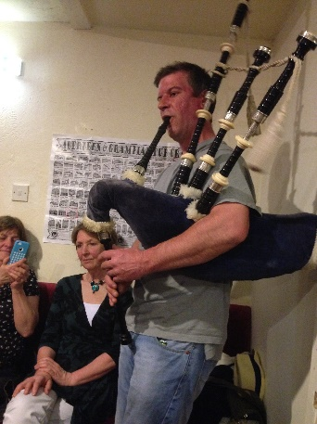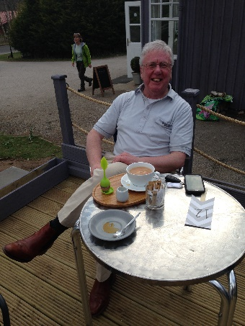

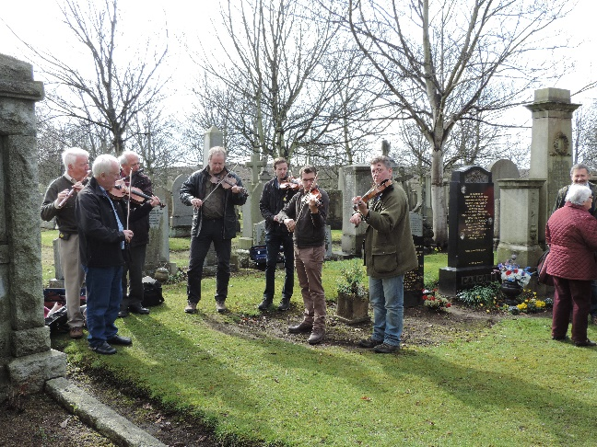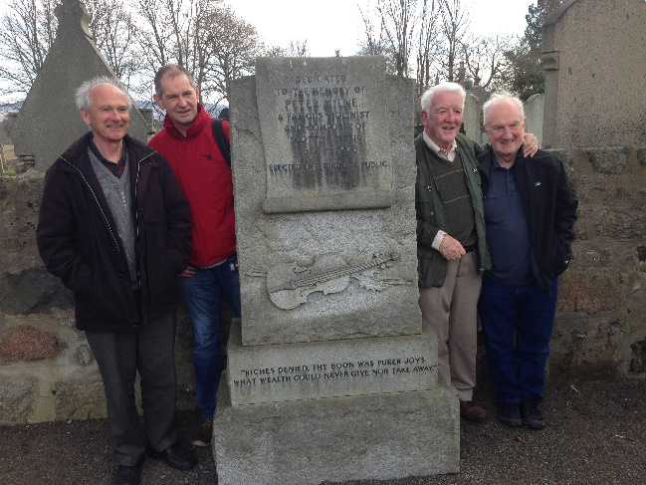

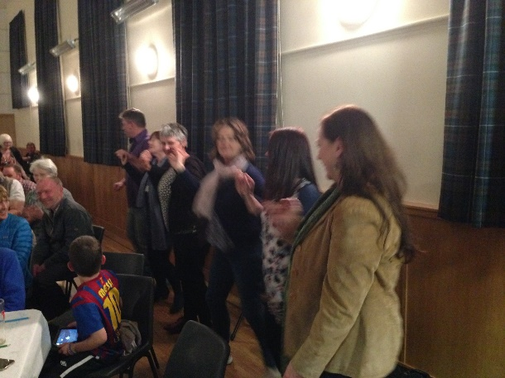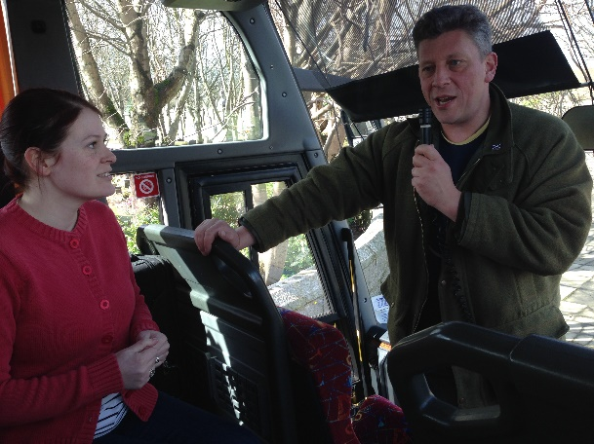

Fit a braw day wis had by aa!

