Terry Moylan
leads a night of songs to remember
The Battle of waterloo, 1815
‘He Went Over The Lowlands Like Thunder …’
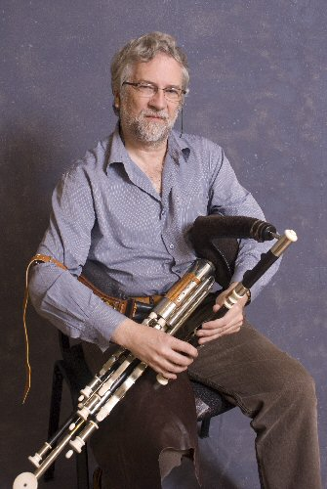
come along and sing , play or listen
downstairs in the Abbey Tavern, Howth
Thursday, 4 June, 2015 at 9pm sharp, €4
all welcome

