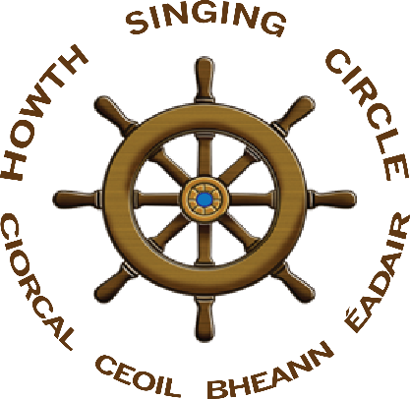
The Sweet Nightingale
New Series, no 5, November 2016

The Sweet Nightingale

This is the fifth of our new series of The Sweet Nightingale. Past issues can be accessed on the HSC website https://howthsingingcircle.com/ We welcome contributions from anyone and thank all those who have contributed to this and previous editions. It probably works best if you print off a copy. Please draw others attention to the newsletter, webpage and Facebook page.
Programme for the Season

As we start our seventeenth year of the Howth Singing Circle, here is the programme for the forthcoming period until the Burns Nicht.

3 November, Helen Lahert & Siobhán Moore, ‘Betwixt & Between’

17 November, Dinner in The House with Special Guest Peter ‘The Racker’ Donnelly

8 December – ‘Oh, Yes It Is!’ – A Night of Pantomime & Christmas Songs with Fergus Russell & Máire
Ní Chróinín

5 January – Irene Bagenal & Éamon Thornton, ‘Songs of the Sea’

21 ‘An Gie’s a Hand o Thine’ - Burns Nicht with Special Guests Siobhán Miller and St Lawrence Howth
Pipe Band

22 Fare Thee Weel Session in Howth Sea Angling Club

Jack Barron

In the early days of the Howth Singing Circle – and especially in the Pier House – two of the Club’s great favourites were Nan and Jack Barron. They both sang and, occasionally, Nan would play the accordion. They brought members of their family and, especially, their daughter Cathy, a fine singer in her own right. What they were most famous for, however, was Nan’s lovely versions of songs to which Jack would provide exquisite harmonies. When Nan and Jack were singing, every face in the room would be wreathed in smiles and they became a much-loved part of the Howth Singing Circle.

Sadly, Jack Barron passed away in October. Nan sang beautifully at the funeral and recalled the days of Nan, Jack and the Barronettes at Howth Singing Circle, represented on the day by John Griffin – another face from the early days – and Francy Devine. To Nan, Cathy and the Barron family, everyone at the Howth Singing Circle sends their sincere condolences and heartfelt thanks for all the joy and fun that Jack and Nan brought to us.

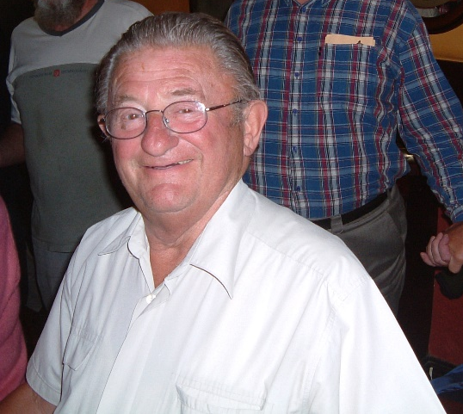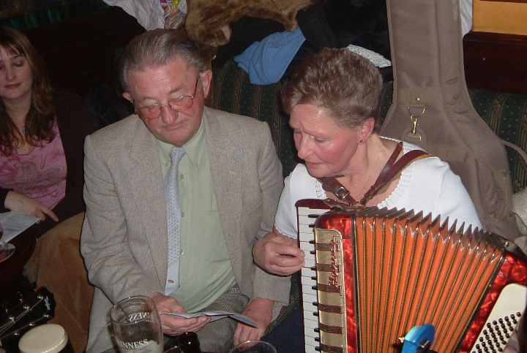
Jack with Nan working out their harmonies with Cathy looking on - photo Paddy Daly

Finances

Our opening balance in September 2015 was €2,980.82. During the year our outgoings were €13,586.34 and our income €11,667.90. This leaves a balance at the start of this year of €1,062.38. Our main outlay was on guests, €4,191.46 with an additional €1,039.78, mostly arising from the Burns Nicht. Our accounts also include the annual Dinner and Fiddle Bus a Trí which ran so successfully to Donegal in April. Publication of our Young Singer in Residence Ruth Clinton’s This Fearless Maid brought in €830 with additional monies outstanding. The year’s accounts include two donations of €400 to St Francis Hospice, Raheny arising from our annual Singing the Fishing Session in Sutton Methodist Church. The Martyn Wyndham Read concert ran at a surplus while the Malinky gig produced a disappointing turnout. We must acknowledge a number of private donations that greatly assisted the Club during the year.

So, that is where your €4 donations each month go. Hopefully you will appreciate that the Club gives great value for money. Last year, in addition to the Burns Nicht and other concerts, we had Tim Dennehy, Dónal Maguire, Maebh Meir and Aodhán Ó Ceallaigh as guests; ran the Fiddle Bus; contributed to the Singathon, Howth Maritime Museum event, Prawn Festival and Blessing of the Boats; held the Dinner; and published This Fearless Maid. We also maintained our website, Facebook page and published two editions of The Sweet Nightingale. If we are to maintain this range of activity, we need your continued support, your generous donations and your kind goodwill.

One Voice ?

In reviewing the year, the Howth Singing Circle Committee considered complaints from some Club members that ‘singers are not allowed sing on their own anymore’ or that ‘nights are turning into singalongs’. It has become practice common in many singing sessions that people free to join in, whether chorus or not, often loudly and in style, phrasing or even words and tune, different to the singer. Similarly, good or funny lines are taken off the singer. In extreme cases, singers are forced to sing their song at the pace and in the manner of the audience rather than be left deliver their own phrasing and style.

The Committee decided that, as when we first began seventeen years ago, audiences would be asked to respect the singer, listen to the singer’s version/interpretation and – as in choruses or when invited to join in by the singer – when singing along to do so in the manner of the singer, even if the singer’s version/pace/delivery is different to the audience member or to standard versions.

So, we ask that singers be let sing; that audiences listen to and respect the singer’s version of a song. Of course, singers are free to invite folk to sing along and chorus singing is encourage but, again, in both cases, it is the singer’s version of the song that is being accompanied.

Is this over-reaction? Is not joining in a way of expressing appreciation of the singer, solidarity with the sentiments of the song? Well, of course, it may be and there is no suggestion that ‘joining in’ is in anyway intended to anything other than that – to complement or compliment the singer. But surely the first requirement of ‘joining in’ is to listen to what is being sung and to respect that in the ‘joining in’.

The HSC Committee would like to hear what members think, although we have begun the new season by re-emphasising our original guidelines before each session

- respect the singer;
- refrain from accompanying unless invited to do so by the singer or in chorus;
- if you do ‘join in’, sing the version, tune or words being sung at the pace and in the phrasing of the singer rather than another version of the song;
- do not accompany instrumentally unless asked to do so when all of the previous points equally apply

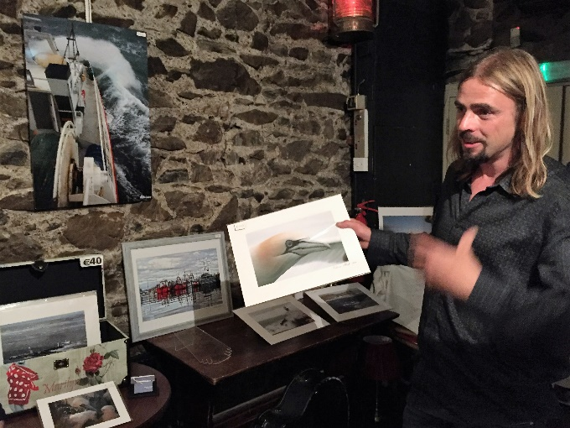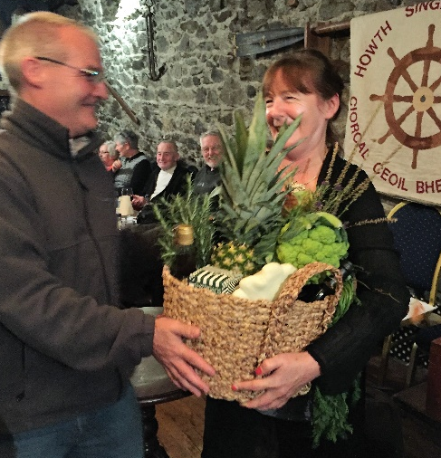
Pádraig Cuthbert with his wonderful photographs and Larry Bond presenting Ann Riordan with her winnings of the Harvest Basket

Songs of Water

Paddy Daly and Tony Fitzpatrick led a lovely night to start the new season in September. There were many fine songs and fine renditions. Tony McGaley – complete with steel drums and maracas – held the record for the most mentions of ‘water’ with ‘Water Come To Me Eye’ while Kieran Wade took us along the ‘Banks of the Moy’ and the ‘Banks of Newfoundland’. Jack Plunkett gave us the beautiful ‘Jeanie C – I’ll Go to Sea No More’ and his own ‘Salt Water; Tina Walden gave a great version of ‘Sweet King Williamstown’ and Angela Murray was in fine style with ‘Sweet Thames Flow Softly’ and ‘All For Me Grog’. Peter ‘The Racker’ Donnelly provided three very varied recitations featured Yeats and Gogarty, swimming with or without the assistance of textiles, and a moving tribute to the Lifeboat service. Walter Kennedy warmed his hands on ‘The Little Pot Stove’ and concluding the night by sailing out of ‘Old Whitby Harbour’. Some twenty four folk sand and for everyone a highlight was our first ‘One Singer, Three Songs’ spot from Eugene McEldowney. He sang Rabbie Burns’s ‘Dainty Davie’, Richard Thompson’s dark ‘Poor Ditching Poor’ and The Watersons’ version of ‘The Jolly Ploughboy (The Khaki and the Blue)’, the version before Dominic Behan got his hands on it and – as a memory of the night, here are Eugene’s words

Well I once was a merry ploughboy,
I was a-ploughing in the fields all day,
Till a very funny thought came to my head
That I should roam away.
For I'm tired of my country life
Since the day that I was born
So I've gone and join the army
And I'm off tomorrow morn.

Chorus (after each verse):
Hoorah for the Khaki and the Blue,
Helmets glittering in the sun,
Bayonets flash like lightning
To the beating of a military drum.
And no more will I go harvesting
Or gathering the golden corn,
'Cause I got the good king's shilling
And I'm off tomorrow morn

Well I'll leave aside my pick and spade
And I'll leave aside my plough,
And I'll leave aside my old grey mare,
For no more I'll need her now.
For there's a little spot in England,
Up in the Yorkshire dales so high,
Where we mast the good king's standard,
Saying, “We'll conquer or we'll die.”

But there's one little thing I must tell you
About the girl I leave behind,
And I know she will prove true to me
And I'll prove true in kind.
And if ever I return again
To my home in the country
I'll take her to the church to wed
And a sergeant's wife she'll be

‘Sing Now the Lusty Song of Fruit & Flowers’

Laurence Bond & Ann Riordan led a lovely night in October with its title drawn from William Blake’s poem from 1783, ‘To Autumn’.

O Autumn, laden with fruit, and stain’d
With the blood of the grape, pass not, but sit
Beneath my shady roof; there thou may’st rest,
And tune thy jolly voice to my fresh pipe,
And all the daughters of the year shall dance!
Sing now the lusty song of fruits and flowers.

The narrow bud opens her beauties to
The sun, and love runs in her thrilling veins;
Blossoms hang round the brows of Morning, and
Flourish down the bright cheek of modest Eve,
Till clust’ring Summer breaks forth into singing,
And feather’d clouds strew flowers round her head.

The spirits of the air live in the smells
Of fruit; and Joy, with pinions light, roves round
The gardens, or sits singing in the trees.”
Thus sang the jolly Autumn as he sat,
Then rose, girded himself, and o’er the bleak
Hills fled from our sight; but left his golden load.

As requested, Club members brought a cornucopia of delights to fill a number of Harvest Baskets and, to mark Ivy Day and memories of Charles Stewart Parnell, Brain Doyle thoughtfully dressed each table in strands of ivy. A further treat was the exhibition of Pádraig Cuthbert’s wonderful photograph of Howth’s maritime and wildlife heritage. As all this was not enough, there was some mighty singing topped off by Tony Fitzpatrick’s excellent ‘One Singer, Three Songs’ spot.

Among the twenty-five singers, Brian Doyle, appropriately, began the night with ‘Avondale’ while Máire Ní Bhaoill begged us ‘Please Forget Me Not!’ Bernie Dermody travelled up from Portlaoise to sing ‘Sweet William, Thyme & Rose’, Martina Nic Cearnaigh mowed ‘Pat Murphy’s Meadow’ and Helen Lahert remembered ‘Jamie Foyers’. Stiofán Ó hAaoláin chan 'Cuisle Mo Chroí' agus Brenda Ní Ríordáin chan ‘Pléaráca na Ruarcach’, an chéad amhrán macalla de Diarmuid Ó Súilleabháin. Laurence Bond reaped rushes, Antoinette Daly wondered where all the flowers had gone and Irene Bagnel chased ‘Heather Down the Moor’. Siobhán Moore charmed with ‘The Irish Girl’ and Larry O’Toole told of the heroic Mayfield men.

Tony Fitzpatrick’s spot was high class. He began with Liam Weldon’s ‘Dark Horse on the Wind’, then faced the perils of the ‘Greenland Whale Fishery’ before – it would have to be said, very lustily – concluding with ‘The Kerryman’s Rambles’. He chose three great songs and delivered them beautifully. Folk left feeling that had enjoyed a special night.

Betwixt & Between

Helen Lahert & Siobhán Moore led a night on which many showed great imagination in conjuring up songs that fitted what, at first, appeared an obscure theme. Tony McGaley, resplendent in ‘The Little Shirt Me Mother Made For Me’, and Brian Doyle, singing the classic ‘Unquiet Grave’, brought widely differing moods to the night. Tony Fitzpatrick – perhaps with a sense of what was to come across the Atlantic – sang ‘Save Vietnam from the Vietnamese while Maridhe Woods celebrated Bob Dylan’s Nobel Prize with one of his many great songs. Mary McCarthy recited Joseph O’Connor’s ‘The All Souls Hotel’ to remind us of Féile na Samhna and Siobhán reflected on ‘The Nobleman’s Wedding’. Helen wondered what was keeping her now and Walter Kennedy couldn’t help wondering where he was bound! Gerry O’Connor’s fields lay silent; Andy Burke’s Kitty was trying to remember him; and Tom Finn thought today was the today. Antoinette Daly, Laurence Bond, John McGee, Aoife Caomhánach, Manus O’Riordan – a great re-work of Wilfred Owen, Joyce Mahon and Philip O’Connor were among the thirty-six items on the night.

Fiddle Bus 4

Fiddle Bus 4 will be based in the Deeside Inn, Ballater, Scotland from Thursday/Friday 20-21 April to Sunday 23 April, 2017. A Formal Concert will be held in the Burnett Arms, Banchory on the Friday to raise funds for the James Scott Skinner statue to be erected in the town. The Fiddle Bus itself will travel from Balleter south to Blair Castle and Dunkeld, our main interest the life and work of the great Scots fiddle player Niel Gow. An informal session in the Coilacriach Inn on the way back will be followed by dinner and session in the Deeside Inn.

Arrangements are finalised but anyone interested in travelling, please let us know as early as possible. Early booking of flights and accommodation is advised, not least to cut travel costs.

1916 in Howth, Sutton, Baldoyle

Philip O’Connor, Road to Independence – Howth, Sutton & Baldoyle Play Their Part, (Coiste Comórtha 1916 Binn Éadair, Cill Fhiontan, Baile Dúill, 2016),

As a young boy I would often be taken by my parents to visit a family friend – Fanny Cooney (née Harford) of Balglass, Howth. I was a little shy of her because she spoke to me in her fluent Irish and my school Irish was poor. But she was a very likeable old lady and as I got older I was intrigued by her as my father told me she had been ‘out’ during the Troubles in the 1920s. Fanny’s daughter Bernadette Cooney wrote a little about her but now the gaps have been filled in regarding this brave woman and many, many more women and men who played their part in the revolutionary years 1913-1923. Philip O’Connor’s book must rank as one of the finest and most important works of history published during the 1916 Centenary year. For people from Howth, Sutton and Baldoyle, or connected with the area, it is fascinating with its details of participants with familiar surnames from familiar places. For the general Irish history reader it gives a totally absorbing and very detailed picture of the years of turmoil in one local area. And all shades of political opinion, including the significant local Unionist voices, are covered.

Howth, Sutton and Baldoyle were uniquely positioned close to the capital city yet set in what was then predominantly rural North County Dublin. Their communities were destined to figure prominently in the dramatic events. Philip has rediscovered and retold the story of the farm labourers’ struggle in Baldoyle where there was an active branch of the Irish Transport & General Workers’ Union (ITGWU) and a unit of the Irish Citizen Army (ICA). Baldoyle ICA Volunteer James McCormack was killed in the battle of Moore Street during Easter Week 1916.

The book is comprehensive on the entire period covered. I found especially interesting the chapter on the First World War. So-called ‘revisionist’ historians have often downplayed the extent to which recruitment to the British Army was resisted and how, after an initial surge, it declined, influenced both by the senseless slaughter in the imperialist conflagration and by political events at home as separatism grew in influence, with the growing realisation that the Irish people had been dragged into the war by the British government.

Frances Harford married Joseph Cooney, also a Republican, and was active in Cumann na mBan locally. I, and no doubt many others, owe to her our interest in the Irish language. To Fanny and her comrades locally and nationally we also owe the degree of freedom obtained and the inspiration to work for the full implementation of the 1916 Proclamation of the Irish Republic.
Mícheál Mac Donncha

Mícheál MacDonncha is Sinn Féin Dublin City Councillor serving the Donmaghmede Ward

James Connolly’s Under Which Flag? in Liberty Hall

James Connolly’s play Under Which Flag? was performed in Liberty Hall on 15 October last. Originally played in March 1916, its lead actor Seán Connolly – no relation to James – led the Irish Citizen Army detachment to City Hall in Easter Week and was shot dead on the building’s dome. The play was directed by Kevin McGee and presented and produced by Bryan Murray with the cast of Steve Cash, Brendan Conroy, Steve Gunn, Donna Anita Nikolaisen and Frank O’Sullivan, together with Sabina Coyne-Higgins who was presented with Honorary Life Membership of Irish Actors’ Equity. A musical presentation followed with our own Francy Devine singing with Ciarán and Pádraig Óg Mac Aodhagáin [fiddle and pipes], Teresa O’Donnell [harp] and cast members. The rendition of Patrick Galvin’s ‘Where O Where Is Our James Connolly’ was very moving.

Down By the Liffeyside – City Hall Lunchtime Lectures
– And the Ha’penny Bridge

On the four Tuesdays in October, Howth Singing Circle’s Francy Devine arranged four lectures on ‘Traditional Music in Dublin’ together with Mary Clarke, Dublin City Archivist. The talks were: Liam O’Connor, ‘Fiddle Music in Dublin’; Terry Moylan, ‘Dublin’s Piping Tradition’; Seán Corcoran and Finbarr Boyle, ‘The Tradition Club, 1967-1989’; and Francy Devine & Jimmy Kelly, ‘A Voice Like No Other: Luke Kelly’. Each week a song was presented: Fergus Russell, ‘Rags Upon the Poddle’; Anne Buckley, ‘The Night Before Larry Was Stretched’; Aoife Dermody, ‘Dark Horse on the Wind’; and Dave O’Connor, ‘Hannah Healy the Pride of Howth’. HSC regular Councillor Larry O’Toole chaired one session and Lord Mayor Brendan Carr the last talk. The series was hailed as a great success and brought knowledge and understanding of traditional music in Dublin to a wide audience.

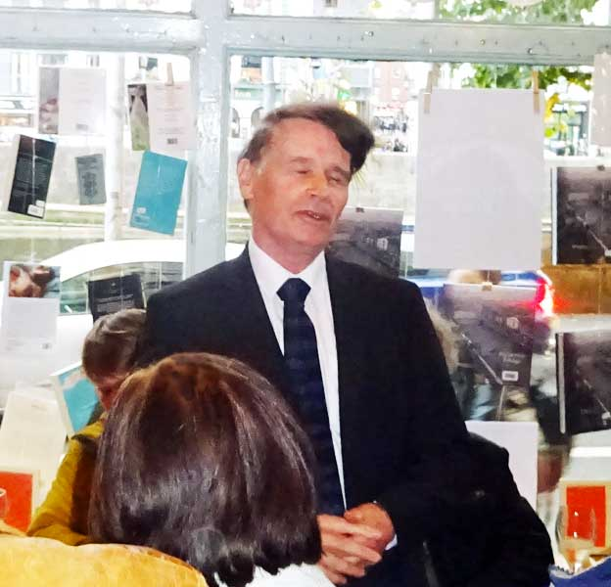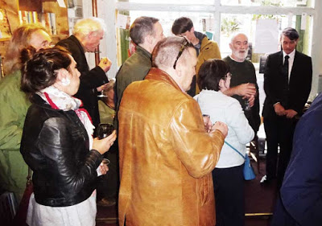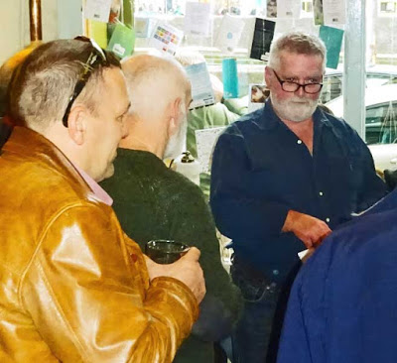
Seán, Tony and Éamonn crossing the Ha’penny Bridge in song

Tony Fitzpatrick, Éamonn Hunt and Seán Ó hEarcháin read and sang – to great acclaim – at the crowded launch of Michael English’s The Ha-penny Bridge, Dublin, published by Dublin City Council in association with Four Courts Press. Howth Singing Circle were asked to arrange the performers and the three lads’ splendid singing and reciting certainly added to the Circle’s reputation.

On Inis Meáin – Poems From Mick Fowler

Mick Fowler has sent The Sweet Nightingale three poems inspired by his stay on Inis Meain with Fergus Russell. The poems were written during Mick’s stay on 27 August, 2015 and then subsequently on 2-3 November.
On Inis Meáin

for Fergus Russell)

I. Stone Bramble

Passing abundant Oxeye daisy
- Leucanthemum Vulgare, Nóinín Mór -
On the roadside by Dún Fearbhaí
On Inis Meáin in Aran
A glint catches my eye - Stone Bramble,
With leaves like strawberry leaves
Sparkles in the sunshine
It's ruby red sacks in rich clusters
Of juicy red fruits, ripening in late Summer
- Rubus Saxatilis, Sú na mBan Mín .

II. Six-Spot Burnet

Crossing a grey-stone wall
At a stile on our walk
And on the stile I spy
A Six-Spot Burnet moth
Delicate, fragile, yet rugged beauty;
Minutes later
On a stone chair as we rest-
An Icumen Fly
With stick-like tail as a scorpions,
Fergus informs me,
Used for boring into trees.
And the tough Burren flora
Weave aquiver in limestone pools

Dublin, November 2nd, 2015

III. Pyramidal Orchid

He had taught me the name
Of the Moth on the stile
And also the part of the Fly
Used for boring into a tree.
But as we tread his two small fields
The site for his house on Inis Meain
Among the meadow to be kept untouched
I spot an Orchid he had missed before
The Pyramidal Orchid
Carmine purple in shadow
Anacamptis Pyramidalis
Magairlin na Stuaice.

Dublin, November 3rd, 2015

Buíochas Mór

As ever, The Sweet Nightingale does not just appear. Thanks must be given to the Howth Singing Circle Committee – Laurence Bond, Paddy Daly, Brian Doyle, Stiofán ÓhAoláin, Diarmuid ÓCathasaigh, Gerry O’Connor, Niamh Parsons, Ann Riordan and Fergus Russell; to Paddy Daly for photographs; to Niamh Parsons for uploading the newsletter to our website; and to Mick Fowler and Mícheál MacDonncha for their contributions.

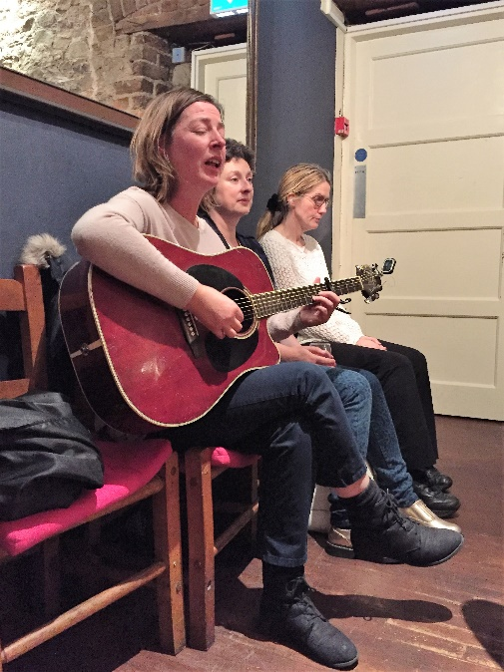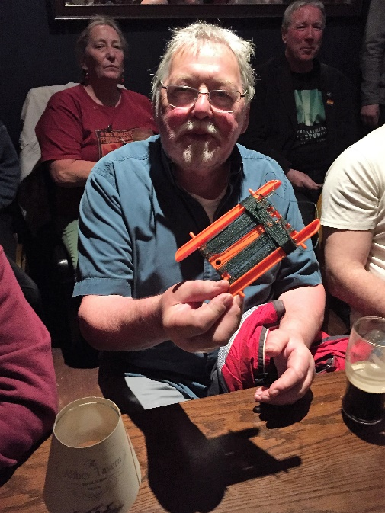

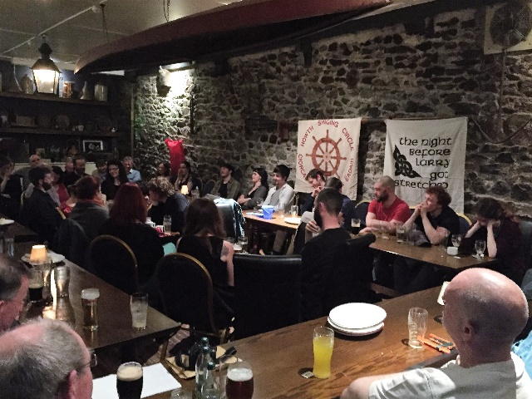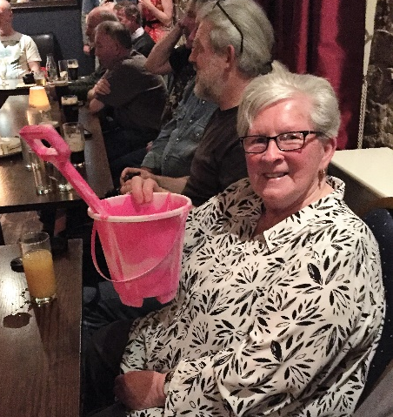
Top: Siobhán Moore with ‘The Irish Girl’ and Jack Daly winning something he always wanted!
Bottom: part of the big crowd when The Night Before Larry Was Stretched came to the seaside and Nellie Weldon all set for Claremont Beach!

Thank you for supporting the Howth Singing Circle

We welcome all suggestions for ways of improving our events so feel free to give us your views

HOWTH BURNS NICHT 2017 –
Saturday, 21 January
with Special Guests from Scotland,
the SIOBHÁN MILLER BAND

