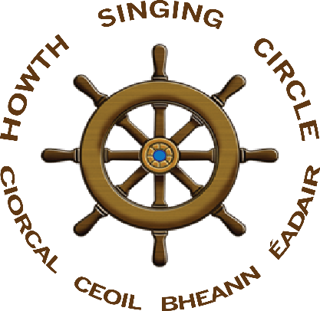
The Sweet Nightingale
New Series, no 4, May 2016

President Willie D.

At the April session – Niamh Parsons’ conducting ‘Easter Snows’ – the highlight was the inauguration of Willie O’Connor as the first Uachtaráin Ciorcal Ceoil Bheann Éadair in honour of his approaching ninetieth birthday and in appreciation of all he has contributed to the HSC over many years.

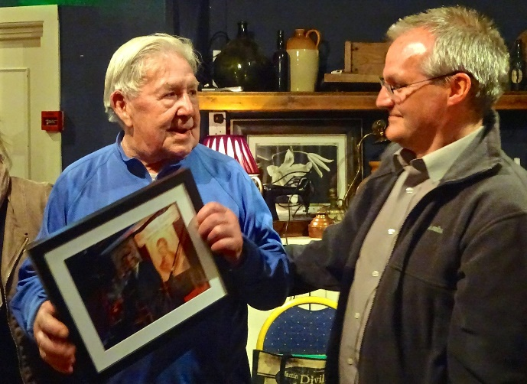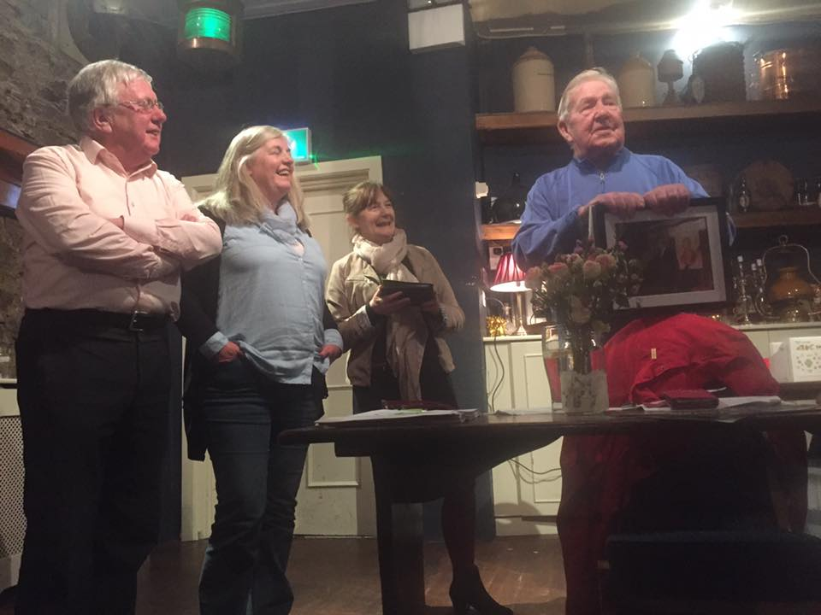
Laurence Bond, Gerry O’Connor, Niamh Parsons & Ann Riordan with President O’Connor

The night welcomed back Eugene McEldowney from his estates in Spain and he sang ‘Twas On One April Morning’ and the rousing ‘Young Banker’ to remind us of what we have been missing. Laurence Bond echoed the previous weekend’s Fiddle Bus by performing Johnny Doherty’s version of ‘Moorlough Mary’ and also went home with Paddy Tunney’s The Stone Fiddle, a prize offered by Diarmuid Ó Cathasaigh to anyone who could name the four tunes he played on the harmonica. Other notable performances came from Tony Fitzpatrick, ‘The Banks of Newfoundland’; Drogheda’s Irene Bagenal, ‘The Isle of France’ and ‘The Two Constant Lovers’; Martina Nic Cearnaigh, ‘John Adair’; Eddie Phillips – in honour of our new President – ‘Away From the Roll of the Sea’; Liam Ó Droma, ‘Rodaí Mac Amhlaigh’; Úna Kane, ‘Galway to Graceland’; Robert Kelly with the haunting ‘Back in the Westport Way’; Walter Kennedy, harking back to Martyn Wyndham-Read, was tormented by ‘The Creaking of the Saddle’; and Tony McGaley’s wry reflections on the Decade of Centenaries, ‘The Fall of the Empire’. Over thirty songs were sung but the highlight, naturally, was President Willie with ‘My Kathleen’ and ‘Down By the Sally Gardens’. It was a lovely night and a fitting tribute to a lovely man.

New Version of HSC Logo

At the top of this edition of The Sweet Nightingale is a new version of our logo, designed by Richard Tobin of the Abbey Tavern and available to us for use. Our sincere thanks to Richard who did the re-work when designing the much sought-after light shades that adorned the tables at the Burns Nicht. They were in such demand that there were none left at the end of the night!

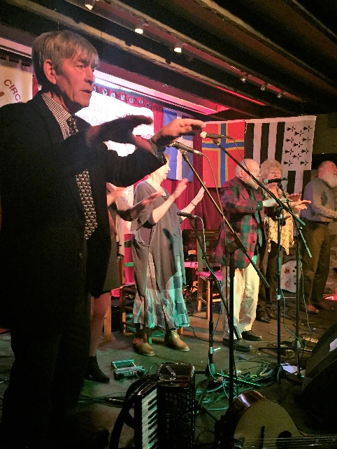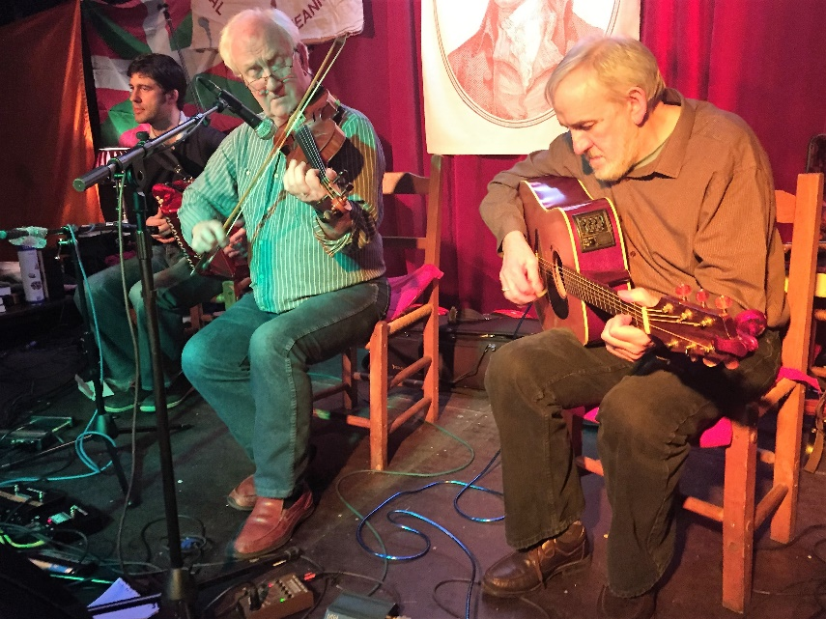
Dave McCracken, Ann Riordan, Sheila Bentham, Janet Weatherston and John Bentham support Billy Jolly and ‘The Old Balena’; and our fabulous Resident Band, Larry Egan, John Kelly and Michael Mullen

‘Twas in Sweet Senegal - Burns Nicht 2016

It is hard to gauge one Burns Nicht against another but general feedback suggests that many found the 2016 event to be up there among the best. The five women who contributed the Burns section set the bar very high. Anne Fitzpatrick recited ‘Tae a Moose’ and Ann Riordan ‘Address Tae the Woodlark’ while Angela Murray sang ‘Ye Banks & Braes o Bonnie Doon’ and Eibhlís Ní Riordáin ‘Ae Fond Kiss’, this latter one of the individual performances of the night. The section concluded with Graham Dunne and Niamh Parsons’ contributing ‘The Slave’s Lament’ – from which the night’s title ‘Twas in Sweet Senegal’ was taken – and a track from their newly pressed CD Kind Providence.

The first of two musical spots was provided by John Kelly (fiddle), Larry Egan (accordion) and Michael Mullen (guitar). It is regretted that many of the audience take this as a cue to talk as the quality of the tunes played was extremely high. At least many took the chance to dance – both waltzes and a set – as indication of their appreciation of perhaps the most under-valued element of the Howth Burns Nichts. At a quarter to ten came the undeniable highlight when Pipe Major Noel Kelly led in the St Lawrence Howth Pipe Band. The room fills with swirling kilts, skirling pipes and birling senses. It is a spectacle that excites and raises everyone to their feet. The Band came in playing ‘Colin’s Castle’ and ‘Castle Danish’, their second set being ‘A Man’s a Man For A’ That’, ‘The Green Fields’ and ‘The Battle’s O’er’. After a wee break, Noel Kelly played the lament ‘Tommy Tully’s Air’ in memory of departed family and friends before a demonstration of drumming. Noel and Agnes Kelly played ‘The Inner Guard’, ‘Let Erin Remember’, ‘The Old Rustic Bridge’ and ‘Scotland the Brave’ with Robert Doyle and Tommy Clancy on side drums and John Carton on bass. The stars, however, were the young tenor drummers Amy Higgins and Jane, Laura and eight year old Eva Garbutt. It was a magical moment.

Morag Dunbar (Kirkcaldy & Edinburgh) addressed the haggis in stunning fashion and you can see and hear her do so at https://www.facebook.com/AbbeyTavernHowth/?fref=ts&ref=br_tf It is rare to hear a woman do the ‘Address’ and we are proud of Morag and grateful to her long-standing support of our event – together with her pal Janet Weatherston (Dalkeith) and friends. Tunes from Diarmuid Ó Cathasaigh and songs from Frank Speirs (Glasgow & Portsoy), our own Willie O’Connor, Luke Cheevers and – as Gàidhlig – Stiofán Ó hAoláin completed the first half.

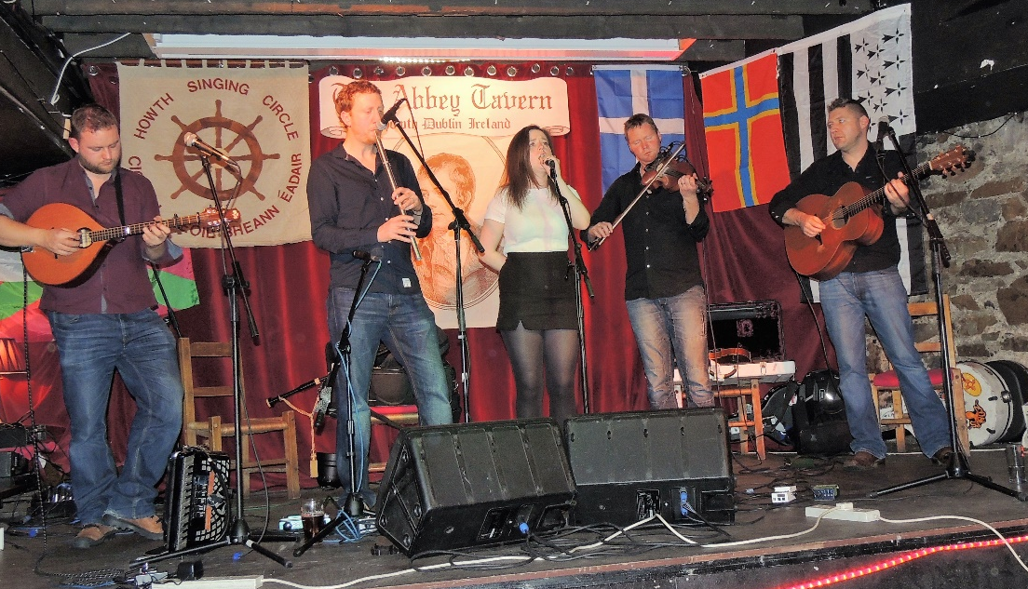
Ellen Macdonald singing with Murdoch Cameron (mandola), Angus McKenzie (whistle), Gabe McVarish (fiddle) and Ross Martin (guitar) – our very Special Guests, Dàimh

Three songs were chosen to commemorate the 1916 Rising: Lawrence Bond ‘My Old Howth Gun’, Catriona Crowe ‘The Foggy Dew’ and Fergus Russell ‘Where O Where is Our James Connolly’. This was a powerful element of the event, the atmosphere in the room a mixture of the sombre and the proud. It was in marked contrast to the unbridled joy that greeted the last set from our main guests Dàimh. Based in the West Highlands and Western Isles, the group consisted of Ross Martin (guitar), Murdoch Cameron (accordion and mandola), Angus McKenzie (bagpipes and whistle) and Gabe McVarish (fiddle), with vocals from Ellen Macdonald who charmed the audience from the outset. Ellen’s signing of ‘Gur e Mo Ghille le Dubh Dhonn’ was enchanting and you can gear it here https://drive.google.com/file/d/0B66bcHYiy3J4Z3pRbDBTUll0Vlk/view?pref=2&pli=1

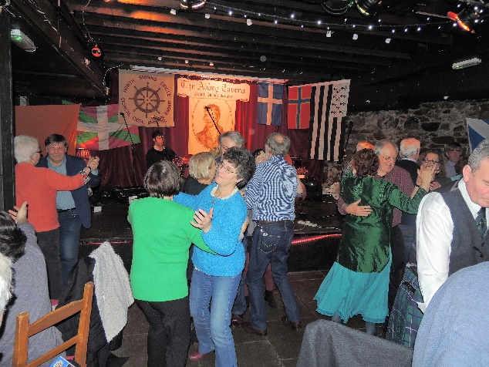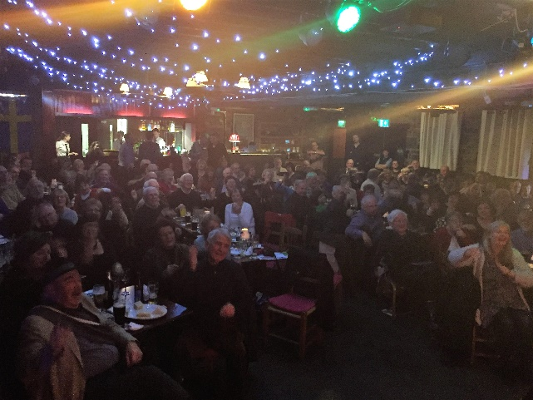
The real stars of this and every Burns Nicht - yersels

The finale was begun by Dàimh slowly assembling a mighty crescendo with Angus leading off with elements of the celebrated pibroch ‘Lament for the Children’ which you can be thrilled by again here https://www.facebook.com/francis.devine.77 Perhaps few in attendance would have been familiar with Dàimh before the night but the consensus among folk leaving was that they had witnessed very special talents and the Howth Singing Circle is proud that it could support artists who have committed to much to their area and to gaelic culture. Other visitors impressed, however. Billy Jolly (Kirkwall, Orkney) led his crew – Dave McCracken, John & Sheila Bentham (Loughborough), Ann Riordan and Janet Weatherston – and thence the audience in his all action version of ‘The Old Balena’. Dave McCracken (Tarset, Northumbria) kicked off the singing finale with ‘Fare Thee Weel Regality’ with Fergus Russell leading the charge of ‘The Bonnie Light Horseman’. Kathy Hobkirk (Hawick) then took us through the swinging arms and folding arms of ‘Auld Lang Syne’ to conclude a memorable four and half hours of non-stop entertainment of the highest quality.

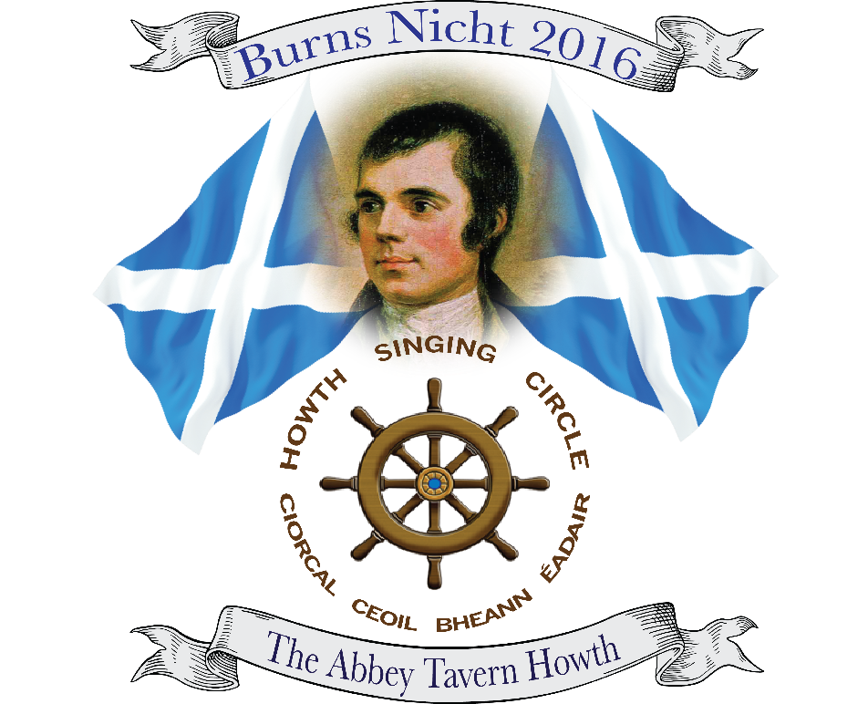
Richard Tobin’s eye-catching design for Howth Burns Nicht 2016

In the Angling Club the following day, Niamh Parsons and Gerry O’Connor conducted the Fare Thee Weel Session. A little down in numbers, the quality of the singing was of the highest order with highlights from Tony Fitzpatrick, Seán Ó hÉaracháin, Kevin Shelly, Máire Ní Chróinín, Corinne Male (Ibstock, Leicestershire), and Majella Mullarkey. The friendship, good humour and joy in each other’s company epitomised what the Burns Nicht weekend has come to be.

Lastly, thanks must be extended to Richard Tobin, Allison O’Rourke & staff, Abbey Tavern; Gabriel & Peter in the Howth Sea Angling Club; Chris Boland for sound – which despite some technical difficulties beyond his control was excellent; Christy Hammond and CRM Design & Print; Finola Young for donating hampers to the raffle; Dave McCracken for unspoken generosity; John and Sheila Bentham for erecting the flags and banners and other behind the scenes work; Ricky Higgins for making the presentation haggis; Ann Riordan for the thankless task of handling ticket sales; our presenters Fergus Russell, Niamh Parsons and Gerry O’Connor; and all the other members of the Howth Singing Circle Committee Lawrence Bond, Paddy Daly, Brian Doyle, Diarmuid Ó Cathasaigh, Stiofán Ó h Aoláin and Niamh Parsons.

Most of all, of course, special thanks to all of you who attended the events and in other ways supported the Club inn all its endeavours.

Aodhán Ó Ceallaigh

San Abbey Tavern a bhíomar agus aoi speisialta Aodhán Ó Ceallaigh óna Déise againn. Thosaíomar ag 2130 mar as gnáth le roinnt amhránaí ón t-urlár.Bhí meascán maith ann idir amhráin ar an Sean-Nós agus na cinn Béarla, Léigh Seán Ó Meara dán iontach a scríobh sé féin in ómós do Phádraig Ó Connaill, fear a d'fhreastail HSC anois is arís agus a raibh ina fhear an tí uair nó dhó. Fuair sé bás go tobann um Nollaig.Go raibh dheis Dé ar a anam. Sula i bhfad bhí Aodhán Ó Ceallaigh ina sheasamh i lár an t-úrlar ag tabhairt blaiseadh beag amhráin na Déise dúinn. Chas sé trí amhráin agus chuamar ar ais go dtí an t-urlár le haghaidh tuilleadh amhráin iontach idir Gaeilge agus Béarla óna sár amhránaí a tagann amach go Binn Éadair beagnach chuile mí.

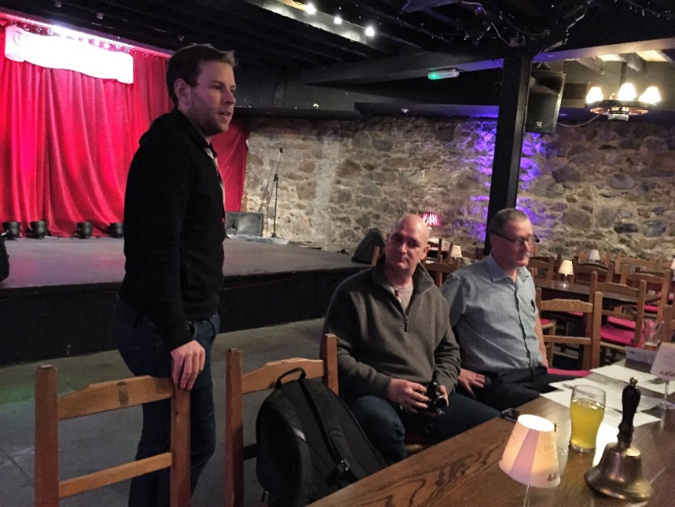
Aodhán Ó Ceallaigh, Stiofán Ó hAoláin agus Liam Ó Droma

Ar ais arís go Aodhán Ó Ceallaigh agus chas sé ceithre amhráin dúinn, ceann a fuair mé óna mhathair deich mbliain ó shin 'An Sciúirse'.Níor fuair mé deis chun é a fhoghlaim go dtí anois agus tá súil agam go mbeidh mé in ann é a chur ar mo ghlanmheabhair ceann de na laethanta seo. Go raibh míle maith agaibh go léir a tháinig amach agus Nár laga Dia sibh.
Stiofán Ó hAoláin

As a great memory of the night, you can see and hear Aodhán sing ‘An Sciúirse’ on Stiofán’s video at https://www.youtube.com/watch?v=iwfm_tSnFWI&feature=youtu.be

A Forgotten Hero? Michael Davitt

One of the forgotten heroes of the Land War and national movement was Michael Davitt. He was the second of Martin and Catherine Davitt’s five children and born in Straide, County Mayo on 25 March, 1846, the height of the Great Famine. In 1850, the family were evicted and ended in the Workhouse. Fearing separation from her children, Catherine led the family to emigrate, eventually settling in Haslingden, Lancashire. From nine years old, Davitt worked in textile mills. On 8 May, 1857, his right arm was trapped in a cogwheel at Stellfoxe’s Victoria Mill, Baxenden, and it was amputated. He received no compensation but was sponsored by John Dean to receive an education, working in a Post Office from 1861 and learning to typeset and book-keep. Davitt also attended the Mechanics’ Institute, reading voraciously and discovering Ernest Jones, Chartism and other radical ideas.

In 1865, Davitt joined the Irish republican Brotherhood (IRB) becoming Organising Secretary for Northern England and Scotland. He was involved in the failed Chester Castle raid on 11 February 1867 and sentenced to fifteen tears penal servitude in Dartmoor. After years in solitary, he was granted a ‘ticket of leave’ on 19 December 1877, receiving a hero’s welcome in Ireland. Davitt became a member of the IRB Supreme Council, toured America and returned to Mayo in 1879 to lead the land agitation. At Irishtown on 20 April, the Land League was begun, formally being founded in Castlebar on 16 August. The Coercion Act led to much repression and Davitt was elected MP for County Meath but disqualified as he had been returned to prison where he developed his theory of land nationalisation.

Davitt founded and edited Labour World in September 1890 and initiated the Irish Democratic Labour Federation in Cork in 1891. He was elected to Westminster in North Meath, 1892; North East Cork, 1983; and South Mayo, 1895. He supported Home Rule and welcomed Keir Hardie’s new Labour Party. He resigned his seat over the Boer War but remained a highly influential thinker and writer. After the Labour Party successfully contested the 1906 General Election and held the balance of power, Davitt came to Dublin but died in Elphis Hospital on 30 May from blood poisoning, aged only sixty. He is buried in Straide where the Michael Davitt Museum is now housed.

Our guest on the night, Dónal Maguire, originally from Drogheda but long resident in Haslingden, illustrated Davitt’s life with images and songs from the times in an absorbing presentation. Among the songs Dónal sang were ‘An Druimfhionn Donn Dílis’, ‘Michael Murphy’, ‘Davit’s Lover’s Lament’ [‘The Banks of the Moy’], ‘Hold Your rent, Hold Your Harvest’, ‘Lord Leitrim’, ‘The Wife of the Bould Tenant Farmer’, ‘Erin’s Lament for her Davitt a Stór’, and ‘The Trial of John Twiss’. Maguire is a fine singer, studied and clear. The songs told their tale of a great man, one whose loss is scarce considered in the Decade of Centenaries.

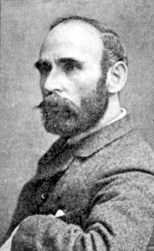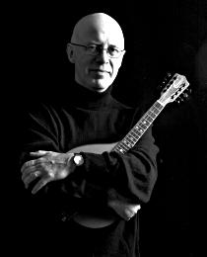
Davitt & Maguire

The session opened out after the formal presentation and, among many songs of as high standard, Micheál Quinn maintained the theme with ‘The Manchester Martyrs’; Tony Fitzpatrick delivered emigrant letters from ‘Kilkelly, Ireland’; Angela Murray rekindled the textile mills with ‘The Jute Mill Song’; Tonyum McGaleyum sang a songeum most funnyum and the Real Gerry O’Reilly was equally amusing; Laurence Bond pined for his ‘Collier Laddie’; and Helen Lahert sang ‘This Land is Your Land’. Maguire, free from the constraints of Davitt, sang again, impressing all with his diction, timing, phrasing and range of song. It was a fine night and a great tribute to a Forgotten Hero.

Pádraig Ó Conaill

Ár mbuíochas le Stiofán agus Liam Ó Droma haghaidh oíche amhránaíochta an- mhaith . Chomh maith leis sin le Seán Ó Meara as a dhán i gcuimhne ar Pádraig Ó Connáill , tá Bhinn Éadair rialta Ciorcal Amhránaíochta.

Marbhna Phádraig

le Seán Ó Meara

Conus a déarfainn, a Phádraig, nár lig gearrfhógra an bháis
Deis dúinn ‘slán leat’ a rá?
Meabhrach nach ‘slán’ nó fiu ‘goodbye’, a bhí ann
Ach deire ár scéil le céile sa saol seo
Idir cheol, bhéarsaíocht is craic,
Béaloideas Chiarraí gur mhian leat a roinnt linn;
Bhí an teach solais múchta gan fhios ag na báid
Nó fiu coinneall Nollag fágtha i bhfuinneoig
Chun tú a sheoladh thar teorainn an bháis;
Tá an Seanchaí imithe uainn,
An droighneán scratha ós na fréamhacha
Is na síoga, scaipthe go deo.

Crann beithe ina cholgsheasamh, ceann san aer
B’sin an Conalach grinnsúileach caoin;
Na cosa ag bogluascadh le port nó ríl
Srón iolarach árd an ghliaire spóirt,
Briathra á scaipeadh mar duilliúr fomhair
I gcanúint ceolmhar Deiscirt Chiarraí;
An bród a choimeád beo thú, a Phádraig,
Ach cá rabhamar, nach bhfaca lomadh na ngéag?
Bhíomar báite sa seanchas is draíocht an scéalaí!
Nuair a scríobh tú marbhna an Chláirínigh dhil
Ní raibh súil agat bheith á leanadh gan mboill
Tú fhéin is Jimmy Smyth i bhFlaitheas na nGael
Is bhúrmbeirt le céeile in ndichuimhne rainn.

Pádraig Ó Connaill as Baile na Sceilg, iar Fear an Tí, Clasach Cluainn Tarbh. Ar dheis Dé go raibh a anam.

Ruth Clinton, This Fearless Maid

No two folk clubs, sing-arounds, open night sessions etc. are the same. ‘Well, we all know that’, you might say but what I’m getting at is the way they are run. Tigerfolk, for instance, is probably the only club that has two intervals and three halves. There are clubs that are just sings and do not have guests, others that just have guests. Some will pass a stick, a cap or some similar object round that is handed from performer to performer. Others will just let the night flow with people jumping in to entertain whilst you may go somewhere and you find that someone is nominated to play, sing or tell by the previous person. You will find clubs that have any number of associated activities like morris, mumming, social dancing and the like but here is one singing circle that has perhaps taken things a bit further.

The Howth Singing Circle not only has sings, guests, fund raising events for local charities, a dinner dance and a Burns Nicht but also a ‘Young Singer in Residence’. Ruth Clinton is currently in residence and is making a fine job of it too. A singer in the traditional style that belies her young years, she has won recognition not just locally but nationally and Ruth is no slouch when it comes instruments either. Her singing career has recently developed with the forming, along with three other women, of Landless who are achieving recognition in their own right. Not content with that Ruth has joined with others to open a young singers club in Dublin at the Cobblestones called The Night Before Larry Got Stretched. But there’s more because Howth Singing Circle asked Ruth to research songs on a theme of her choice and the very interesting book This Fearless Maid is the outcome.

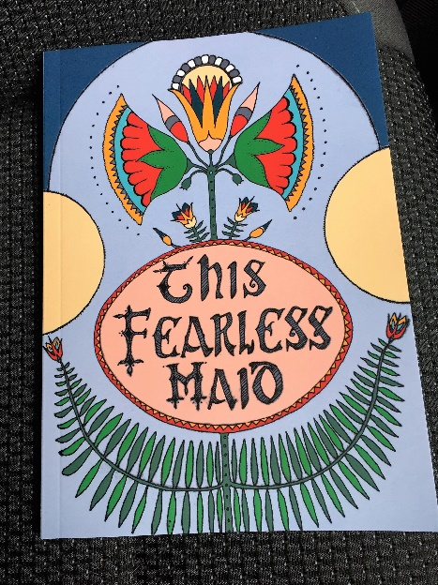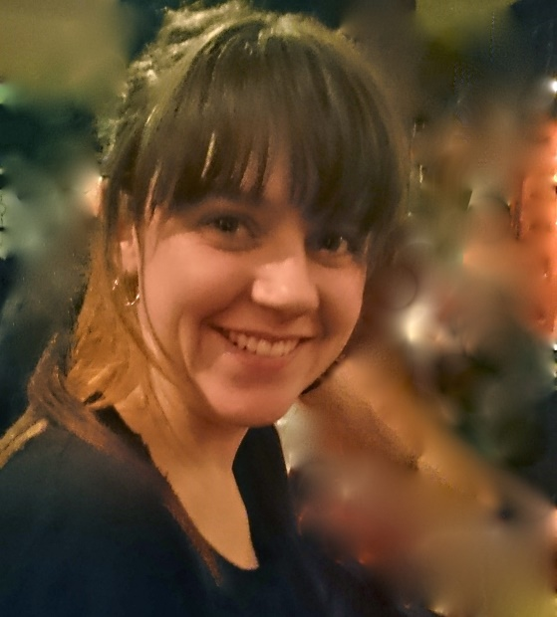

To quote Ruth, ‘I decided to make things difficult: to find songs that feature a woman who is not defined by her relationship to a man. Specifically, this might be a song written by, about or from the perspective of a woman, which does not involve any romance. In addition, the song must have been written before 1950 and be in the English Language’. Straight forward then! The subject matter varies greatly from nationalism, working women, death, emigration, war and the super-natural and all the fourteen songs are from printed sources and come with brief but informative notes. Now, if it wasn’t for Ruth the majority of these would, in all probability, still be languishing in unopened tomes atop unfrequented shelves. So good on her for bringing them to our attention and for those looking for something a bit different, how’s about ‘The Female Duel’ or ‘The Witchcraft Murder’ based on a true story of a woman roasted alive in County Tipperary?

The book has been published by the Howth Singing Circle and does credit both to Ruth and themselves. It deserves the widest audience. And if HSC is looking for another project, maybe the next step would be a CD of Ruth singing the songs to promote This Fearless Maid.
John Bentham

Kind Providence: New CD from Niamh Parsons & Graham Dunne

Across all genres of music mention a performer, a tune or a song and very often associations are made. In the mind(s) of the person or people you are talking with a particular artist is synonymous with an air, a certain ballad etc. Now, if you mention Robert Burns’ ‘The Slave’s Lament’ the singer who immediately springs to my mind is Niamh Parsons. It was some eight years ago when Niamh and Graham were guests at Tigerfolk, Traditions at the Tiger as it was then, that I first heard them perform this wonderful song and it took my breath away, and do you know what, it still does. So I am absolutely delighted to hear it on Kind Providence.

May I suggest one of the best ways of listening to this fine CD? Pour yourself a decent measure of a single pot still whiskey and luxuriate in its complex flavours whilst being seduced by the singing of Niamh and the most subtle and understated of guitar accompaniment courtesy of Graham. Journeys either short or long wend their way through this recording from the epic disastrous retreat across Spain as described in ‘The Road to La Coruna’ to ‘Sweet Daffodil Mulligan’ although her trip to Pine Forest appears to have been very brief. We travel with lovers, sailors, soldiers, emigrants, patriots, slaves as well as Biddy Mulligan’s girl Daffodil (Don’t I just love her).
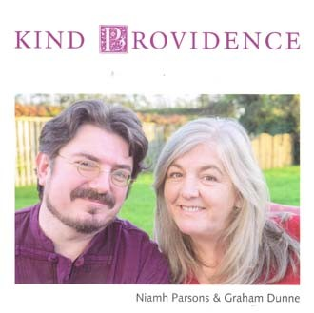
For all his background work Graham is rewarded with the chance to shine when he is given his head when playing ‘The Monaghan Jig’ which has extra tricky and twiddly bits that are studio based. As for a favourite track, well, ‘The Slave’s Lament’ is mine but there’s not much more than one of Niamh’s fag papers between any of the tracks for it is a joy from start to finish. And do you know what makes it better are the short, clear and concise notes that are easily read between sips from the glass that you have to hand.

With Kind Providence Niamh and Graham deserve to reach a wider audience and I cannot recommend it highly enough.
John Bentham,
Tigerfolk Traditional Folk Club, Long Eaton

‘It’s Just Me Saggin’ Shelf’ by the Raytown Rambler

Charisma? - Yes, lots; Humour? - Yes, but I don’t know about those jokes; Character? – Loads of it. The fact that the late Mary Phelan produced eight one-hour programmes on Luke Cheevers for Dublin Radio South last year, says it all. So, what can I say in reviewing this CD , having spent many singing weekends in his great company over 30 years – whether journeying to Donegal, Armagh or Clare in ‘McGann-the-Van’s Hiace or O’Murchu’s Jolly Jalopy? ‘The man”, as Róisín Gaffney said, ‘is a treasure’. So, to review a recording of his would not reflect properly a singing performance by him. One has to experience him in a ‘live’ situation at a session- pure entertainment, often acting out the participants in the story of the song. Comparisons to Mick Quinn would not be out of place.

Now to review the songs: ten of these are humorous, showing Luke’s preference for one of life’s essential elements- to have ‘a bit of gas!’ His regular rendition of ‘Purty Molly Brannigan’ is here replaced by James Joyce’s parody of the same, titled ‘Buxom Molly Bloom’. His wide-ranging reading material includes The Odyssey and The Iliad, and the former is reflected by the inclusion of Robin Laing’s composition Ulysses, preceded by Simon Armitage’s poem on the same. An admirable trait is to compose an additional verse which enhances a song, for example, a popular one that may be too short. That said, the number with added verses is a surprise, five in all: Innisfaddie’s Annie, Miss Mousie’s Ball, Fall Down Billy O’Shea, The Country I’m leaving Behind and Sargeant William Bailey.

A high regard for songwriters is evident, as ten are included, from the little-known Frank McCrory (The Treacherous Waves of Lough Muck) to the famed Peadar Kearney (Sargeant William Bailey), the latter song being topical in showing the anti-recruitment movement in Ireland during the Great War and the Easter Rising. Brendan Phelan’s wonderful ‘Paddy’s Walk to China’ is here, a salute to the great Louth composer John Shiel’s version of The Cuckoo’s Nest, and lastly Hugh McWilliams’ Peace in Erin- a subject dear to Luke’s heart.

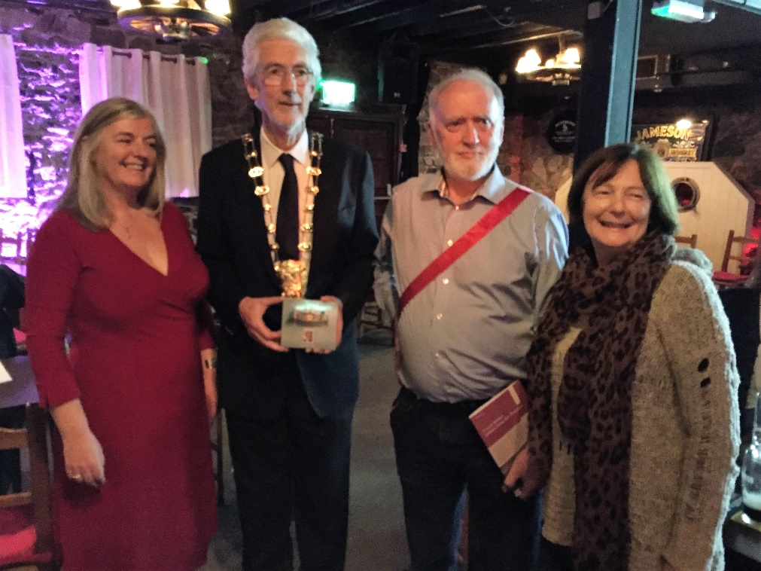
Councillor Dave O’Connor, Mayor of Fingal, launching Luke’s CD in Howth with Niamh Parsons and Ann Riordan

Luke’s style of singing is purely traditional, all-encompassing in its choices; from the haunting Radcliffe Highway to the music hall number Nice Little Jenny from Ballinasloe. This CD represents but a few morsels of the Pure Drop that inimitable Luke possesses – he has hundreds of songs and recitations. We just need to hear more recordings from him. (Somewhere I hear choruses of ‘Hear! Hear!’ ringing around the country)

Alas! A minor design quibble- no name or title is on the side of the cd copy. When filed away it could be difficult to find, especially if you have a full Saggin Shelf!!
Mick Fowler
Phil Callery’s Challenge

Phil Callery recently said he would like me ‘to accept the seven singer challenge by posting your selection of influential singers through your life. With some interesting stories on how they came your way’. I responded to his challenge on Facebook and a few folk have suggested I reproduce some of the entries in The Sweet Nightingale.

And what more appropriate way to begin than with Phil himself? His CD From the Edge of Memory remains a classic. Before I met Phil, I had encountered ‘The Boys’ – Gerry Cullen, Fran McPhail and Brian Leahy – on many great Sunday morning’s in Bean Uí Chairbré’s pub in Drogheda. These sessions from 12.30 to, supposedly, 2, were crowded with musicians, singers and listeners. Residents included Tom O’Sullivan on piano accordion who played Irish and Scots music with a discernible dash of the Champs-Elysées; Wally Murphy on banjo and singing his own, often highly amusing songs; Liz and Jim McArdle, she having a wonderful, haunting voice and he with multi instruments; Seán Corcoran and Desi Wilkinson – now most familiar as two thirds of Cran; and the serendipity of whoever might drop in. The stars, the turn that got instant order, were ‘The Boys’. I had never before heard such harmonic singing and, in the confines of the dark, smoky pub, the voices swaddled you with joy. Sadly, Brian died a very young man and Phil joined Fran and Gerry in what became The Voice Squad, everyone’s favourite singing group. Their ‘O The Holly’ has become an essential part of all our Christmases so they are now indelibly woven into the very cultural fabric of contemporary Ireland: some achievement. For me, Fran McPhail has a most unusual but iconic voice, towering high, seemingly not going to make the notes but always taking them comfortable like some sonic steeplechaser literally flying Beecher’s Brook. Fran is a compelling artist, wonderfully funny on occasion, but a serious candidate for this list of seven. Today, I hear more of Gerry Cullen, song for song, in my view, currently the best singer in English on the island. Gerry always ‘hits the spot’, has great phrasing and timing, and a wonderful song selection, regularly drawing from Drogheda and Louth writers and tradition bearers like Shields and Mary Ann Carolan.

So, before turning to Phil, I offer a memory of those Sunday mornings, the beginnings of my musical upbringing in Ireland.

Sunday Mornings in Carbery’s

do Chaitlín Bean UíCairbré

She lay last in the dark bar,
still commanding order,
spiriting invisible pints
as reward for silk-spun airs,
listening for godwits in the night,
wrens singing among stones.

Fiddlers came from
hardy country beyond Collon,
flutes from Cooley Fell and Termonfeckin,
songs floated down from Mullagbawn
and there was, somehow,
a Yellowbatter bouzouki:
Wally Murphy stirred himself
from under the clock
and Tom O’Sullivan effortlessly squeezed
a set of tunes lilted in every parish in Louth –
‘Les Parapluies de Cherbourg agus Ruaille-Buaille’;
Cloistered harmonies tumbled down
from Sunday’s Gate and Fran McPhail led
two foolish youths in praise of fine ale,
holly berries and bonnie Irish maids:
it was any Sunday morning,
and every Sunday morning.

You sat besdie Darach Ó Catháin –
ag choinneáil ceol –
black and red the two of you,
a fluttering standard of language and lore.
Nic Jones berthed his creaking austral whaler,
huddled around that little pot stove,
you serving fresh penguin eggs as treat.
Out the hard, gangs of excited youngsters
madly peddled Usher’s sad treadles,
hide and chased, darting in and out
for more crisps, fizzy drinks
and hopes that sense might
strike their elder care.

We all passed this way,
string, reed and goatskin,
seán-nós and nasal crooner,
lost-head lovers and otherwise dull,
habitual couples, quiet corner hides
just listening with nodding beams,
and that fellah would always stand
to be constantly hit
by the inner half-door;
occasionally dogs borne of curiosity
dropped in and once a robin,
lost but soothed,
perched on high trying to figure
silver, cigarette-paper stalactites.

And here we pass again,
Gerry Cullen singing true
‘The Parting Glass’,
seeing your shroud as weft from
from our memories, times and faces,
melodic phrases and poetic mysteries,
each thread snagged some Sunday morning
but all woven on your secret loom
to a pattern
rich your own.

I still attend regular singing sessions in Drogheda, today’s treats being Gerry, the Branigan Brothers, Pat and Stuart Carolan, Gilly Cullen, Pat from the fields round Ferbane, Noel Bailey – when he isn’t firing cannons, and many more. I surely owe Drogheda much in musical terms, its core my friendship with Éamon Thornton.

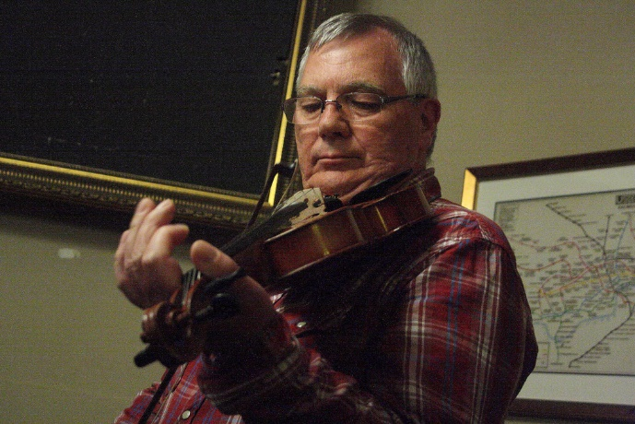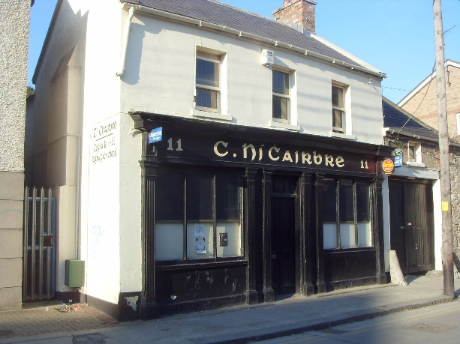
Phil Callery, the fiddle player and Bean UíCairbré’s

I have utter respect for Phil Callery as singer and musician; organiser of ‘The Singers’ Club’ in 1970, forerunner to so many others since like our own Howth Singers’ Circle; as source and inspiration for songs and their provenance; and as gentle and engaging company, especially when reminiscing about singers, songs and song significances. ‘The Edge of Memory’ came out in 1999 with Phil and The Long Wave Band: Níall Ó Callanáin, bouzouki; Kevin Murphy, cello; Colm McCaughey, fiddle; Jimmy Faulkner, guitar; and Belinda Morris, oboe and sax. Phil’s daughters Sarah and Rosa added vocals. The CD blew everyone away with its power and gentle sensitivity, Phil’s vocal range and interpretations of songs, its laying down of what would become ‘definitive versions’ of songs. I have two copies – one in the house and one in the car, compliment enough. The song I have chosen is ‘The Bonnie Blue Eyed Lassie’ and here you can see him too. I remember singing it – very poorly in comparison to this – in the Pier House one night at the request of a couple and an old woman who was clearly the woman’s mother. ‘Did you know ‘The Bonnie Blue Eyed Lassie’’, they asked. I attempted the song and opened the eyes to find the most beautiful, tearful smile from the old woman, her blue, blue eyes filled with emotion. I rightly told her, when she tried to thank me, ‘No, it’s Phil Callery you need to be thanking!’ So, thank you, Phil.
Francy Devine

Sea Shanties at the Prawn Festival

On Friday afternoon, 18 March, a brave crew faced very cold winds to sing shanties and maritime songs at the Dublin Bay Prawn Festival, Howth. In addition to tunes from Diarmuid Ó Cathasaigh, singers included Áine Bean Uí Chathasaigh, Walter Kennedy, Ciarán Ó Maoiléoin, and Finola Young. Gerry O’Connor led ‘Old Whitby Harbour’ and Tony Fitzpatrick steered a great course for ‘The Greeland Whale Fisheries’ aboard ‘The Old Balena’. Bhí againn dhá amhrán i nGaeilge – StiofánÓ hAolain with ‘Óró Sé do Bheatha Abhaile’ and Seán Ó hEaracháin who had crossed the Chops of Dublin Bay to be with us with ‘Óró Mo Bháidín’. A rousing final got the onlookers singing along as Luke Cheevers fell down with ‘Billy O’Shea’ and Fergus Russell charged forward with the Club anthem ‘The Bonnie Lighthorsemen’. It was great to see so many supporters stood off for’ad and singing away. The crew was, alas, press ganged by some wanton brigands and held captive in The Waterside and forced sing some more and consume most unpleasant libations against their will.

Our thanks to all who came and sang or listened – a great turn out on a chilly Friday afternoon but a performance that had brought much favourable comment.

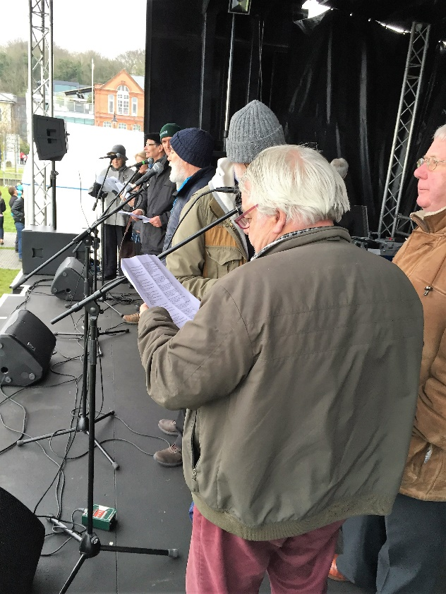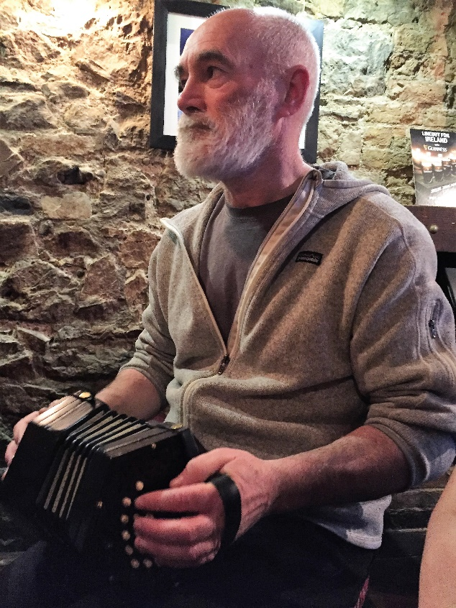

Above: looking across the deck as the crew sing away: Tony Fitzpatrick in the Captain’s lounge afterwards
Below is the shanty crew, l-r: Áine Bean Uí Chathsaigh, Finola Young, Diarmuid Ó Cathasaigh, SeánÓ hEaracháin, Stiofán Ó hAoláin, Siobhán Moore, Francy Devine, Ciarán Ó Maoiléoin,Tony Fitzpatrick, Luke Cheevers, Gerry O’Connor, Walter Kennedy & Fergus Russell

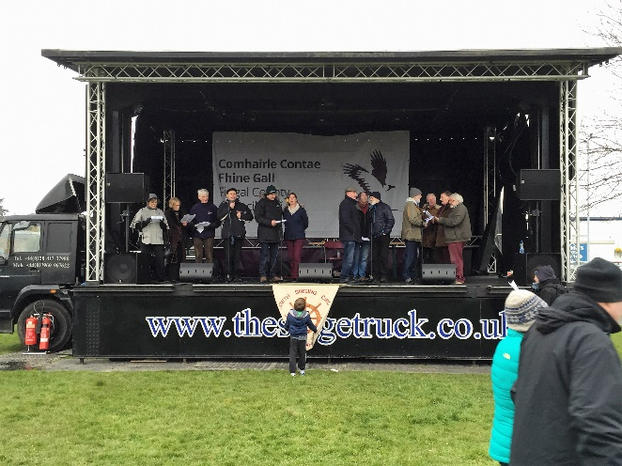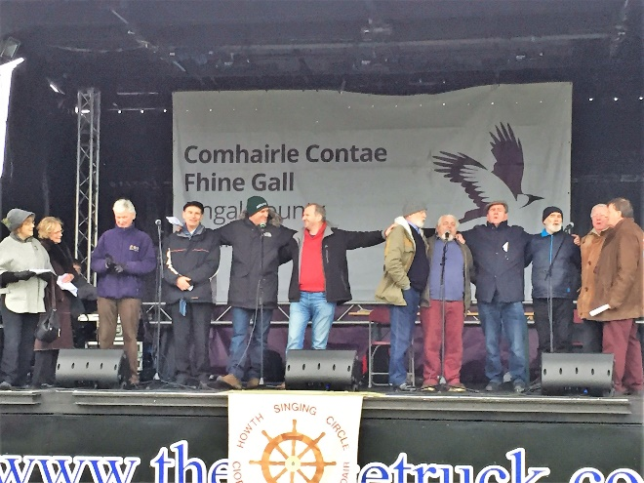

Fidil Bus a Trí

The third Fiddle Bus – this time to Glenties via Omagh – was a triumph. From the American Folkpark, Omagh to the songs and tunes on the way home, the music was superb, singing great and company joyous. A longer account will come later but for now it is is enough to pay thanks to those who made it such a great weekend. Richard Hurst and staff at the Ulster American Folk Park were terrific hosts

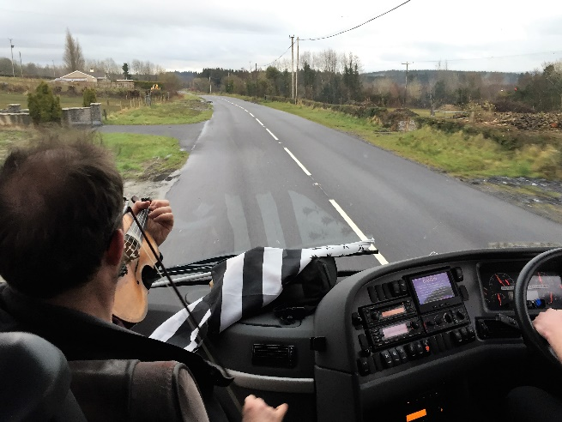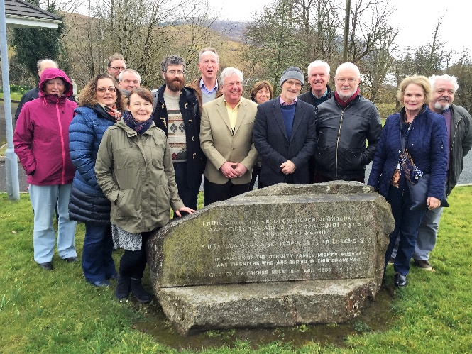
Rónán Galvin leading the way home and Fiddle Bus members at the Doherty family grave at Baile na Finne

and the tunes from Loïc Denis, Ciarán Mac Aodhagáin, Liam O’Connor, Ciarán Ó Maonaigh and Michael Mullen and emigration song from Tony Fitzpatrick a delight in the evocative atmosphere of a tall ship quayside. Sinéad Boyle and staff at the Highlands Hotel looked after us very well – as did the various B+B owners who catered for some. The staff in O’Neill’s, Letterbarrow and the Seven Arches, Laghy – especially Geraldine whose Guinness stew was extremely tasty – were generous hosts. Special thanks must go to Jimmy and Peter Campbell, Danny Meehan and Eddie O’Gara for sharing their special talents with us and to the other local musicians who came along and played.

We must thank everyone who made the trip – especially Paul Bradley and Ger Fitzgerald who travelled up from a festival in Carlow after performing – and those who supported the Bus in other ways. The two that travelled the farthest were the Breton pipers Loïc Denis and Patricia Riou who came over from Lanester near Lorient. As with other Fiddle Bus events, the weekend had short presentations from Liam O’Connor, Ciarán Ó Maonaigh, Rónán Galvin and Rab Cherry – the latter’s illustrated [visually and aurally] talk on tin fiddles gripping everyone. The film footage of John Doherty [and Pete Seeger] preceded a visit to his family grave in Báile na Finne, a hauntingly beautiful spot where the birds undoubtedly took the prize for the weekend’s best singers.

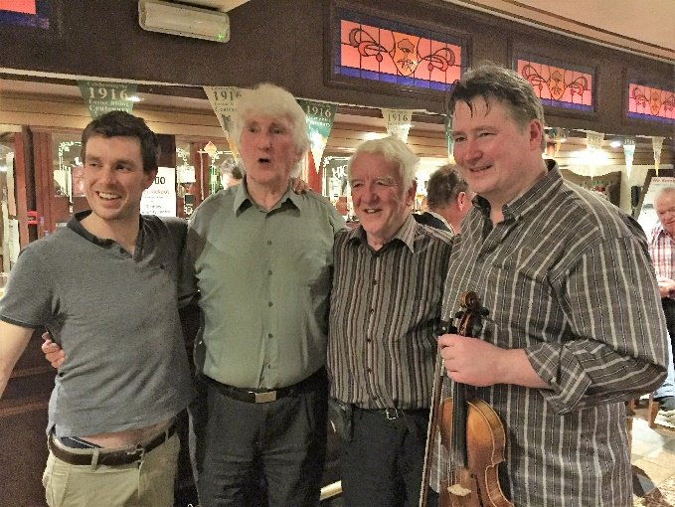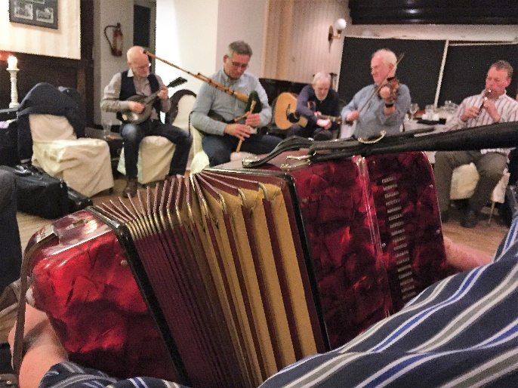
Liam O’Connor, Himmy Campbell, Mick O’Connor, Peter Campbell; Gearóid Ó Cathaláin, Michael Mullen, John Kelly and local whistle player

Special thanks, of course, must go to those who organised everything. Musically, we were indebted to John Kelly, Liam O’Connor and, especially to Rab Cherry and Rónán Galvin with the informal support of Cairdeas na bhFidiléirí whose website www.cairdeasnabhfidileiri.com/index.html is well worth a visit. Their local knowledge and the respect in which they are held by local people were an invaluable asset to us. O’Connor’s Coaches Howth and Anchor Tours’ driver Gavin Arrowsmith drove us safely to all destinations even those up boreens only a crow could get up! Gavin became an integral part of the group and enjoyed every minute of the trip. Ann Riordan smoothly managed administration, bookings and general duties. Most thanks must go to each and every one on the Bus for making the whole two days such a pleasure.

Fiddle Bus 4 will be on the weekend after Easter next year, 21-23 April 2017. There are suggestions that it be in Brittany and indications of interest are welcome. As with Scotland, a number of events around the Bus day will be organised.

HSC Singers at Various Events

HSC singers were featured in Terry Moylan and Francy Devine’s illustrated programme of songs and poems of 1916 – variously titled ‘In Squadrons Passed Me By …’ and ‘The World Did Gaze …’ Performances were delivered on Easter Monday as part of RTÉ’s Reflecting the Rising and on the last Tuesday in April in City Hall as part of Dublin City Council’s lunchtime lecture programme on Dublin and the 1916 Rising. Drawn from Terry Moylan’s new superb book, The Indignant Muse: Poetry & Songs of the Irish Revolution, 1887-1926, (Lilliput Press), those performing were Anne Buckley, Jerry O’Reilly, Ann Riordan and Fergus Russell, as well as Terry and Francy. The presentation – in a re-worked form – will feature on the closing Saturday of this year’s Willie Clancy School in Miltown Malbay. With Luke Cheevers, Francy also performed in City Hall for the Royal Dublin Fusilers Association commemoration of the Hullach Gas Attack and Luke and Tony Fitzpatrick had sung at City Council’s commemoration of the blowing up of Nelson’s Pillar – an event held in Pearse Street Library in March. On all occasions, singers performed to acclaim and the HSC’s reputation was enhanced.

Malinky

Award-winning Scots band Malinky were our guests at a concert in the Abbey on 28 April. Superbly supported by Maitiú Ó Casaide (pipes), Ciarán Mac Aodhagáin (fiddle) and Joey Doyle (keyboard, flute, guitar and vocals), Malinky received a very enthusiastic reception from [from the Club’s point of view, a disappointing] crowd of seventy. Few regulars were seen and their non-attendance raises questions for the Committee about choice and timing of events. All that said, the musical quality was of the highest standard and the finale truly roused the room. Highlights were undoubtedly Fiona Hunter’s stunning version of the Child ballad ‘My Son David – there was a terrific feel in the audience as the song’s gravity and the beauty of the arrangement struck them – and Steve Byrne’s rendition of Violet Jacob’s ‘The Wild Geese’, also known as ‘The Norland Wind’.

Malinky went on to play The Cobblestone and Duncairn Arts Centre, Belfast, again to warm receptions, although nowhere else matched the cheers and whoops in Howth. The Howth event was managed on the night by Ann Riordan and Brian Doyle with assistance from Laurence Bond and Amy Riordan for the raffle. Particular thanks must be given to Finola Young for providing accommodation for band members and the mountain of scones and blueberry muffins they went home with. Thanks must also be given to Chris Boland on sound and Abbey Tavern proprietor Richard Tobin who generously fed the artists and generally offered support to the event.

We must also thank those who attended the event so enthusiastically and for their generous comments afterwards. Many had not previously attended HSC events and a good few took the trouble to comment favourably on the quality of the music and singing by text, e-mail and message.

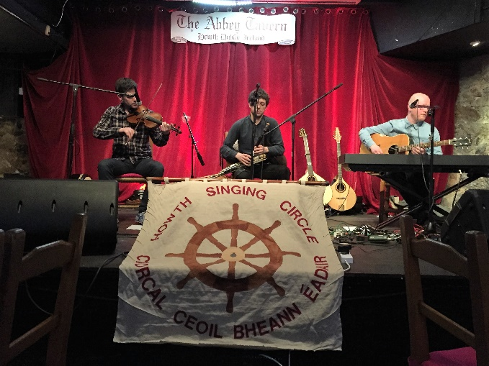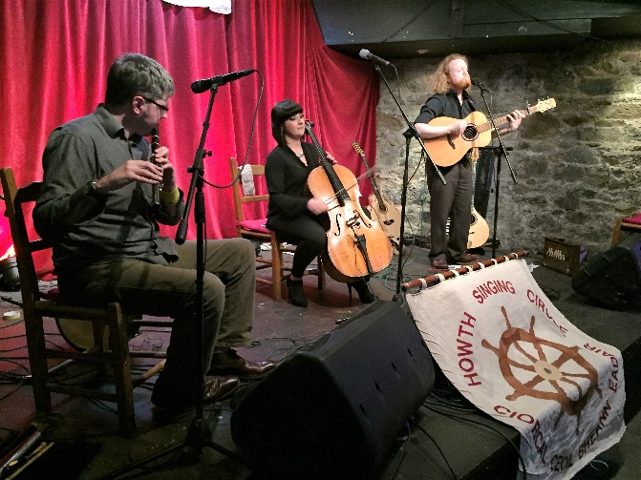
Cia
Ciarán MacAodhagáin, Maitiú Ó Casaide and Malinky – Mark Dunlop, Fiona Hunter, Steve Byrne

Thanks

As ever, The Sweet Nightingale does not simply appear. We thank John Bentham (Tigerfolk, Long Eaton); Mick Fowler; Helen Lahert; Seán O’Meara; Richard Tobin (Abbey Tavern); and your Committee – Laurence Bond, Paddy Daly, Brian Doyle, Diarmuid Ó Cathasaigh, Gerry O’Connor, Stiofán Ó hAoláin, Niamh Parsons, Ann Riordan and Fergus Russell.

And we thank each of you for supporting the Howth Singing Circle
in all its various activities.

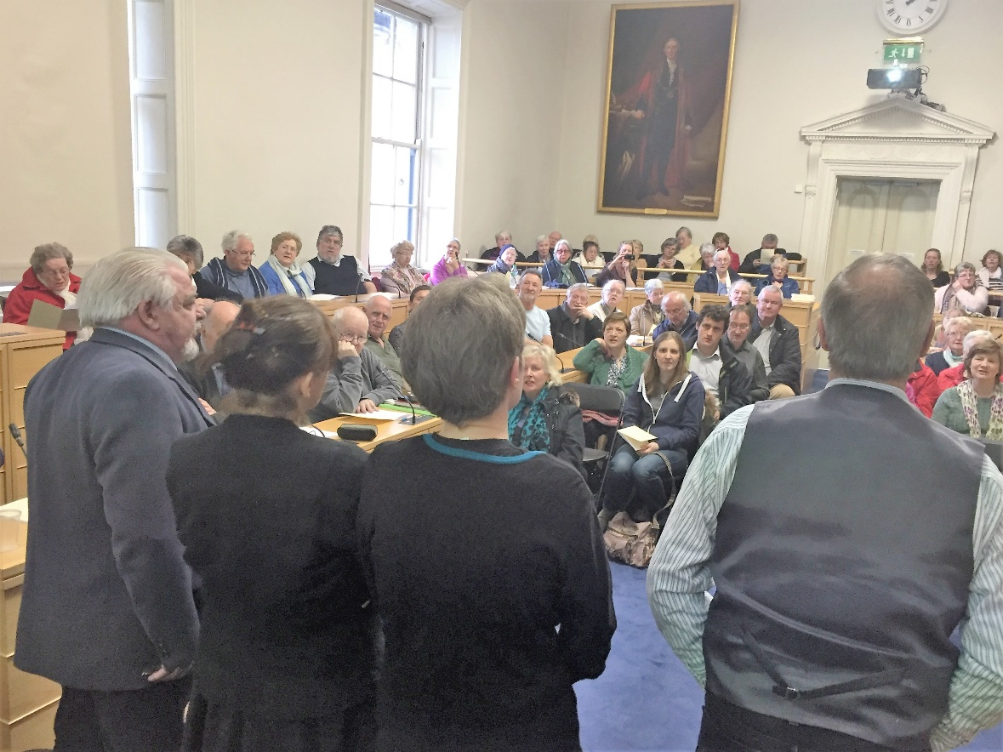
Fergus Russell, Ann Riordan, Anne Buckley and Jerry O’Reilly at the finale of their presentation
of 1916 songs and poems in City Hall on 26 April

